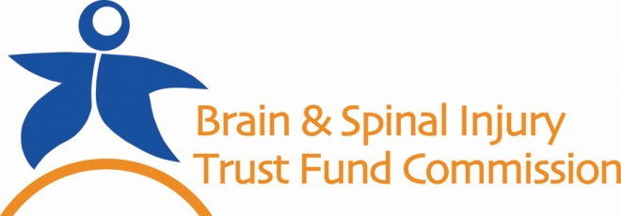

- Georgians with a traumatic brain and/or spinal cord injury may apply to the Commission for goods and services that maximize independence and recovery, such as:
Wheelchair Bathroom Modifications for Accessibility
Physical Therapy Hand controls for a car/van
Driver Evaluation post-injury Speech Therapy
Adaptive computer Hospital bed

- Since 2003 the Commission has awarded over $20,000,000 to 4,800 individuals for their post-acute care and rehabilitation. This does not include the grants awarded to state organizations and camps for Georgians with traumatic brain injury.

- Zero tax dollars are allocated to the BSITFC. The Commission’s sole source of funding is a 10% surcharge on Driving Under the Influence (DUI) fines.

- The dramatic decline in DUI fine collection has resulted in a $15,000 lifetime award cap for each individual, although the lifetime cost of care can easily exceed $1,000,000.

Fiscal Year | Remitted From Courts | DUI Convictions
FY08 | $2,069,640 | 41,518
FY09 | $1,960,830 | 41,340
FY10 | $1,933,528 | 38,802
FY11 | $1,896,580 | Data Unavailable
FY12 | $1,770,818 | 33,449
FY13 | $1,579,626 | 29,634
FY14 | $1,449,027 | Data Unavailable

