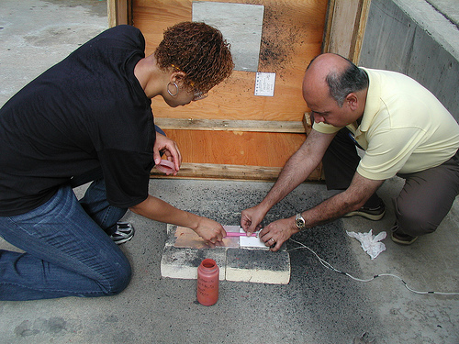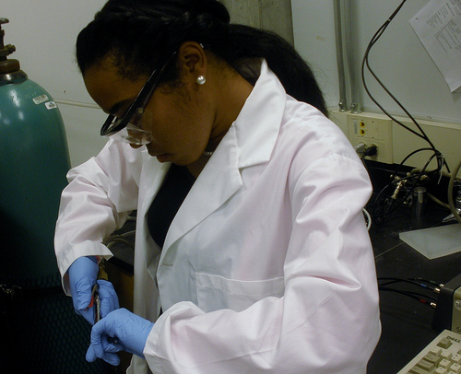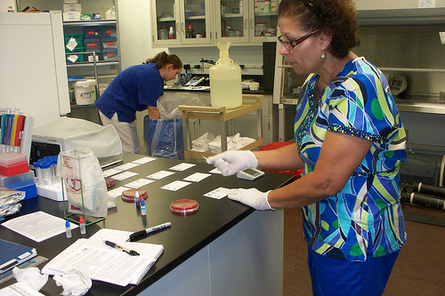

**When:** Summer Months, Annually (June – July)

**Where:** Internships available throughout Georgia. Sample sites include Georgia Tech, , University of Georgia, Georgia Power Plants, JCB Inc., Siemens, UPS and numerous

other companies, research agencies, and universities.

**Internship Benefits:**

* Advanced discipline knowledge
* Strategies for classroom use
* Network of resources
* $728 weekly stipend
* Up to 10 Georgia Department of Education PLU credits

The ***Georgia Tech*** Center for Education Integrating Science, Mathematics, and Computing’s (CEISMC) ***GIFT Program*** - in collaboration with universities and businesses across the state - offers Georgia ***K-12 Science, Math, and Technology Teachers*** paid 4-7 week internships in Science, Technology, Engineering and Math (STEM).

**To learn more and apply for GIFT, visit** [**www.ceiscmc.gatech.edu/gift**](http://www.ceiscmc.gatech.edu/gift)

**EARN WHILE YOU LEARN!**

**STEM PROFESSIONAL DEVELOPMENT OPPORTUNITY**

##### Quisque

.05

##### Integer

##### Donec non metus

Sed tincidunt, mi vitae consectetuer porttitor, mi nulla fringilla nisi, eu consectetuer enim libero a orci. Phasellus at nulla. Aliquam ipsum augue, tristique ornare, posuere a, tristique eu, nulla. Curabitur orci.

In in nisi interdum velit mattis pulvinar. Aliquam sem. Nunc diam odio, ultrices a, lobortis faucibus, commodo id, arcu.

##### Fusce urna

Maecenas quis odio. Nunc semper ullamcorper neque. Vivamus nec felis. Quisque lorem elit, fermentum in, venenatis a, scelerisque eget, risus.

##### Etiam fringilla

Aliquam fringilla. Cras scelerisque mauris eu leo. Aenean viverra sapien vitae sem vestibulum porttitor. Fusce lorem. Nunc vel nulla in sem tincidunt volutpat.

##### Etiam et urna

#### .Etiam