Capitol Event Feb. 23, 2009 – Trauma Survivors
To reach a trauma survivor/family member post-event, contact Katie Little at
770.522.8855 office, 678.316.0304 cell or klittle@hayslettgroup.com.
Photos of trauma survivors and their trauma incidents available upon request.

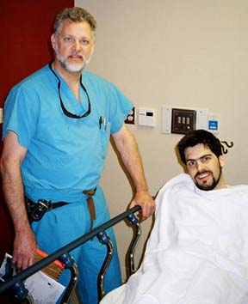
Trauma survivor: Aaron Barth

Available for interview: Aaron Barth

Home: Macon

Date of Trauma: February 20, 2007

Age, at time of trauma incident: 24

Trauma incident: In preparation for a 5K race, Barth was hit by a SUV, pulled approximately 265 feet along the road, was caught on the front tire and run over by both front and back wheels. He sustained severe injuries to his hand in addition to wounds to his chest, back and shoulders.

Trauma response: Police were on the scene within minutes and Mid-Georgia Ambulance EMS services arrived about 10 minutes later. The EMS team transported Barth to the Medical Center of Central Georgia (also his place of employment), a Level I trauma center. He arrived within 30 minutes of the accident. He was taken into the trauma unit where Dr. Dennis Ashley and Dr. Clifton Cannon directed efforts to stabilize him. Nurse Leslie Bassett stayed by his side as he went through radiological testing. Neurosurgeon Dr. Joe Sam Robinson and team checked to ensure that his neurological functions remained intact. Within three hours he was taken into surgery where Dr. Guy Foulkes of OrthoGeorgia worked to preserve as much function in his hands as possible. Barth lost his left index finger and required several skin grafts to cover the areas of his hand and arm.

“The trauma team and staff of MCCG’s orthopedic floor served my family and I selflessly,” says Barth.

The trauma care difference: Barth was incredibly fortunate that his accident took place in Macon near MCCG, one of Georgia’s four Level I trauma centers. The hospital was prepared with all the specialty physicians and nurses, and he was treated with great efficiency and care.

Status: On February 8, 2008, after six surgeries and more than 75 occupational therapy sessions, he was finally cleared from requiring any further medical treatment, almost a year after the accident. Says Barth, “I am grateful to be where I am today after such a traumatic accident. Having experienced what it is like to be a patient and require the care of a trauma team, I am all the more grateful that I have the opportunity to continue working professionally with my colleagues and friends at the MCCG. The coordinated care from physicians, nurses and staff has given me an incredible gift through their expertise, care and compassion. They continue to use their gifts to help other trauma victims daily.”

(Photo: Guy Foulkes, M.D. – Orthopedic Surgeon and trauma survivor Aaron Barth)

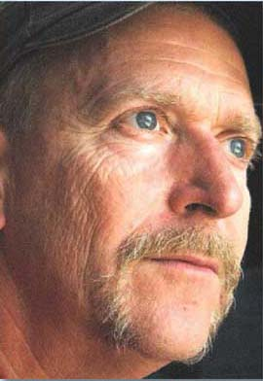
Trauma survivor: Steve Charron

Available for interview: Nancy Charron, wife

Home: Lilburn, a northeastern suburb of Atlanta in Gwinnett County

Date of trauma: April 2, 2006

Age at time of trauma: 49

Trauma incident: Charron was riding his Harley Davidson motorcycle on Highway 78 through Loganville at about 4:30 p.m. when a Ford Expedition coming from the opposite direction stopped at the intersection of Lee Byrd Road and turned left in front of him. Charron had about 10-15 feet to react and hit the passenger side of the Expedition.

Trauma response: Loganville police and a Walton EMS ambulance arrived at the site about five minutes after they were called at 4:31 p.m. Emergency medical technicians assessed Charron's injuries and transported him to Loganville Middle School where he was intubated and flown by a Rescue Air 1 helicopter to Atlanta Medical Center, a designated Level II trauma center near downtown Atlanta. He arrived at the trauma center at 5:28 p.m. - inside the "golden hour."

At one point following the crash, Charron stopped breathing and was revived. He suffered serious head and facial injuries: broken cheekbones and nose, lacerated lips, as well as broken and bulging cervical discs, lung contusions and a broken left wrist. Trauma physicians including surgeon Dr. Ignatius Akpele and resident Dr. Walaya Methodius Ngwodo were able to stabilize Charron.

Several days later, he underwent surgery on his face, mouth and wrist.

The trauma care difference: "With the roadways so congested, there would not have been a way to transport him to any hospital that quickly without the helicopter," says Charron's wife, Nancy, who works as a lab director at Gwinnett Medical Center. "Timing is definitely a key factor in a better outcome, and trauma centers are better equipped to address all of a victim's injuries as a whole. Trauma specialists know how each injury affects the others. We believe that Steve's inpatient stay was shorter and his outcome was better because of the care he received at a trauma center."

Status: As of June 2006 – only eight weeks after the crash – Charron was back at his job several hours a day as the general manager of a pool and spa distribution center.

(Photo: Steve Charron at a motorcycle rally only hours before his accident)

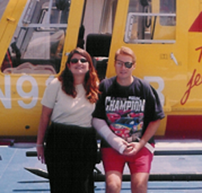
Trauma survivor: Rob Milks
Available for interview: Rob Milks
Home: Grayson, in Gwinnett County
Date of trauma: July 30, 1999
Age at time of trauma: 37
Trauma incident: Milks was practicing for an upcoming race at a motocross track in Loganville when he crashed on a 90-foot jump at a speed of over over 80 mph. The crash shattered the right arm and caused massive brain injuries and a brain stem hemorrhage. The nerves to the left ear and eye were also severed, and he was not breathing when EMTs arrived.
Trauma response: Gwinnett County EMS responded to the 911 call. Due to the severity of his injuries, they called to launch a helicopter to transport Milks to Atlanta Medical Center, a designated Level II Trauma Center in Atlanta. He was then air-lifted to Atlanta Medical Center in 30 minutes. Milks was able to be kept alive by life support. His injuries required reconstruction using screws and plates.
The trauma care difference: Atlanta Medical Center’s timing and speed were the keys to saving Milk’s life. During the first 24 hours, no physician had to be paged or called from home. Atlanta Medical Center’s in-house presence of general surgeons and the prompt availability of orthopedic surgery, neurosurgery, anesthesiology, emergency medicine, radiology and internal medicine, were all needed.
While most ERs have an emergency medicine physician on duty, they do not have an entire medical team and surgical capability 24 hours a day. It requires valuable time to assemble the appropriate staff, equipment and support in a basic emergency room; time that trauma patients don’t have.
Milks remained stable but comatose for several days. When he awoke from the coma, he started to breathe on his own and was taken off life support. Brain activity began to return to normal, but he was paralyzed for several months due to the injuries.
Once removed from life support, Milks underwent surgery to rebuild his arm and wrist. It was successful, but required major rehabilitation.
Following surgery, he remained in ICU for the remainder of the week and was moved to the Brain Rehab area of the hospital. Milks underwent several months of in-hospital rehabilitation and another six months of outpatient rehabilitation.
Status: As of January 2009, Milks has become a successful software executive. He was able to start exercising about two years ago and plans to run in the ING Atlanta Marathon in March.
(Photo: Rob and wife Rita after being discharged from the hospital)

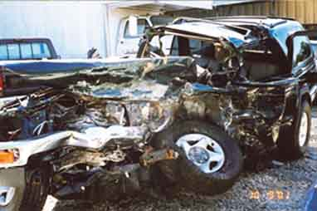
Trauma survivor: Brittni Parks
Available for interview: Brittni Parks

Home: Murrayville, in Hall County

Date of trauma: October 4, 2001

Age at time of trauma: 16

Trauma incident: Parks was traveling north on Hwy. 60 in Hall County when she was struck head-on by another vehicle. The air bag of her Toyota 4Runner deployed, and Brittni was wearing her seat belt.

Trauma response: Hall County EMS responded to the 911 call. Due to the extent and severity of Parks’ injuries, they called a helicopter to transport her to Grady Memorial Hospital, a designated Level 1 Trauma Center in Atlanta. After an hour-and-a-half extrication, Brittni was air-lifted to Grady in 18 minutes.

The Grady trauma team – led by Dr. David Feliciano – rushed Parks to surgery, which lasted 14 hours.

Parks’ injuries included multiple fractures on both sides of her body, most of which required reconstruction using rods, screws and plates.

The trauma care difference: Grady’s timing and speed were the keys to saving her life. During the first 24 hours, no physician had to be paged or called from home. Grady’s in-house presence of general surgeons and prompt availability of orthopedic surgery, neurosurgery, anesthesiology, emergency medicine, radiology, internal medicine, oral and maxillofacial surgery were all needed.

Following surgery, Parks was in an induced coma for four weeks at Grady. She suffered from respiratory failure, requiring prolonged ventilation and a tracheotomy, acute respiratory distress syndrome, pseudomonas sepsis, klebsiella pneumonia, and collapsed lungs requiring chest tubes.

Parks was subsequently transported to Northeast Georgia Medical Center in Gainesville and released within three weeks. After being discharged, she continued physical therapy for six months, progressing from a wheel chair to a walker and then to walking on her own. Parks has had numerous operations following her accident, but is a walking miracle thanks to the EMS team and Grady’s trauma center.

Status: As of January 2009, Brittni was working towards her degree in middle grades education. “I’m healthy and am able to lead a normal life thanks to the trauma care I received from both Hall County EMS and the Grady trauma team,” said Brittni. “It’s unfortunate that every trauma victim in the state isn’t able to receive the same immediate care.”

(Photo: Brittni’s Toyota 4Runner the day after the accident.)

Trauma Survivor: Charlee Lynn Russell
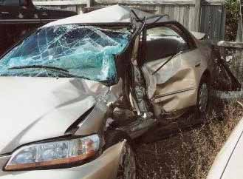
Available for interview: Pam Russell, mother

Home: Valdosta/previously Statesboro

Date of trauma: January 11, 2006

Age at time of trauma: 16

Trauma incident: Charlee Russell was crossing a four-lane highway on her way to school and was hit on the driver’s side door by a Jeep Cherokee traveling 55 mph. The airbags in her 2002 Honda Accord deployed, and Russell was wearing her seatbelt.

Trauma response: Bulloch County EMS responded to a call by the family physician whom happened to be in the car directly behind Russell. He called for the Life Star helicopter to be sent from Memorial Medical Center, a Level 1 trauma center in Savannah. The Jaws of Life were successful in removing Russell from the car in less than 10 minutes. EMS transported her to the local hospital within eight minutes. Life Star landed within 15 minutes, and transported her to Memorial in less than 20 minutes. Russell’s injuries included respiratory failure, a traumatic brain injury, a lacerated spleen, and fractured ribs, pelvis and tailbone.

The trauma care difference: Essential equipment was readily available to assess Russell’s injuries, and qualified physicians, trauma surgeons, neurologists, orthopedic surgeons, radiologists and respiratory specialists were on site, saving Russell’s life.

At the local hospital, the doctor was quick to point out that a Level 1 Trauma Center would be Russell’s best hope of survival.

Russell spent 14 days in a coma in the trauma unit at Memorial. Her respiratory failure required chest tubes and the assistance of a ventilator and endo-tracheal tube. Eventually it was necessary to perform a tracheotomy on her to preserve her vocal cords.

She was gradually weaned off the ventilator and re-taught to swallow in order to remove her feeding tube. Then, Russell spent another 14 days at Memorial’s Rehabilitation Center recovering from her traumatic brain injury.

After 38 days, Russell was finally able to go home. She spent an additional four weeks working with speech and physical therapists. In April 2006, she joined her junior class and completed the school year. She graduated from high school the following year, ranked in the top 14 percent of her class, and was accepted into UGA.

Status: Today, Russell is a sophomore at UGA working towards a journalism degree. She is a healthy, happy 20-year-old with so much to be thankful for. “I know without a doubt that the doctors at Memorial saved my life. Without their sophisticated equipment and continued assessment of my ever-changing condition, my outcome would have been very different. Shouldn’t everyone in the state of Georgia be given the opportunity to have this care readily available? What greater gift can we give Georgians than the gift of life?” says Russell.

(Photo: Russell’s 2002 Honda Accord after the accident)

Trauma survivor: David Benjamin "Ben" Shuman
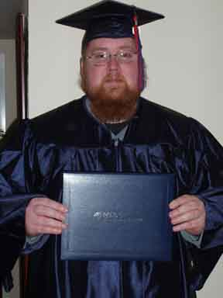
Available for interview: Ben Shuman and Sherry Shuman, mother

Home: Morganton, in Fannin County

Date of trauma: April 9, 2006

Age at time of trauma: 22

Trauma incident: Shuman was driving his red Chevy S10 pickup truck north on Hwy. 84 in Grayson (Gwinnett County) at about 5:30 p.m. when a Chevy 1500 HD truck, traveling eastbound on Bennett Road, ran a stop sign. The vehicle struck Shuman's truck on the driver's side truck bed at an estimated 50 mph, causing Shuman's truck to veer off of the road and roll twice. Shuman was found 10 feet from the truck by his brother-in-law, who had been following Shuman.

Trauma response: Gwinnett EMS, Station 8 responded, and the LifeNet helicopter medical transportation service was called at 5:46 p.m. for immediate transport. The LifeNet crew arrived at 6:13 p.m., intubated Shuman, and took off for Grady Memorial Hospital, a designated Level I trauma center in downtown Atlanta, at 6:33 p.m. The helicopter arrived at Grady at 6:47 p.m. - just a few minutes outside of the “golden hour."

At Grady, Shuman received trauma resuscitation. CT scans and X-rays indicated serious skull fractures and brain injuries. A team led by neurosurgeon Dr. Nanette Harris performed an immediate craniotomy.

The trauma care difference: "Ben's evaluation at a trauma center gave him the edge for survival," says his mother Sherry Shuman, a nurse practitioner. "If he had not been at a trauma center, he would have required transfer that would have delayed treatment. If he had not been initially evaluated at a trauma center, it's questionable if he would have survived his injuries."

Shuman and his family strongly support the expansion of the trauma care system in Georgia, says Sherry Shuman. "Most people do not realize that there is inadequate trauma coverage, even in some parts of the Atlanta area," she says. "Had Ben's accident occurred outside of the Atlanta area, his chances of survival would have been greatly reduced. The only way to make the public aware of the need is to present it in a personalized way. You have to put a face on the problem."

Status: In June 2006, Shuman had completed inpatient rehab at the Shepherd Center in Atlanta and was beginning outpatient occupational and speech therapy in Blue Ridge. Ben’s injuries required him to choose a different career path and in February 2009, he graduated from Nashville Auto Diesel College in Nashville, Tenn.

(Photo: Ben graduating from Nashville Auto Diesel College in Nashville Tenn.)

