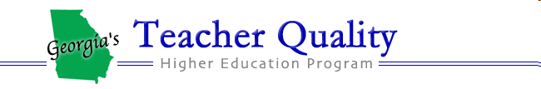
COMMUNICATING & ANALYSIS OF STUDENT EXPERIENCES (CASE) IN THE Physical sciences

A Professional Development Workshop to help teachers create a classroom environment that:
- helps students formulate scientific questions to gain knowledge.
- engages students in activities designed to answer these questions.
- encourages students to develop explanations based on experimental evidence.
- fosters a culture of communicating and justifying explanations between students.
- extends the students’ experience to a socio-economic-political discussion.

Appropriate for Middle and High School
Physical Science, Physics and Chemistry teachers

Each participant completing 50 hour program receives
5 PLU, $300 stipend
(80% support provided by the “No Child Left Behind” Title II Part A Higher Education Improving Teacher Quality Grants)

Workshop Schedule
9 am – 5 pm July 5—July 9, 2011 32 hours
9 am – 4 pm Friday, September 16, 2011 7 hours
9 am – 4 pm Saturday, September 17, 2011 7 hours
9 am – 1 pm Saturday, November 12, 2011 4 hours
TOTAL 50 hours

All sessions will be held at the University of West Georgia in Carrollton
Application deadline: Monday, May 2, 2011

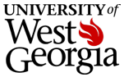 Dr. Sharmistha Basu-Dutt (sbdutt@westga.edu)

Dr. Gail Marshall (gmarshal@westga.edu)
Consultant: Dr. Donald Wink, University of IL-Chicago
Evaluator: Dr. Cianan Russell, Georgia Institute of Technology

APPLICATION FORM

Communicating & Analysis of Student Experiences (CASE)
in the Physical Sciences

NAME

OTHERS FROM YOUR SCHOOL WHO MAY APPLY

SCHOOL SYTEM

SCHOOL NAME, ADDRESS and PHONE NUMBER

HOME ADDRESS and HOME/CELL PHONE NUMBER

HOME/SCHOOL EMAIL CONTACT THAT YOU CHECK EVEN AFTER SCHOOL IS OUT.

GRADE LEVEL and SUBJECT(S) TAUGHT

Questions about the workshop? Email sbdutt@westga.edu or gmarshal@westga.edu

Application Deadline: Application must be post-marked by Monday, May 2, 2011.

Return completed applications to: Dr. Sharmistha Basu-Dutt, Department of Chemistry, University of West Georgia, Carrollton, GA 30118

