ENHANCING THE NATURE OF SCIENCE & PROBLEM SOLVING IN
ELEMENTARY SCIENCE INSTRUCTION

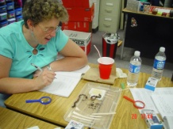A Professional Development Workshop to provide properly conceived inquiry experiences in science teaching and learning for K-5 teachers

Each participant completing 50 hour program receives
5 PLU, $300 stipend, chance to receive materials & supplies.
(80% support provided by the “No Child Left Behind” Title II Part A Higher Education Improving Teacher Quality Grants)

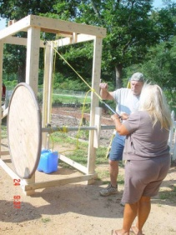Workshop Schedule
9 am – 4 pm July 11 — 15, 2011
9 am – 3 pm Saturday, Aug 27, 2011
9 am – 3 pm Saturday, Oct 15, 2011
1 pm – 4 pm Saturday, Nov 12, 2011

All workshops will be held at the University of West Georgia, Carrollton, GA

Application deadline: Monday, May 2, 2011
Preference will be given to teams of two or more from same school.

Dr. Sharmistha Basu-Dutt

Phone: (678) 839-6018 email:sbdutt@westga.edu

Dr. Gail Marshall

Phone: (678) 839-6081 email: gmarshal@westga.edu

Evaluator: Dr. Roy Forbes

APPLICATION FORM

Enhancing the Nature of Science & Problem Solving in Elementary Science Instruction

NAME

OTHERS FROM YOUR SCHOOL WHO MAY APPLY

SCHOOL SYSTEM:

SCHOOL NAME, ADDRESS and PHONE NUMBER

HOME ADDRESS and HOME/CELL PHONE NUMBER

HOME/SCHOOL EMAIL THAT YOU USE EVEN AFTER SCHOOL IS OUT.

GRADE LEVEL and SUBJECTS TAUGHT

Questions about the workshop? Email sbdutt@westga.edu or gmarshal@westga.edu

Application Deadline: Application must be post-marked by Monday, May 2, 2011.

Return completed applications to: Dr. Sharmistha Basu-Dutt, Department of Chemistry, University of West Georgia, Carrollton , GA 30118

