Jimmy Carter NHS Education Program
presents a
Special Program featuring Rosalynn Carter
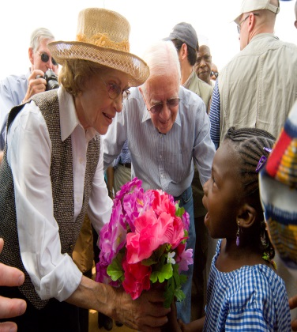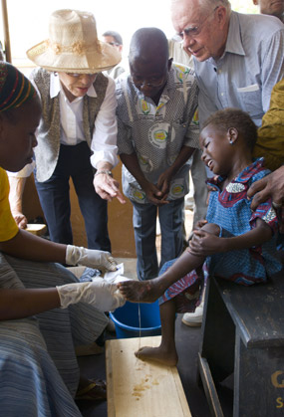
The Carter Center and Rosalynn Carter Institute for Caregiving

May 1, 2014 at 10:30AM
Plains High school museum – plains, Georgia

Program designed for staff and students in the Health Care Field

Former First Lady Rosalynn Carter has worked for more than four decades to improve the quality of life for people around the world. Today, she is a leading advocate for mental health, caregiving, early childhood immunization, human rights, and conflict resolution through her work at The Carter Center in Atlanta, Georgia. The Center is a private, nonprofit institution founded by former President and Mrs. Jimmy Carter in 1982.

A full partner in all the Center's activities, the former first lady is a member of the Carter Center Board of Trustees. She created and chairs the Carter Center's Mental Health Task Force, an advisory body of experts, consumers, and advocates promoting positive change in the mental health field. Each year, she hosts the Rosalynn Carter Symposium on Mental Health Policy, bringing together leaders of the nation's mental health organizations to address critical issues. Former First Lady Rosalynn Carter

The Rosalynn Carter Institute for Caregiving - an advocacy, education, research, and service unit of Georgia Southwestern State University. The work of a caregiver is done willingly and selflessly. Many caregivers do their work quietly, invisibly and around the clock in homes, hospitals and other places across the country.

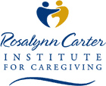
We are facing a caregiving crisis in the United States. Our aging population, increased longevity and the growing burden of chronic illnesses escalate the need for caregivers. Caregivers need support and community programs to help them remain healthy and maintain caring for another. We serve and support both professional and family caregivers. Executive Director - Leisa Easom, PhD, RN

Jimmy Carter NHS Education Program
presents a
Special Program featuring Rosalynn Carter

Reservations form

If you are interested in reserving seats for this special program featuring former First Lady Rosalynn Carter and Dr. Leisa Eason, Executive Director of RCI, please complete this form and return it to plainsed@jimmycarter.info or fax to 229-824-5556. This program is for staff and students enrolled in a health care related field. It is appropriate for high school and college level.

Name __________________________________________________

School__________________________________________________
__________________________________________________

Phone number ___________________________________________
e-mail __________________________________________________

Number of seats for students _______ Staff ________
Grade level or College level__________

List the fields these students are enrolled in:_____________________
________________________________________________________________________________________________________________________________________________________________________________________________________________________________________________________________________________________
________________________________________________________

Seating is limited and will be scheduled as forms are received.
Please make your reservations early in order to secure
seating for your group.

