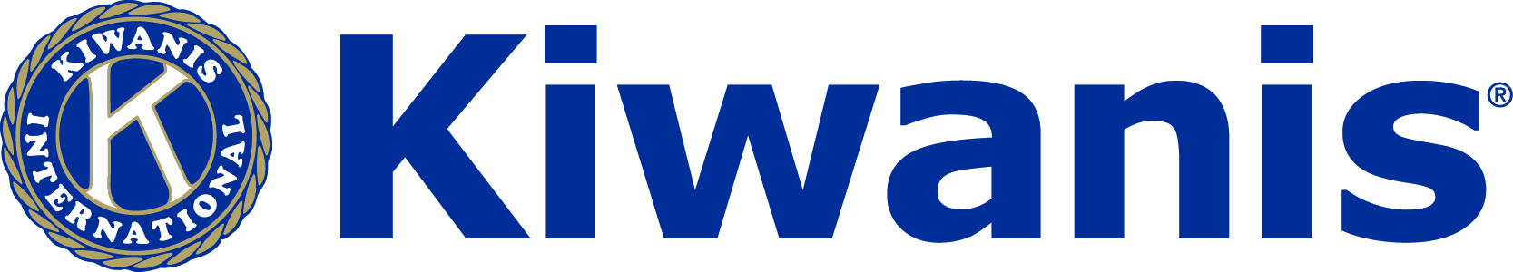
KIWANIS CLUB OF ATLANTA
Soar 2 New Heights!
CAMPAIGN 2014
Contributions to the Kiwanis Foundation of Atlanta, Inc. provide the means by which the Kiwanis Club of Atlanta supports deserving organizations throughtout the Atlanta metropolitan area with an emphasis on those serving children, adolescents and young adults. This year, we hope members will increase their pledges as we will also fund our club’s commitment to the Eliminate Project, working to eliminate maternal and neonatal tetanus around the world.

YES! I will support the 2014 Campaign!
I wish to pledge $_______ payable in __________ (month).
  - Enclosed is my donation of $________ payable to the Kiwanis Foundation of Atlanta.
  - I wish to contribute $_________ by credit card (minimum of $100 each transaction). Staff will contact you for credit card info.

______ My company matches gifts – I will complete the appropriate forms.

______ I have left a legacy to the Kiwanis Foundation of Atlanta. I have made the foundation a beneficiary of my will, trust, retirement plan, or life insurance policy. Please enroll me in the Legacy Fund Society.
______ I would like to learn more about leaving a legacy to the Kiwanis Foundation of Atlanta.
______ I plan to pay my pledge with appreciated securities. Please provide me with instructions on making gifts of stock and other securities.

  - This gift is (circle one) in honor or in memory of ________________________.
  - Please send acknowledgement letter to ( please print Name and Mailing Address): ____________________________________________________________________________________
NOTES:______________________________________________________________________________________________________________________________________________________________________________________________
Name ________________________________________________
Address ______________________________________________
Email Address _________________________________________
Date ____________ Signature ____________________________

Gifts of $1000 or more enable the donor to be recognized as a member of the Maynard Smith Society.
Unless otherwise designated, gifts to the 2014 annual campaign will be split as follows. The first $125,000 raised will be for grants to local nonprofit organizations; thereafter the remaining $40,000 will be for Project Eliminate. If you have any questions, please contact Rae Weimer at 404-343-7125 or rweimer@atlantaopera.org. Thank you in advance for your support!

