
Box Tools tab to change the formatting of the pull quote text box.]



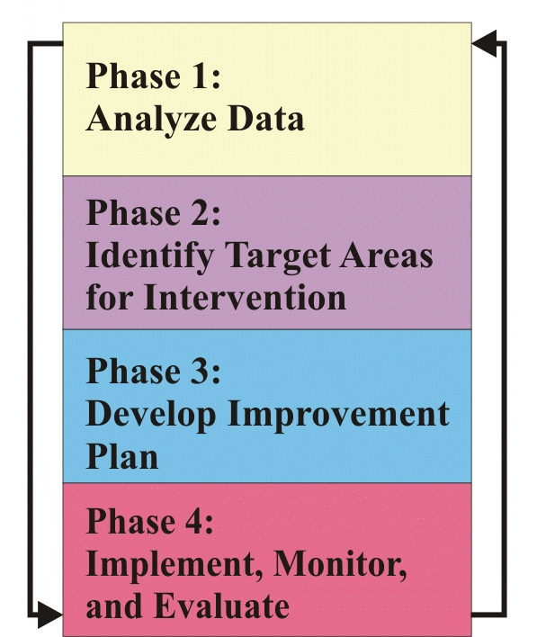
Intervention Framework
National Dropout Prevention Center for
Students with Disabilities
Model

Month | Topics
AUG | Overview  Tools for Success
SEPT | Data Analysis
OCT | Academic Strategies
NOV | Transition Strategies
DEC | Attendance Strategies
JAN | Behavior Strategies
FEB | Family Engagement Strategies
MAR | Reading Intervention Strategies
APR | Math Intervention Strategies
MAY | Student Engagement

Overview of the Georgia Graduation/Dropout Prevention Project
State Personnel and Development Grant (SPDG)

This project, a major component of a five-year grant from the U.S. Department of Education, focuses on improving graduation rates for students with disabilities in Georgia.

Project Goals are to:

- Increase the graduation rate for students with disabilities (SWD) who receive a general education diploma.
- Decrease the dropout rate for SWD.
- Increase the achievement of SWD in reading and mathematics.
The National Dropout Prevention Center for Students with Disabilities www.ndpc-sd.org has developed training to help schools analyze their needs based on information gained from a comprehensive data probe analysis.

Following training, schools will match
research-based interventions to their individual needs. Action Plans will be developed and implemented. Participating schools are supported by a regional SPDG collaboration coach. Training is being scheduled and dates will be announced soon!

Training Opportunities 2010-2011
Does your school need?

