There are some public needs or problems whose scope is so great that they exceed the resources of individual towns and cities or even states. The resolution of such problems often requires a response on the part of the national government.

(Item#:302-01)

1. What is the division of power between a national government and the individual states called?

      A. Balance of power

      B. Federalism

      C. Limited government

      D. Nationalism

Answer: B

(Item#:302-02)

2. How does the United States Constitution address the issue of the division of power between the national and state governments?

      A. It allows Congress to limit state power

      B. It provides for a Supreme Court to take over state programs.

      C. It allows the national government to preempt most state authority.

      D. It gives specific powers to the national government and reserves others to the states.

Answer: D

(Item#:302-03)

3. The national government exercises more power today than it did during the administration of George Washington. Which of the following is one important reason for this increased role?

      A. Americans demand more services of the national government.

      B. American presidents view their office as an 'imperial presidency.'

      C. Congress has reduced the Constitutional powers of the states.

      D. The Supreme Court has held that the national government is supreme.

Answer: A

(Item#:302-04)

4. Identify two government functions that are carried on by both state and national governments. Explain why both levels should exercise those functions.

[Scoring Criteria](http://metacat2.com/cssap/sg/302-4sg.html)

**Module: 302  
Item: 4   
Descriptor: National Problems-- National Programs**

**Scoring Criteria**

Scores are based on the student's ability to:

* Identify two governmental functions exercised by both state and national governments.
* Explain why both levels of government should exercise those functions.

A proficient response will provide two examples of governmental functions exercised by both state and national governments, and explain why both levels of government should exercise those functions. Examples of functions include:

* Taxation
* Education
* Police powers
* Health and safety, and environmental regulation
* Other logical answers should be accepted

The student will indicate that government at the state level is closer and most responsive to the needs of citizens. The provision of services at this level is more efficient. However, the federal government shares in the interests of the states', provides additional resources, and ensures that the states are fulfilling the needs of their citizens. State and federal government must cooperate to ensure that laws are executed and that vital public services are provided.

**Score Level Descriptions**

**NS** Not Scorable (blank, off-topic, hostile, etc.)

**1** A response at this level demonstrates minimal understanding of functions jointly carried out by state and national government, and why both levels should exercise those functions. The response is incomplete or inaccurate (one or no examples). The explanation of why both levels should exercise those functions, if provided, is ambiguous or seriously flawed. The response is insufficient to demonstrate understanding.

**2** A response at this level demonstrates an understanding of functions jointly carried out by state and national government, and why both levels should exercise those functions. Two appropriate examples of shared functions are provided. The explanation of why both levels should exercise those functions is clear and generally accurate. Although minor flaws may be present, the response is sufficient to demonstrate understanding.

Student Work Not Available

(Item#:302-05)

5. The United States interstate highway system stretches from Canada to Mexico and from the Atlantic to the Pacific; yet individual state governments can set different speed limits for different parts of the system. At the same time, there can be a particular product, produced from raw materials and manufactured entirely within one state, over which the national government exercises regulatory powers. Using these examples, or others of your own choosing, explain this apparent inconsistency.

[Scoring Criteria](http://metacat2.com/cssap/sg/302-5sg.html)

**Module: 302  
Item: 5   
Descriptor: National Problem--National Programs**

**Scoring Criteria**

Scores are based on the student's ability to:

* Explain the rationale underlying interlocking responsibility and "layers" of power and authority among levels of government.

A proficient response will demonstrate an understanding that, while states have certain expressed and reserved powers, the federal government has regulatory authority over the states. For example, state governments have police powers that allow them to regulate safety matters that affect people within that state, as is the case of people driving vehicles on a highway within a state. The federal government has the authority to oversee the health of citizens or the regulation of the safety of something (for example, a hazardous waste) that will be transported across the country, or even internationally. No single state could enforce health or safety regulations nationwide.

Other examples must be evaluated on their own terms.

**Score Level Descriptions**

**NS** Not Scorable (blank, off-topic, hostile, etc.)

**1** A response at this level demonstrates minimal understanding of the rationale underlying interlocking levels of governmental regulatory power and authority. The explanation, if provided, are exceedingly vague or inaccurate. Logic and reasoning are very simplistic and/or seriously flawed. The response demonstrates minimal understanding.

**2** A response at this level demonstrates some understanding of the rationale underlying interlocking levels of governmental regulatory power and authority. The student will provide a partially accurate response, but the explanation is inadequately developed or incomplete. Evidence of rudimentary logic will be present, but it will contain flaws. The response demonstrates partial understanding.

**3** A response at this level demonstrates an adequate understanding of the rationale underlying interlocking levels of governmental regulatory power and authority. The explanation is generally complete and accurate, although minor errors may be present. The logic and reasoning employed are justified, but may contain minor flaws. The response is sufficient to demonstrate understanding.

**4** A response at this level demonstrates a superior understanding of rationale underlying interlocking levels of governmental regulatory power and authority. The explanation is detailed, thorough, and accurate, and may go beyond that which is required in the question. The logic and reasoning used are sophisticated. The response demonstrates superior understanding.

Student Work Not Available

(Item#:302-06)

6. **Introduction**

The nature of the relationship among the federal, state, and local governments has always been an important issue in our nation's political life. 'Federalism' has always meant that the states were available to perform governmental functions that the Constitution delegated to them, did not deny to them, or that Congress did not claim.

The one historical event that caused the greatest change in relationship between state, local, and federal governments was the Great Depression. Until the Great Depression of the 1930s, the responsibility for relieving the misery of the unemployed, assisting the recovery of ailing businesses, and reforming abusive business practices was primarily a task for state and local governments. The Great Depression proved too difficult a challenge for state and local governments, as they had neither the power nor the resources to lift their citizens out of the harsh economic conditions. The federal government took the leadership of guiding the economy by means of a variety of New Deal programs.

Since the 1930s there have been efforts to further expand the role and power of the federal government, and there have been attempts to reduce its influence and power. New Deal programs such as Social Security have been expanded to include more people and to encompass Medicare. On the other hand, there have been successful efforts to deregulate businesses such as banking and utilities, which were first regulated during the New Deal period.

**Instructions**

What is the trend for the federal government today? Will the federal government continue to expand New Deal programs and add new programs? Or, will the federal government continue to deregulate and curtail programs that have been around since the Great Depression?

You will research these two questions and write a persuasive essay in which you take a position and provide evidence to support your position. Your essay must address **one** of the following points:

* Explain how the role of the federal government has increased since the 1930s, using specific examples.
* Explain how the role of the federal government has decreased since the 1930s using, specific examples.

It is necessary for your position be informed by research on **one** of the questions above. The work will not be judged on the force of its emotion, but rather on the weight of its evidence. The use of specific examples drawn from your research is required, and you must document the your sources of information to make your case.

The audience for your essay will include both your teacher and your classmates.

Scoring Criteria Not Available

Student Work Not Available

The Articles of Confederation, an important first step toward formal self-government, outlined a plan of government that bound the states into a loose union. However, there were serious problems with the new governmental structure, notably the national government's very limited authority to collect taxes. In the absence of this power, and as the costs of the War for Independence mounted, the government was forced to borrow more and more money from other countries.

The burden of repaying the war loans fell to the individual states, each of which possessed the power of taxation. In 1786, amidst a serious economic depression that had resulted from the loss of British markets, Massachusetts voted to raise taxes in an effort to pay off its war debt. The new tax law required payment of taxes in gold or silver. The law hit the state's farmers especially hard. Accustomed to a barter system of trading products and services, farmers seldom handled hard currency. Pressured by the depressed economy and fearing that the state would foreclose on their land mortgages to collect taxes, Daniel Shays led a group of some 2,000 angry farmers to the Springfield Arsenal where they threatened to seize weapons. The farmers rebelled for six months in an effort to shut down the courts and stop the sheriff's auctions of property for unpaid taxes. For many, Shays' Rebellion symbolized the Republic's fragility under the Articles of Confederation.

(Item#:303-01)

7. Which reason best describes the position of those favoring government under the Articles of Confederation?

      A. They believed the French model of government would also work for the U.S.

      B. They did not believe a federation was practical because the country was too large.

      C. They feared a powerful central government would limit state and individual freedom.

      D. They knew that only a confederation could provide a system of checks and balances.

Answer: C

(Item#:303-02)

8. What was a major cause of the economic depression during the period of government under the Articles of Confederation?

      A. Wasteful spending by the newly-formed federal government

      B. Increasing debt and limited federal authority to raise tax revenue

      C. Uneven growth of state economies resulting from increased trade

      D. Hoarding of food and other goods in the hope that prices would rise

Answer: B

(Item#:303-03)

9. Which of the following best describes the relationship between the states and national government under the Articles of Confederation?

      A. The various state governments shared power equally with the national government.

      B. The national government exercised military and financial control over the states.

      C. The states and the national government had little or no relationship with each other.

      D. The national government was dependent on the various state legislatures.

Answer: D

(Item#:303-04)

10. There were several limitations evident in the Articles of Confederation with respect to the structure and authority of the national government. List and explain three of these limitations.

[Scoring Criteria](http://metacat2.com/cssap/sg/303-4sg.html)

**Module: 303  
Item: 4   
Descriptor: From the Articles to the Constitution**

**Scoring Criteria**

Scores are based on the student's ability to:

* Identify and explain three limitations to the structure or authority of national government under the Articles of Confederation.

A proficient response should explain *three* of the following weaknesses:

* Congress could not collect taxes. There was no money to support a national military or any other federal structure by which defense or social well being could be assured, and the government was always short of money; although states could collect taxes, there was no national authority.
* Congress could not regulate trade. There were no rules involving the movement of goods, and no money was brought into the federal government from tariffs or duties of any kind.
* There was no executive branch and no official body to promote revenue laws and therefore, no revenue.
* There was limited capacity of the national government to provide for the defense of the states.
* There was no uniform system of currency to facilitate exchange.
* There was no judicial branch. No judicial body existed to oversee disputes of any kind, even those related to financing.
* There were disagreements over tariffs between states, and no national branch to settle the dispute.

**Score Level Descriptions**

**NS** Not Scorable (blank, off-topic, hostile, etc.)

**1** A response at this level demonstrates minimal understanding of the limitations to national government under the Articles of Confederation. The response is largely inaccurate or incomplete. The explanations are exceedingly vague and/or inaccurate. The response demonstrates minimal understanding.

**2** A response at this level demonstrates partial understanding of the limitations to national government under the Articles of Confederation. The response is partially accurate but incomplete. The student may provide two or three examples, but the explanations are somewhat unclear and inadequately developed. The response demonstrates partial understanding.

**3** A response at this level demonstrates an understanding of the limitations to national government under the Articles of Confederation. The response is complete and accurate, although minor errors may be present. The student will provide three examples, and the explanations are clear and generally complete and accurate. The response exhibits valid logic and reasoning. The response is sufficient to demonstrate understanding.

[Student Work](http://metacat2.com/cssap/sg/303-4ss.html)

**Sample 303-4 #1 of 3**

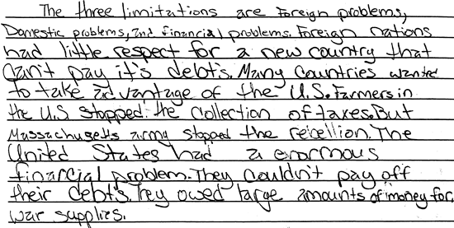

**Score 1:** This response demonstrates minimal understanding of the limited authority of the national government under the Articles of Confederation. The "facts" presented are exceedingly vague. There is an unconnected reference to taxes, farmers, debts, and war supplies. Ideas are inadequately developed, and fail to directly address the limitations to the structure or authority of national government under the articles of confederation.

**Sample 303-4 #2 of 3**

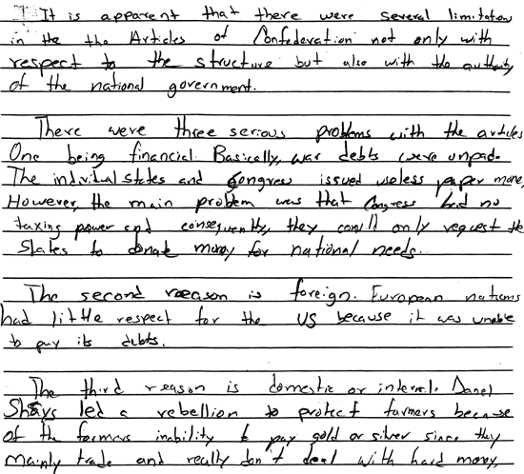

**Score 2:** This response demonstrates partial understanding of the limitations to national government under the Articles of Confederation. The response is partially accurate, but incomplete. Of the three problems noted, only the first is fully developed. The remaining explanations are incomplete and partially inaccurate, revealing an insufficient understanding of the topic.

**Sample 303-4 #3 of 3**

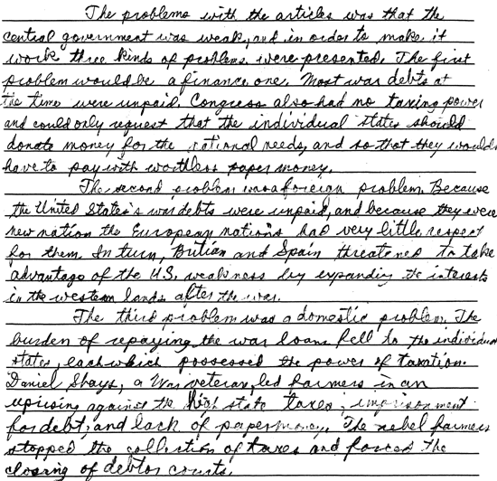

**Score 3:** This response demonstrates understanding of the limitations to national government under the Articles of Confederation. The response is complete and accurate, providing three problems with a clear explanation for each. The connection to central authority could be made clearer in relation to vulnerability to foreign powers, but, overall, the response is sufficient to demonstrate understanding.

(Item#:303-05)

11. The creation of the United States Constitution involved several important compromises among the delegates at the Philadelphia Convention. List and explain three important compromises that were instrumental to the subsequent ratification of the Constitution by the popularly-elected delegates of the various state conventions.

[Scoring Criteria](http://metacat2.com/cssap/sg/303-5sg.html)

**Module: 303  
Item: 5   
Descriptor: From the Articles to the Constitution**

**Scoring Criteria**

Scores are based on the student's ability to:

* List and explain three main compromises that were instrumental to the subsequent acceptance and ratification of the Constitution.

A proficient response will explain three of the following:

* *Great Compromise* or *Connecticut Compromise:* A compromise made at the Constitutional Convention of 1787 that settled a representation dispute between those in support of the Virginia Plan, which favored the larger states, and the New Jersey Plan, which favored the smaller states. Such a compromise had to be made so that all in attendance would agree to a particular pattern of representation. Ultimately, the larger states got representation in one house, based on their populations (House of Representatives), while the smaller states received equal representation in the other house, in spite of their smaller populations (Senate).
* *"Three-Fifths Compromise":* A compromise made at the Constitutional Convention of 1787 that settled a representation dispute between northern and southern states. For the purposes of representation in the House of Representatives and taxation, three-fifths of a state's slaves would be counted.

The North initially asked that slaves be given less weight only in terms of representation in the House. The South wanted them to be given less weight, if any weight at all in relation to taxation. The 3/5 Compromise appealed to both sides, as northern states were satisfied that they were not given full representation and the southern states were content that they did not have to pay full taxes.

* *Commerce and Slave Trade Compromise:* Congress would not legislate against the importation of slaves until 1808, and export taxes would not be imposed by Congress on any state. Southern agricultural interests feared that if northern commercial interests co-opted the power of the new government, southern commercial interests would be jeopardized. The southern states pushed for two things: (a) protection of the export duties, as southern cotton was the major export of the time, and (b) protection of the slave trade until 1808.

**Score Level Descriptions**

**NS** Not Scorable (blank, off-topic, hostile, etc.)

**1** A response at this level demonstrates minimal understanding of the compromises that were instrumental to the subsequent acceptance and ratification of the Constitution. The response is largely inaccurate or incomplete. The student may address one or two compromises, but the explanations, if provided, are exceedingly vague or inaccurate. Logic and reasoning are very simplistic and/or seriously flawed. The response demonstrates minimal understanding.

**2** A response at this level demonstrates partial understanding of the compromises that were instrumental to the subsequent acceptance and ratification of the Constitution. The student will provide a partially accurate response. The student will address two compromises, but the explanations are inadequately developed or incomplete. Evidence of rudimentary logic will be present, but it will contain flaws. The response demonstrates partial understanding.

**3** A response at this level demonstrates an adequate understanding of the compromises that were instrumental to the subsequent acceptance and ratification of the Constitution. The student will address two or three compromises, and the accompanying explanations are generally complete and accurate, although minor errors may be present. The logic and reasoning employed are justified, but may contain minor flaws. The response is sufficient to demonstrate understanding.

**4** A response at this level demonstrates a superior understanding of the compromises that were instrumental to the subsequent acceptance and ratification of the Constitution. The student will address three compromises, and the explanations are detailed, thorough, and accurate, and may go beyond that which is required in the question. The logic and reasoning used are sophisticated. The response demonstrates superior understanding.

[Student Work](http://metacat2.com/cssap/sg/303-5ss.html)

**Sample 303-5 #1 of 4**

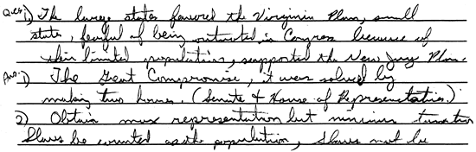

**Score 1:** This response demonstrates minimal understanding of the compromises that were instrumental to the subsequent acceptance and ratification of the Constitution. Three compromises are asked for, but the student only identifies one, The Great Compromise.

**Sample 303-5 #2 of 4**

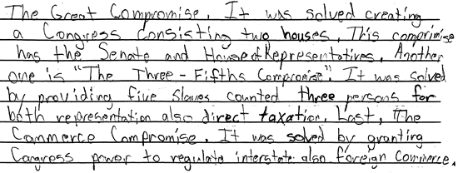

**Score 2:** This response demonstrates partial understanding of the compromises that were instrumental to the subsequent acceptance and ratification of the Constitution. The student accurately identifies three compromises, but the explanations are underdeveloped. There are no details about what led to the compromises, and few details about the outcomes. The response reveals partial understanding.

**Sample 303-5 #3 of 4**

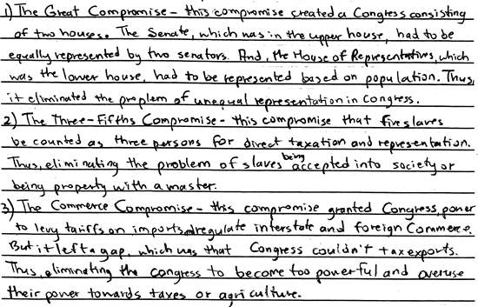

**Score 3:** This response demonstrates adequate understanding of the compromises that were instrumental to the subsequent acceptance and ratification of the Constitution. The descriptions are clear, accurate, and logical. One weakness: the student could provide more information regarding who the opposing sides were and the conflicting concerns that made a compromise necessary. Despite this shortcoming, the development of ideas is sufficient to demonstrate understanding.

**Sample 303-5 #4 of 4**

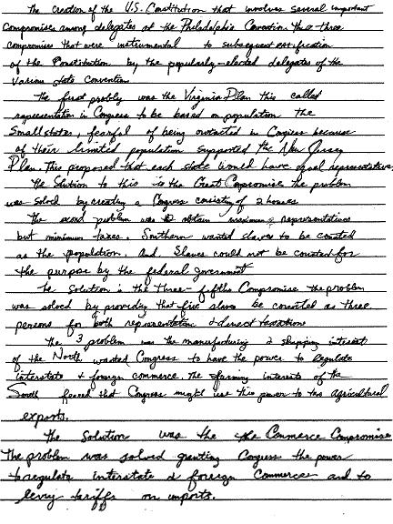

**Score 4:** This response demonstrates a superior understanding of the topic. In each case--representation, taxation with respect to slaves, and export duties--the writer clearly, accurately, and coherently identifies the interest of the opposing sides and explains how the compromises satisfied their concerns. The response is detailed and the logic and reasoning are sophisticated.

(Item#:304-06)

12. **Introduction**

Sophia, a foreign exchange student from Bosnia, arrived in America for a year of studying and to learn about American customs. Sofia's host family, the Smiths, met her at the airport. As they were leaving the airport, Sophia noticed a group of reporters following a man and yelling questions at him. This man, the Smiths told Sophia, was the mayor of New York City. Sophia looked at the group of reporters and the mayor and she was puzzled.

When driving out of the airport, Sophia saw a group of people carrying signs around some new construction at the airport. The Smiths explained that these people were on strike against their employers for more money. They had slowed down construction for three weeks now. Sophia watched in silence as they drove past.

On the way home, the Smiths pointed out many places of worship for different religions. She found it very interesting that so many different places of worship existed in one place.

Later that night on the news, there was an ordinary citizen giving his opinion regarding the president's trip overseas. She felt sorry for this man, because he would be punished, and perhaps physically hurt for giving his opinion. Her host family explained that nothing would happen to him. On this newscast, the reporters spoke on many topics and again Sophia seemed puzzled. She asked her host family, 'How can all of this be allowed: reporters following a leader, stopping construction, different religions but no state religion, and people giving their own opinions on television?'

**Instructions**

Over the next several weeks you will conduct research to determine the answer to Sofia's question. These are the steps to be completed.

1. Your teacher will assist the class in constructing a survey. This survey will attempt to capture the following information:

* Gender
* Age
* Religion
* Race
* Questions that will enable you to determine if the person answering the survey knows the rights guaranteed in the First Amendment
* Questions that will enable you to determine why that person believes the rights guaranteed in the First Amendment are important. (You may have to inform them of those rights. Make sure you document this if you do so.)

2. Obtain 40 copies of the survey.

3. Survey 20 adults. For example, you might request permission from a business to survey their patrons. Attempt to survey people from different age groups, sex, and race.

4. Ask 20 students to complete the survey.

5. After completing your survey, analyze the results. Design four graphs using the data you have gathered. You should have a graph comparing responses on the basis of different factors (i.e., race, sex, age, religion).

6. Write a paper that answers Sofia's questions. You should be able to present evidence from your survey that answers the questions. You should provide a comparative examination of this data and hypothesize as to the reasons why your results may be true. Make sure you cite examples using the data gathered and used in the graphs.

[Scoring Criteria](http://metacat2.com/cssap/sg/304-6sg.html)

**Module: 304  
Item: Task  
Descriptor: The Right to Peaceably Assemble**

**Scoring Criteria**

Scores are based on the student's ability to:

* Analyze and interpret data from a survey on First Amendment rights.

A proficient response will demonstrate an understanding of how to analyze and interpret data from a survey on First Amendment rights. Responses will vary, but should include the following elements:

* Explanations of First Amendment rights that answer Sophia's questions
* Four graphs comparing responses based on factors such as sex, gender, race
* Analysis of data that indicates whether people understand the right to peaceably assemble, freedom of the press, freedom of religion, and freedom of speech

**Score Level Descriptions**

|  |  |
| --- | --- |
| **NS** | Not Scorable (blank, off-topic, hostile, etc.) |
| **1** | Performance at this level demonstrates minimal understanding of how to analyze and interpret data from a survey on First Amendment rights. The response is largely inaccurate or incomplete. The explanations, if provided, are exceedingly vague or inaccurate. Logic and reasoning are very simplistic and/or seriously flawed. The required presentation elements are seriously deficient. The response demonstrates minimal understanding. |
| **2** | Performance at this level demonstrates partial understanding of how to analyze and interpret data from a survey on First Amendment rights. The response is partially accurate. The explanations are inadequately developed or incomplete. Evidence of rudimentary logic is present, but it contains flaws. Some presentation elements are present. The response demonstrates partial understanding. |
| **3** | Performance at this level demonstrates an adequate understanding of how to analyze and interpret data from a survey on First Amendment rights. The explanations are generally complete and accurate, although minor errors may be present. The logic and reasoning employed are justified, but may contain minor flaws. The required presentation elements are generally present. The response is sufficient to demonstrate understanding. |
| **4** | Performance at this level demonstrates superior understanding of how to analyze and interpret data from a survey on First Amendment rights. The explanations are detailed, thorough and accurate. The logic and reasoning used are sophisticated. All required presentation elements are present. The response demonstrates superior understanding. |

[Student Work](http://metacat2.com/cssap/sg/pt304-sg.html)

**Item:**304-6, Sample #1 of 4

1.

As we read in the story of Sophia, a foreign exchange student from Bosnia was lost about the freedom that we as Americans have. Although the Bosnian must have forgot that she to has these rights, enough about this I will now get started on my report.

The first amendment of the United States of America states. "Congress shall make no law respecting an establishment of religion, or prohibiting the free exercise thereof; or abridging the freedom of speech, or of the press; assemble, and to petition the government for a redress of grievances."

We, as a class then conducted a series of surveys which we handed out to people amongst the community. Our results showed that most of the people that received and completed the survey didn't even know what the rights in which the first amendment allows us.

Now going back to my first paragraph. I would like to conclude that before the state should have schools do this "little assessment" then they first should do a little research of their own. I say this is because I find it somewhat strange that "Sophia" had such a hard time understanding all the stuff the people were doing, when her country "Bosnia" has the same rights that we do.

**Score:** 1   
**Score Justification:**   
This response demonstrates minimal understanding of how to analyze and interpret data from a survey on First Amendment rights. The required presentation elements are seriously deficient. The student quotes the First Amendment but fails to provide any evidence to support the ambiguous claim that those people surveyed "didn't even know what the rights in which the First Amendment allows us." The student embarks on a subjective criticism of the question based on an inaccurate and illogical premise.

**Item:** 304-6, Sample #2 of 4

2.

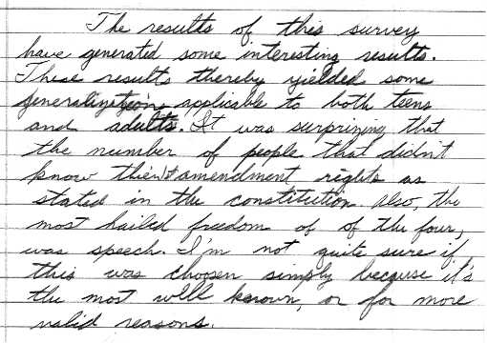

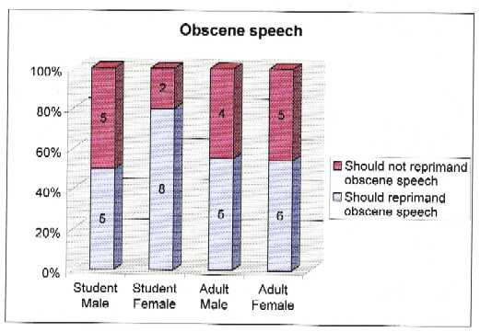

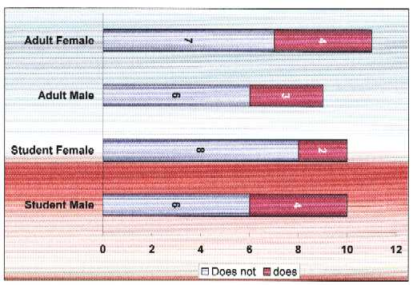

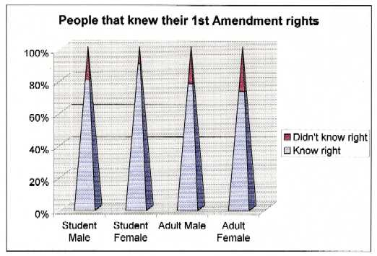

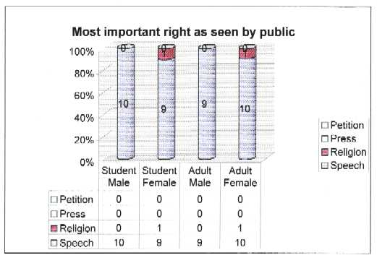

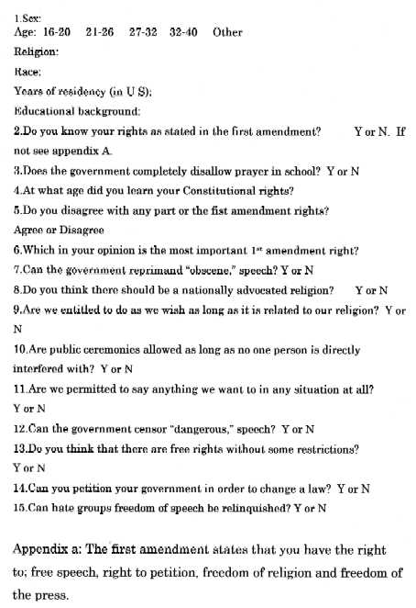

**Score:** 2   
**Score Justification:**   
This response demonstrates partial understanding of how to analyze and interpret data from a survey on First Amendment rights. The presentation of the results of the survey in graph form is well done. Unfortunately, the explanation of findings is quite weak and incomplete. Additional analysis and application of logic would greatly enhance this response.

**Item:** 304-6, Sample #3 of 4

3.

U.S.'s customs and Constitution

In America, there are many customs and rights that are used that many countries do not have or use. These things could make someone from another country, like Sophia from Bosnia, wonder or be surprised at our customs. Something we see every day, may be something that is unacceptable in other countries.

When Sohpia saw the reporters following the mayor, she was surprised that they were allowed to even get that close to a leader. Well in our constitution, there is a part that gives the press the right to do things like that. The freedom of press, they are allowed to do most whatever they want, with some restrictions. According to my survey most people were aware of the freedom of the press. About sixty-four percent of the people surveyed had been aware of the rights of the press in our country, given to them in the first amendment of our Bill of Rights. In other countries the press, or anyone may not even be able to get near the leaders in politics.

When Sophia saw the people on strike, again she wondered why they are allowed to do such things. This right falls under the right to peaceably assemble. This right is pretty much how it sounds. The First amendment lets people assemble for whatever reason, as long as it is in a peaceable manner, and causing no harm to others. In Sophia's case, the people were assembling to protest against their employer, they wanted to get more money, and in doing so, they stopped the construction that was supposed to be going on there. This is allowed because they are causing no harm to anyone and are remaining peaceful. Although there are laws against where you can strike, they don't apply here. According to my survey, only about half the people knew about the rights of picketers and peaceable assemblies. It's no wonder that Sophia was quite surprised about this, especially when only about half of our own citizens are fully aware of the rights granted to people who wish to assemble or strike. In other countries striking my be cause for punishment by law.

Long ago in our county, the government and the church broke apart, and became separate. Since then, there hadn't been an official religion of state. Our country is very diverse and to have a single religion be the official one, is really unfair, and probable cause for controversy. We believe that people have the right to believe what they want and how they want. This too is granted in the constitution, the first amendment of the Bill of Rights. In many countries, there is one official religion, and the government and church work side by side. Back to the survey, about sixty-four percent of the people were aware of the constitutional rights given to everybody in the United States regarding freedom of religion, and not favoring one religion.

Lastly, people in our country have the right to their own opinion and the right to express that opinion. This is the freedom of speech part of the First amendment. People can say whatever they want, with certain decency rules and common good rules that basically must be obeyed. As long as what you have to say, or so doesn't force anyone to listen or force anyone to believe what you are saying, then there is nothing wrong with it. People can go on the news or radio and criticize the president, and as long as they don't present a threat toward him, then it is perfectly legal. About sixty percent of the people surveyed knew all about the freedom of speech. In other countries people can be punished severely for criticizing their leader. Many people are very restricted to what they can say, despite what they think.

So to answer Sofia's questions, most of them can be summed up all together. Our country is one of much freedom and expression. Our constitution provides us with guidelines to which we live, and creates a strong nation where nobody is favored or has more power than someone else. Our country is one of the strongest and most advanced in the world, so as long as we stay strong and united, there is not need to tighten government policies and laws, there is no need to have the church and government share power, and there is no need for punishment for expressing what you feel. That is our First amendment in a nutshell, and what is does for us, and how our customs work.

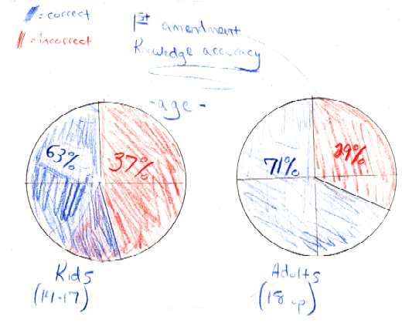

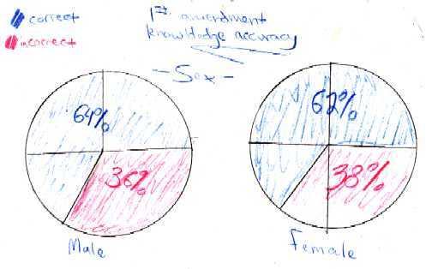

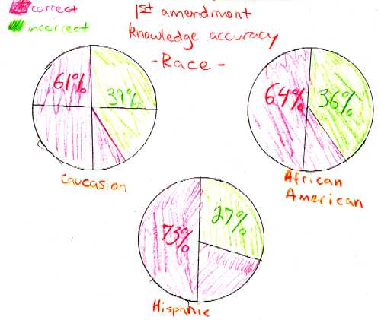

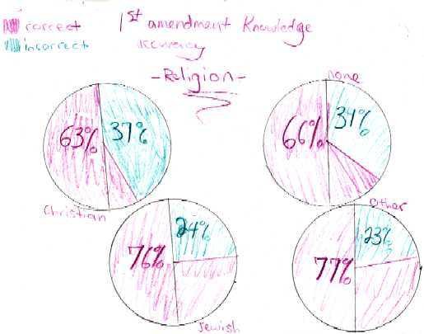

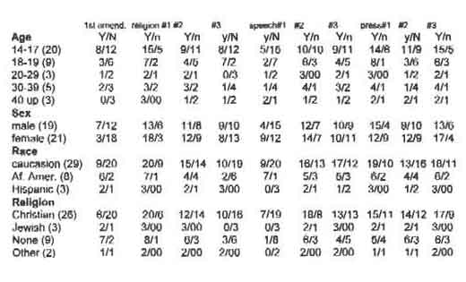

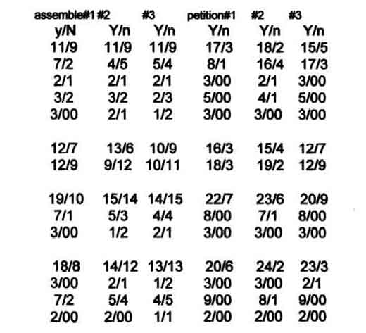

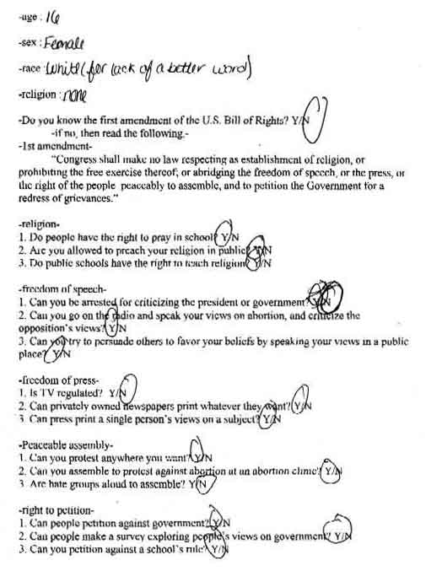

**Score:** 3   
**Score Justification:**   
This response demonstrates adequate understanding of how to analyze and interpret data from a survey on First Amendment rights. The response is generally complete and accurate, and the required presentation elements are present. The explanation of the results of the survey and the meaning of the First Amendment provisions is quite general, however. In the absence of clear descriptive headings, the charts are somewhat difficult to understand. Additional analysis of the results would strengthen this response. This is a "low 3" response.

**Item:** 304-6, Sample #4 of 4

4.

The Freedoms We Don't Understand

Before the ink dried on the constitution, America has been considered the land of the free. American citizens enjoy countless freedoms and rights, which many other countries do not grant their citizens. The first ten amendments, known as the Bill of Rights, insure that citizens' rights will be protected by and from the government. The first amendment, containing five parts, grants freedoms which the public exercises on a regular basis. It grants citizens of America freedom of speech, religion, press, assembly, and the right to petition the government. Unfortunately, like Sophia, many American citizens do not know or understand their rights.

It may be shocking to think, but many people do not understand or even know that their first amendment rights exist. People are unaware that items in their daily routine, such as praying to a certain god or reading editorials in the newspaper would not be possible if it weren't for the first amendment. For example, only forty percent of the people over twenty understood their rights, as the graph shows. That doesn't say much, considering they only had to get two-thirds of the questions right on the survey. Those surveyed that were twenty and under had a slightly better understanding with forty-three percent, as shown by the graph. This was probably due to the fact that those who are under twenty had more recently been taught their first amendment rights. I looking at understanding compared to sex, only forty percent of females surveyed and fifty-seven percent of males surveyed had an understanding of their first amendment rights, as seen in the graphs. Although women would normally be expected to have a better understanding of their rights since they have to fight for them more than men do, men had a better understanding. This is probably due to the fact that less men than women were surveyed (since the group was random this is possible) leading to inconsistencies in the data. Although there is a smaller percentage than those who did not understand, some people surveyed did actually understand their first amendment rights.

Looking at the religions of those who did have an understanding of the first amendment proved to be interesting. As shown in the graph, thirty-one percent of those surveyed were Catholic, thirty-one percent were Christian, and thirty-eight percent had no religion. American citizens are all granted the rights listed in the first amendment, and this data, along with the fact that others surveyed who did not have an understanding practiced other religions, shows that some citizens actually do exercise their rights. Furthermore, of those surveyed, a majority of them said they practice their religions on a regular basis, showing that many citizens use their first amendment rights frequently. The fact that people can openly admit their religious standing, and that some do not have a religion, shows that citizen not only has freedom of religion but from religion. The fact that more of those who understood have no religion than any other religion is probably because they have had to face other religions who try to pressure them into a religion, and they have resisted since they know the first amendment protects them. The first amendment protects everyone, even though some may not realize it. The first amendment has helped to make America great. Without it our country would be completely different. The first amendment came about to protect the citizens from the government; after all, Americans rebelled as British citizens since they were not protected from the British government. Without freedom of religion, citizens would all be forced to worship one god. Freedom of religion was granted since many of the original Europeans to live in America came here fleeing religious persecution. Without freedom of press, citizens could not read editorials in newspapers, or read articles pertaining to government wrongdoings. Without freedom of speech, the civil rights movement might not have occurred. Without the right to petition, citizens would be forced to accept whatever the government does, with their only leverage being who they elect. Without the right to assemble, many issues of importance would have gone unnoticed, such as problems dealing with specific issues; like the impurities and lack of sanitation in food at the turn of the century. Our country would be completely different without the first amendment.

Everything that Sophia witnessed when she first arrived in America is possible because of the first amendment. The questioning of New York's mayor can occur because there is freedom of the press. The press can ask him questions, and he can choose not to answer. The pressw can have freedom because they can only print the truth or people's opinions; slander laws protect the mayor from the Press doing wrong. The striking that she witnessed is possible because of freedom of speech and the right to assemble. The workers arc allowed to assemble to inform others of their employer's wrongdoings in hopes of changing them. The employer is protected by union and striking laws, which keep workers from doing anything but making their voice heard. The many places of worship Sophia saw are the result of freedom of religion. Citizens can peacefully practice any religion they want without fear, since no other religion can discriminate against them for their religion (or lack thereof). The man she saw on the news voicing his opinion is possible due to the freedom of speech. He can voice his opinion because it is only an opinion; others can take in what he says and draw their own conclusions. Slander laws protect the president. Everything Sophia witnessed is made possible by the first amendment

The Bill of Rights, including the first amendment, was designed to protect American citizens' rights from the government. The first amendment, containing five parts, grants freedoms which the public exercises on a regular basis. It grants citizens of America freedom of speech, religion, press, assembly, and the right to petition the government. Unfortunately, many people, like Sophia, do not understand or even know that the first amendment exists. Without the first amendment, America would be completely different. Everything that Sophia witnessed when she came to America is made possible by the first amendment. The first amendment grants citizens rights that other countries do not even allow, helping to make America great.

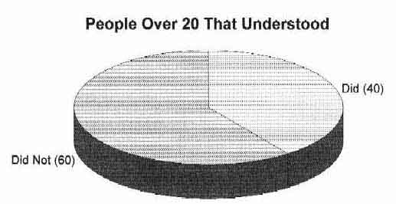

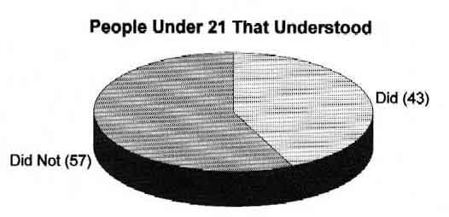



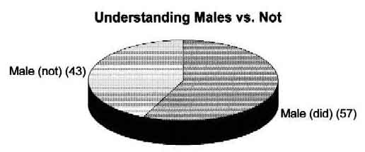

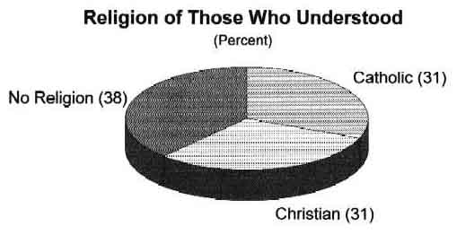

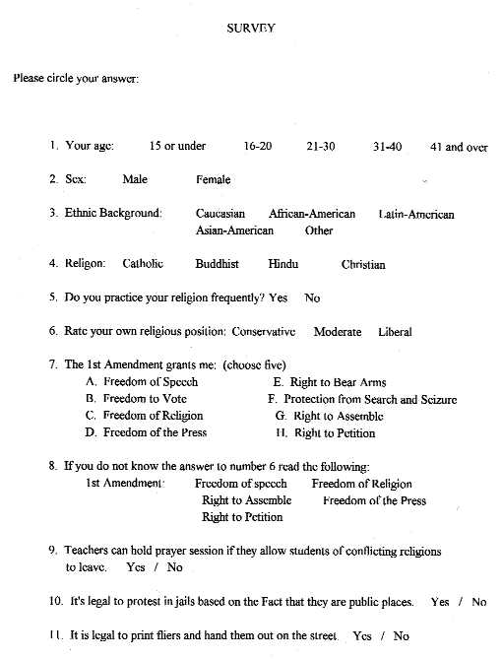

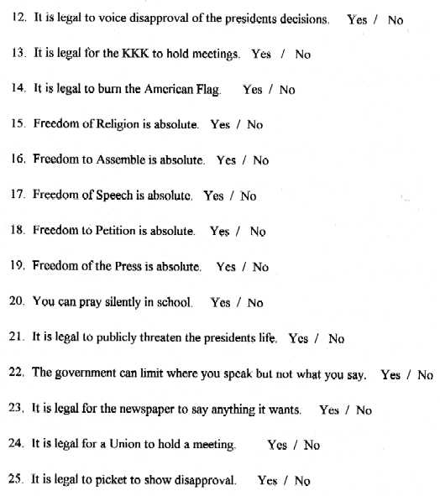

**Score:** 4   
**Score Justification:**   
This response demonstrates superior understanding of how to analyze and interpret data from a survey on First Amendment rights. This is a "low 4" response. The response is complete and accurate, and the logic is sophisticated in places. The charts are clear, however chart on religion is somewhat "suspect," given the unknown number of respondents. Although the student demonstrates some insight in interpreting the results, the analysis is somewhat uneven. Overall, however, the response demonstrates superior understanding of the topic.

(Item#:306-06)

13.

Peace in the largest sense cannot be accomplished by the United Nations system or by governments alone. Non-governmental organizations (NGOs), academic institutions, parliamentarians, business and professional communities, the media and the public at large must all be involved. This will strengthen the world organization's ability to reflect the concerns and interests of its widest constituency...

--From *An Agenda for Peace,* by Boutros Boutros-Ghali  
Secretary-General of the U.N., January 31, 1992.

NGOs are any local, national, or international citizens' groups that are not part of a government and do not work for profit; for example, OXFAM, CARE, Amnesty International, etc. NGOs have a wide variety of functions, including work in fields as diverse as law, refugee work, human rights, and disarmament; their work can range from influencing policy or organizing communities around special issues, to providing technical or medical assistance, to conducting research. Although the amount of development assistance has doubled since 1980, the relationship between the U.N. and NGOs dates back to the writing of the United Nations Charter in 1945.

NGOs participate in the U.N. system in four ways:

* They raise issues.
* They shape decisions taken by the U.N.
* They enter into partnership with the U.N. to help carry out its objectives and programs in the field.
* They serve as watchdogs of the U.N., observing, criticizing, and reporting to the U.N. progress or lack of progress.

In this task, you will demonstrate your understanding of the relationship of a specific NGO to a specific U.N. agency. Your success in this task depends on familiarizing yourself with at least one NGO and one of the agencies of the U.N. with respect to a specific problem and purpose. For example, Save the Children and UNICEF both work for the protection of children in the world, although they may have some differences in the way they approach the problem or in their policies.

After you get an idea of how such a relationship works, you should investigate the background and operations of a U.N. agency of your choice. Find out what specific problems or issues it works on that you are interested in exploring. With that knowledge, your task is to create a model NGO that will do the following.

* Identify a current issue, problem, or phenomenon of international concern and define your NGOs goals.
* Define, research, and explain the background and significance of the issue, problem, or phenomenon to an international agency within the U.N.

[Scoring Criteria](http://metacat2.com/cssap/sg/306-6sg.html)

**Module: 306  
Item: Task  
Descriptor: The United Nations and Non-Governmental Organizations**

**Scoring Criteria**

Scores are based on the student's ability to:

* Explain the role of NGOs and U.N. agencies with respect to a specific international problem or purpose.
* Create a model NGO to function as an intervention in an international problem or purpose.

A proficient response will demonstrate an understanding of the role of NGOs and U.N. agencies in their work abroad. Responses will vary, but should include the following elements:

* Identification of a current issue, problem, or phenomenon of international concern
* Explanation of the background and significance of the international issue or problem relative to an existing U.N.
* Description of a model NGO and explanation of its goals relative to the international issue or problem identified

**Score Level Descriptions**

|  |  |
| --- | --- |
| **NS** | Not Scorable (blank, off-topic, hostile, etc.) |
| **1** | Performance at this level demonstrates minimal understanding of the role of NGOs and U.N. agencies in their work abroad. The response is largely inaccurate or incomplete. The explanations, if provided, are exceedingly vague or inaccurate. Logic and reasoning are very simplistic and/or seriously flawed. The required presentation elements are seriously deficient. The response demonstrates minimal understanding. |
| **2** | Performance at this level demonstrates partial understanding of the role of NGOs and U.N. agencies in their work abroad. The response is partially accurate. The explanations are inadequately developed or incomplete. Evidence of rudimentary logic is present, but it contains flaws. Some presentation elements are present. The response demonstrates partial understanding. |
| **3** | Performance at this level demonstrates an adequate understanding of the role of NGOs and U.N. agencies in their work abroad. The explanations are generally complete and accurate, although minor errors may be present. The logic and reasoning employed are justified, but may contain minor flaws. The required presentation elements are generally present. The response is sufficient to demonstrate understanding. |
| **4** | Performance at this level demonstrates superior understanding of the role of NGOs and U.N. agencies in their work abroad. The explanations are detailed, thorough and accurate. The logic and reasoning used are sophisticated. All required presentation elements are present. The response demonstrates superior understanding. |

[Student Work](http://metacat2.com/cssap/sg/pt306-sg.html)

**Item:**306-6, Sample #1 of 4

1.

Children's Relief Objective Program (CROP)

My Non-governmental Organizations main objective is to prevent the malnutrition and bad education of the world's future leaders They would prevent letting other nations and third world countries from keep their smart children from being abused in anyway or in any category of person's basic human rights. These rights are obtained on the same ones that the United Nations has established. We are forming this organization because I do not believe that UNICEF is not holding there ground against the wrong doings of other nations. We want to pick up the slack that they are leaving behind.

We would accomplish this by locating any cases of smart children that have their rights taken away. Once we find it, we would set up a task force to go into the area hostile or not to feed this child or children When we withdraw from the country, we will hope that the United Nations will realize what they over looked and try to find a way to penalize the country for what they have done. The only reason that we would not try to set a penalty up for them is that we do not have enough influence as an organization at this time for anyone to take us serious.

The UN agency that we would like to work along side would have to be UNICEF. They have the same goals as ours, and have almost the same process of getting those goals accomplished. Such as, the way that children are treated all over the world and the way that the world need to improve their learning capabilities.

**Score:** 1   
**Score Justification:**   
This response demonstrates minimal understanding of the role of NGOs and U.N. agencies in their work abroad. The explanation of the NGO is unclear, and the activities and plan of the model proposed are impractical. The logic is exceedingly simplistic and contradictory.

**Item:** 306-6, Sample #2 of 4

2.

Animal Relief

UNICEF is an organization that helps children that are involved in disasters around the world. They provide disaster relief in the form of food for people who have none, clothes for people who have lost all of their possessions, and shelter for the homeless. Their goal is to bring relief and hope to the children of the world so that they may have a future of promise. Some of the things that they have been involved with lately include the earthquakes in Turkey and children with AIDS.

The organization that I would start would not only help people, but also help the animals that are involved in disasters. When something like a flood happens, the people aren't always able to go back and get their animals. Our first priority, of course, would be the people, but after them, we would focus on the animals. If we rescued an animal, but couldn't find the owners, we would find someone to adopt it, so the animals would not just die. Many of these animals will not have a chance without an organization like mine, so I feel that I could help a lot.

**Score:** 2  
**Score Justification:**   
This response demonstrates partial understanding of the role of NGOs and U.N. agencies in their work abroad. The response is somewhat accurate but incomplete. Although the student brings some accurate facts to bear on the topic, and indeed proposes a plan, the ideas are quite underdeveloped. The plan is not without merit, but is somewhat devoid of many considerations that should be taken into account in ensuring the success of the NGO.

**Item:** 306-6, Sample #3 of 4

3.

ART:  
Australian Reef Trust

The Great Barrier Reef, in the Coral Sea, off the northeastern coast of Australia is being destroyed by many things. One major cause of this destruction is the lack of communication between oceanographers, biologists, resource managers, and educators. Another main cause of the destruction of the reef is coral bleaching, which causes the coral to lose its algae and soon die. Coral bleaching is caused by a significant rise in the sea surface temperatures (global warming). Population growth and development, destructive fishing practices, land-based sources of pollution such as agricultural runoff, and excessive coastal development also continue to the destruction of the Great Barrier Reef.

Coral reefs are very important in the modern world. They are one of the most productive ecosystems on Earth. Coral reefs are home to an estimated one million species. They cover less than 0.2% of the ocean's area, but contain 25% of marine fish species. Many island populations are dependent on income derived from tourism, such as Queensland, Australia, which generates 1.5 billion dollars from tourism on the Great Barrier Reef each year. They also reduce storm damage, coastal erosion and flooding by intense wave action. Coral reefs contain about half of the potential pharmaceuticals being explored in the ocean. Many promising drugs have already been identified, developed, and tested, If the Great barrier Reef and other coral reefs are destroyed, this will no longer be possible and many lives, that could have keen saved, may be lost.

If this problem is not corrected and the Great Barrier Reef and other coral reefs die out, many things will be lost. There will not be as many marine fish species for our research and food, and many areas where the coral reefs are, such as Australia, will lose money each year that comes from tourism. The lands near the coral reefs could be destroyed by natural disaster if there is nothing there to help with reducing storm damage, coastal erosion and flooding. Also, there will no longer be new drugs to find in the areas that could help with curing many diseases.

The main goal of this NGO is to save the Great Barrier Reef. To accomplish this goal, many things have to be done. First of all, communication between oceanographers, biologists, resource managers, and educators must be improved. To do this, there needs to be security guarding the area in the Coral Sea, where the Great Barrier Reef is located at all times. There will be a schedule, and only the people that are listed on the schedule will be allowed to study the reef at their scheduled time. This will help to improve the communication between educators, oceanographers, biologists and resource managers that are studying the Great Barrier Reef. Next, global warming must be eliminated. The temperatures in 199b were the warmest in at least 600 years, and since 1990, the temperatures have gotten warmer each year. burning of fossil fuels, changes in the land use, and reduction in forest cover are increasing the atmospheric concentrations of greenhouse gases, altering radiative balances and warming the atmosphere. This results in the warming of sea surface temperatures, which causes coral reefs to bleach. The number of factories that release greenhouse gases needs to be decreased in the area of the Coral Sea, and all around the world. Then, the population, and excessive coastal development must be decreased. The number of people living near the Great Barrier Reef needs to be brought down. The Australian government should pay to have people move inland, away from the Coral Sea, and the coastal development needs to be slowed down. Also, destructive fishing practices must be stopped. Fishermen should not be allowed into the area of the Great Barrier Reef, instead, they should be relocated to another area where there will be nothing to destroy.

This NGO, Australian Reef Trust (AKT), hopes to establish a close relationship with the United Nations Educational Scientific Cultural Organization (UNESCO). These are many ways in which the Great barrier Reef can be saved. If it is not saved, many things will be lost, including peoples' lives. There are still many unidentified creatures living in the Great Barrier Reef, and if the reef is not saved, they may never be identified. These creatures could be cures for deadly diseases, or the answers to the many questions about our past. There is no answer to what we may find if the Great Barrier Reef is saved.

**Bibliography**

1.) http://ikm59O.aims.gov.au/reports/reports-index.html  
2.) http://ikm59O.aims.gov.au/pages/outline.html   
3.) http://www.state.govIwwwIglobaI/global_issues/coral_reefs  
4.) Microsoft *Encarta* 90 Encyclopedia: Great Barrier Reef

**Score:** 3  
**Score Justification:**   
This response demonstrates adequate understanding of the role of NGOs and U.N. agencies in their work abroad. The response is generally complete and accurate; the plan for the NGO is practical, and important considerations essential to the plan's success are addressed. The student does a very good job of explaining potential problems associated with the destruction of the Great Barrier Reef, but the response generally lacks specific suggestions for interventions, instead providing general statements of what should be done. The specific structure and functions of the proposed NGO ("ART") are not addressed in any detail.

**Item:** 306-6, Sample #4 of 4

4.

**Organization for providing Refugees Care (OPRC)**

Seeing the thousands of men, women and children lack medical, nutritional and economical needs moved the OPRC's founders to develop an organization that would help refugees. Our mission is to help support and to aid refugees by providing food, shelter and medical care.

The OPRC consists of two high commissioners that work together to maintain a caring and welcoming environment in refugee shelters. The high commissioners also work keeping track of all volunteers. The volunteers are placed in different groups according to the qualifications needed to fill that task and their ability. One team talks to large companies, seeking money to help pay for food, clothing and other essential materials needed to keep the shelters in good condition. A second team works to maintain cleanliness in the shelters and to check up on individuals to make sure they are receiving adequate care. The third team finds doctors, nurses and clinical assistants that will take the time to care for the refugees at little or no cost.

Once a month the elected high commissioners, the volunteers, and representatives from large corporations and small local companies gather to discuss how we can further help refugees. At these meetings money is often donated, by the numerous companies, to help maintain the quality care given by the OPRC. Doctors and nurses often vow to provide free or low cost health care. Grocers from nearby areas offer to provide food to their local shelter. These meetings are an essential part of fund raising for the OPRC. In addition to the meetings other fund raising activities are planned. Charity balls, based at one hundred dollars per couple, auctions, celebrity dinners, based at one hundred dollars per person, and food and clothing drives are also important fund raising tactics.

**The United Nations High Commissioner for Refugees**

The OPRC is affiliated with the United Nations High Commissioner for Refugees (UNHCR). The UNHCR was established as the successor to the International Refugee Organization. The main office is based in Geneva Switzerland; there are sixty other field offices located throughout the world (Encyclopedia Americana). The UNHCR originally concentrated on the plight of refugees but now concentrates on an array of topics. The UNHCR coordinates relief efforts to refugee groups, helping to meet their basic needs for food, shelter, and medical care as well as supplying material and training to enable refugees to become self-supporting (Encyclopedia Americana). The UNHCR encourages voluntary repatriation, resettlement, and local integration as solutions to the refugee program (Encyclopedia Brittanica).

The United Nations High Commissioner for Refugees was established on December 14, 1950, by the General Assembly. The IJNIICR was to be a successor to the International Refugee Organization. (Encyclopedia Britanica) The base office is located in Geneva Switzerland but has multiple field offices around the world. The high commissioner is elected every five years by the general assembly. (Encyclopedia Americana)

The UNHCR takes a humanitarian approach and exceeds over four hundred and fifty million dollars annually. The UNHCR encourages voluntary repatriation, resettlement, and local integration as a solution to the refugee program. (Encyclopedia Americana) The UNHCR helps refugees with their legal protection; it coordinates emergency assistance and relief efforts. It helps meet the human needs for food, shelter and medical attention. The UNHCR also supplies the materials and the training needed to qualify refugees for work, so that one-day they can be self-supporting. (Encyclopedia Britanica)

The UNHCR intervenes with various governments to ensure minimal rights such as freedom of arbitrary expulsion, access to courts, the right to work and to receive an education, and the possession of identification, as well as travel documents. The UNHCR provides social and economical aid. (Encyclopedia Britanica)

Many programs to help refugees are set up every day. One such program was "Clear the Camps". Clear the Camps was a campaign used to help resettle African refugees south of the Sahara. (Encyclopedia Britanica)

The UNHCR wan the Nobel Prize in 1954 and in 1981 for its many outstanding achievements. (Encyclopedia Americana)

**The Human Rights Watch**

Links between faced displacement and human rights is crucial, according to HRW (hrw.org/worldreport99). At the end of 1997 there was an estimated 13.6 million refugees (hrw. org/worldreport99).

The Human Rights Watch monitors an entire spectrum of the refugee experience; from human rights violations and conditions during the flight and reception in the country of asylum to the search for a durable solution and to post return human rights monitoring, rehabilitation and reintegration (hrw.worldreport.org/worldreport99)

A vast majority of the world's refugees have continued to seek haven in the poorest places. The human rights watch helps aid in finding a safe place to seek refuge. Many countries in the developing world have offered refuge to thousands of people who flee in masse from persecution, civil conflict, violence, discrimination, and social and economical hardships.

The Human Rights Watch helps provide humans appropriate and needed care.

**Organization for Providing Refugee Care**

Directors:

Organization for Providing Refugee Care (OPRC)

Date Founded and why:

Seeing men, women and children lack medical, nutritional and economical needs moved… to develop an organization to help refugees in need. The organization was founded in 1999.

Our Mission:

Our mission is to help support and aid refugees by providing food, shelter, and medical care.

Structure and Policy:

Governing Body: Two high commissioners.  
Staff Volunteer Teams  
Team 1: To talk to large companies, in the hopes of a donation to help pay for food and clothing, as well as medical supplies, blankets, pillows and more. This team also organizes fund-raisers and encourages people to volunteer within the OPRC.  
Team 2: Works to maintain the cleanliness in the rented shelters and to Make sure each individual is receiving the care that they deserve.  
Team 3: Finds doctors, nurses and clinical assistants that will take time to check the well being of the refugees at little or no cost.  
Language: The barriers of language are broken. There are many volunteers that speak multiple languages, so receiving adequate care or supplies is not an issue, there will always be someone that understands.  
Budget: Varies with the amount of money taken in trough charity and donation.

Relation with other Organizations:

IGO' s: Varies as required  
NGO's: The International Red Cross

Activities to raise money for Food. Clothing, Shelter and Supplies:

Balls and Galas  
Celebrity Dinners  
Auctions  
Food Drives  
Clothing Drives

Activities - How we achieve our mission.

Set up camps and shelters  
Give each individual food when he or she is hungry  
Supply every individual with clothing to keep warm

Publications:

Our newsletter.  
Many newspapers and magazines have featured articles on the organization achievements. The organization can also be reached on the web at www.OPRC.org.

Collaboration with UN agency:

United Nations High Commissioner for Refugees (UNHCR)

Presentation

At the end of 1997 there was an estimated 13.6 million refugees in around the world. As of September the Kosovo conflict had produced 300,000 refugees alone. With Albania in a state of turmoil and instability, no refuge in Montenegro, West European states unwilling to accept refugees; it is difficult to see where those fleeing are headed (hrw.org/worldreport99).

Countries continue to favor voluntary repatriation as the preferred solution to refuge situations; causing many debates about conditions in which refugees can return. These debates are now the most controversial issues in the refugee policy (hrw.org/worldreport99). The problem of security in refugee camps has also received a great deal of international attention in recent years. The militirization and non-civilian charter of refugee camps, the use of camps as military training grounds, cross-border attacks and incursions, the forced conscription and abduction of children, and sexual and domestic violence, are all problems faced in refugee camps. Women refugees often face protection and security risks. In many situations women make up a large proportion of the refugee population. Women are subjected to rape, sexual exploitation, sexual abuse and sexual violence in the camps (hrw.orglworldreport99).

Vakha, a 40-year-old businessman, reported a series of explosions, on Lennin Street, that overturned a truck, transporting civilians, killing eight. Vakha believed the attack could have been aimed at what he believed was the home of a chechnian commander, two hundred yards away (hrw.org/chech1110).

Hand in hand, the UNHCR and the OPRC, hope to put an end to the painstaking ordeals that refugee's face. Refugees are people, they do not deserve to be thrown from their homes and dismissed from their country. Every person deserves to be treated as an individual. No one needs to witness what Vakha has witnessed.

**Bibliography**

United Nations High Commissioner for Refugees

Encyclopedia Americana, The UNHCR  
Grolier Incorporated  
1995  
William A. Hazleton  
Page 469

Encyclopedia Brittanica, The UNHCR  
Encyclopedia Brittanica Inc.  
University of Chicago  
Volume 10  
Page 269

Http //www. hrw.org/hrw/press/1999/nov/chech1109.htm  
Monday November 15, 1999

Http://www.hrw.org/hrw/ press/1999/nov/chech1110.htm  
Monday November 15, 1999

Http://www.hrw.org/hrw/ press/1999/nov/chech1118b.htm  
Friday November 19, 1999

Http://www.hrw.org/hrw/worldreport99/special/refugees.html  
Friday November 19, 1999

**Score:** 4  
**Score Justification:**   
This response demonstrates superior understanding of the role of NGOs and U.N. agencies in their work abroad. The student provides a thorough and comprehensive treatment of the "OPCR," and clearly explains its role in relationship to the problem of refugees in general and the UNHCR specifically. The structure of the organization is well conceived, and despite the brevity of the explanations of some of its roles, the response demonstrates a sophisticated understanding of the essential components of such an organization.

Article III of the Constitution established the third branch of the federal government, the judicial branch. The judicial branch is made up of all the federal courts in the country. At the top of this system is the United States Supreme Court. It is the nation's most powerful court and is the final court to which anyone can appeal a legal decision. According to the Constitution, the Supreme Court has two types of jurisdiction, original and appellate.

(Item#:307-01)

14. What is meant by the statement 'without the Supreme Court, the Constitution would be a dead letter'?

      A. The Constitution would have no power without the Supreme Court to uphold it.

      B. The Constitution is the supreme law of the land and the Supreme Court is the highest court.

      C. The Constitution is what the Supreme Court says it is, without regard to anything else.

      D. The Constitution would be useless because, without the Supreme Court, no one would understand its language.

Answer: A

(Item#:307-02)

15. If a resident of Missouri sues a California resident and another Missouri resident in state court over a claim in a Missouri traffic accident, where is the case tried?

      A. The Supreme Court

      B. The Missouri courts

      C. The California courts

      D. The courts of both states

Answer: B

(Item#:307-03)

16. Which of the following positions is generally held by organizations committed to civil liberties?

      A. The rights of society and the rights of individuals are equal, regardless of the circumstances of the case.

      B. The protection of the state is more important than the liberties of the individual.

      C. The rights of the state are the work of law enforcement, while the courts protect the individual.

      D. The rights of individuals are to be protected even if the work of law enforcement becomes more difficult.

Answer: D

(Item#:307-04)

17. The Supreme Court has both original and appellate jurisdictions in certain cases. Describe one example of when the Supreme Court has original jurisdiction and one example of when it has appellate jurisdiction.

[Scoring Criteria](http://metacat2.com/cssap/sg/307-4sg.html)

**Module: 307  
Item: 4  
Descriptor: The Supreme Court**

**Scoring Criteria**

Scores are based on the student's ability to:

* Provide an example of "original" and "appellate" jurisdiction of the Supreme Court.

A proficient response will demonstrate an understanding of the difference between original jurisdiction (disputes between states or that involve ambassadors and other foreign representatives) and appellate jurisdiction (cases that question whether a federal or state law or an official government action is in line with the Constitution). Examples will vary, and may be hypothetical, but should reflect an understanding of the distinction.

**Score Level Descriptions**

**NS** Not Scorable (blank, off-topic, hostile, etc.)

**1** A response at this level demonstrates minimal understanding of the distinction between "original" and "appellate" jurisdiction of the Supreme Court. The response is largely inaccurate or incomplete. The examples are exceedingly vague and/or inaccurate. The response demonstrates minimal understanding.

**2** A response at this level demonstrates partial understanding of the distinction between "original" and "appellate" jurisdiction of the Supreme Court. The response is partially accurate but incomplete. The examples are somewhat unclear and inadequately developed. The response demonstrates partial understanding.

**3** A response at this level demonstrates an understanding of the distinction between "original" and "appellate" jurisdiction of the Supreme Court. The response is generally complete and accurate, although minor errors may be present. The examples are clear and generally complete and accurate. The response is sufficient to demonstrate understanding.

[Student Work](http://metacat2.com/cssap/sg/307-4ss.html)

**Sample 307-4 #1 of 2**

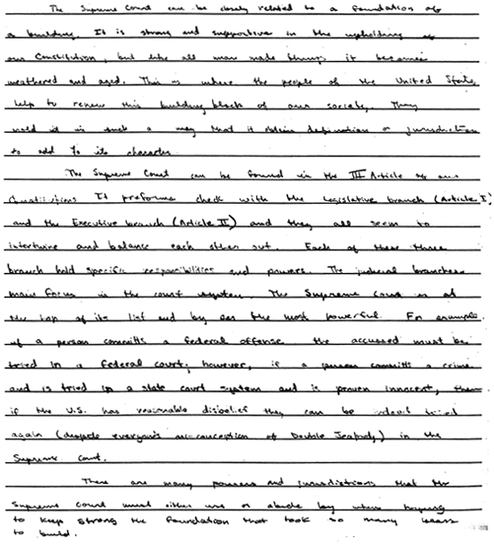

**Score 1:** This response demonstrates minimal understanding of the distinction between "original" and "appellate"jurisdiction of the Supreme Court. The student fails to engage with the question directly. A basic understanding of the Supreme Court is exhibited, but no differences between the two jurisdictions are noted. The development of relevant ideas is minimal.

**Sample 307-4 #2 of 2**

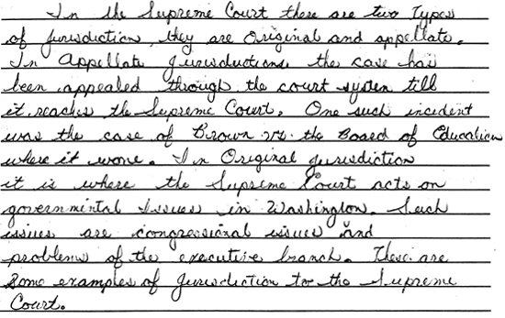

**Score 2:** This response demonstrates partial understanding of the difference between "original" and "appellate" jurisdiction of the Supreme Court. The student offers a partially accurate, yet incomplete, explanation. The examples provided are clear but underdeveloped, although a basic understanding of the distinction is evident in the example of *Brown v. Board of Education* and the contrasting congressional, governmental, and Washington emphases. The development of the points reveals partial understanding.

(Item#:307-05)

18. During World War II, the United States government held American citizens of Japanese ancestry in prison camps without charging them with crimes and without trying them in court. Years later, in 1998, Congress held that action to be unjust and appropriated money to compensate those held in prison camps. Explain three Constitutional principles that were violated by the United States government's treatment of Japanese - Americans.

[Scoring Criteria](http://metacat2.com/cssap/sg/307-5sg.html)

**Module: 307  
Item: 5  
Descriptor: The Supreme Court**

**Scoring Criteria**

Scores are based on the student's ability to:

* Identify three constitutional principles violated by the United States' government during the internment of Japanese-Americans during WWII.

A proficient response will demonstrate an understanding of how the internment of Japanese-Americans in camps during World War II was a violation of constitutional principles. For example:

* The right to "due process" of law was violated because Japanese-Americans were not given a trial before they were imprisoned.
* Civil rights were violated, as Japanese-Americans were denied "life, liberty and property."
* Equal protection of the law was violated because Japanese-Americans were being singled out solely because of their race.

**Score Level Descriptions**

**NS** Not Scorable (blank, off-topic, hostile, etc.)

**1** A response at this level demonstrates minimal understanding of how constitutional principles were violated by the United States' government during the internment of Japanese-Americans during WWII. The response is largely inaccurate or incomplete. The explanation, if provided, is exceedingly vague or inaccurate. Logic and reasoning are very simplistic and/or seriously flawed. The response demonstrates minimal understanding.

**2** A response at this level demonstrates partial understanding of how constitutional principles were violated by the United States' government during the internment of Japanese-Americans during WWII. The response is partially accurate. The student may address two or three principles that were violated, but the explanations are inadequately developed or incomplete. Evidence of rudimentary logic is present, but it contains flaws. The response demonstrates partial understanding.

**3** A response at this level demonstrates an adequate understanding of how constitutional principles were violated by the United States' government during the internment of Japanese-Americans during WWII. The student will address three principles that were violated. The explanations are generally complete and accurate, although minor errors may be present. The logic and reasoning employed are justified, but may contain minor flaws. The response is sufficient demonstrate understanding.

**4** A response at this level demonstrates a superior understanding of how constitutional principles were violated by the United States' government during the internment of Japanese-Americans during WWII. The student will address three principles that were violated. The explanations are detailed, thorough, and accurate. The logic and reasoning used are sophisticated. The response demonstrates superior understanding.

[Student Work](http://metacat2.com/cssap/sg/307-4ss.html)

**Sample 307-4 #1 of 2**



**Score 1:** This response demonstrates minimal understanding of the distinction between "original" and "appellate"jurisdiction of the Supreme Court. The student fails to engage with the question directly. A basic understanding of the Supreme Court is exhibited, but no differences between the two jurisdictions are noted. The development of relevant ideas is minimal.

**Sample 307-4 #2 of 2**



**Score 2:** This response demonstrates partial understanding of the difference between "original" and "appellate" jurisdiction of the Supreme Court. The student offers a partially accurate, yet incomplete, explanation. The examples provided are clear but underdeveloped, although a basic understanding of the distinction is evident in the example of *Brown v. Board of Education* and the contrasting congressional, governmental, and Washington emphases. The development of the points reveals partial understanding.

...Give me your tired, your poor,  
Your huddled masses yearning to breathe free,  
The wretched refuse of your teeming shore.  
Send these, the homeless, tempest-tost, to me.  
I lift my lamp beside the golden door!

--*The New Colossus*, Emma Lazarus

(Item#:308-01)

19. What was one of the purposes of the Fourteenth Amendment?

      A. To protect citizens against unfair actions by state governments

      B. To protect citizens against unfair actions by the federal government

      C. To guarantee women the right to full citizenship and the vote

      D. To grant black males the right to vote

Answer: A

(Item#:308-02)

20. How does the Fourteenth Amendment define a "citizen?"

      A. All persons who take the state oath of allegiance

      B. All persons born or naturalized in the U.S.

      C. All persons who go before the federal courts and swear they are U.S. citizens

      D. All persons whose parents were born in the U.S.

Answer: B

(Item#:308-03)

21. What clause of the Fourteenth Amendment was violated when African Americans were not allowed to vote in primary elections?

      A. Affirmative action clause

      B. Interstate commerce clause

      C. Equal protection clause

      D. Grandfather clause

Answer: C

(Item#:308-04)

22. Select one of the following Supreme Court cases. Briefly describe the main issues of the case and explain its significance in relationship to the Fourteenth Amendment.

A. *Plessy v. Ferguson*

B. *Brown v. Board of Education of Topeka, Kansas*

C. *Bakke v. Regents of California*

D. *Shaw v. Hunt*

E. *Reynolds v. Sims*

[Scoring Criteria](http://metacat2.com/cssap/sg/308-4sg.html)

**Module: 308  
Item: 4  
Descriptor: Who Is a Citizen?**

**Scoring Criteria**

Scores are based on the student's ability to:

* From a list provided, identify the main issues of one Supreme Court case relating to the Fourteenth Amendment.
* Explain the relationship of the case to the Fourteenth Amendment.

A proficient response will demonstrate an understanding of the main issues inherent in one Supreme Court case related to the Fourteenth Amendment. The student will explain the case's importance in relationship to that Amendment. Following are brief synopses of the cases:

*Plessy v. Ferguson* (1896)

An African-American citizen, Homer Plessy, bought a railroad ticket and sat in a car reserved for whites. He was arrested when he refused to ride in the car designated for African-Americans. Plessy was convicted in the state court. He took his case to the United States Supreme Court, arguing that the Louisiana law violated the Equal Protection clause. Plessy lost his case at that level, and appealed. The Supreme Court ruled that under the equal protection clause of the Fourteenth Amendment, a state could provide "separate but equal" facilities for African-Americans.

*Brown v. Board of Education* (1954)

Linda Brown, an African-American student, attended a neighborhood school in which the rest of the students were white. She was forced to attend a school for African-American children twenty-one blocks away. Her parents sued the school board of Topeka, Kansas, maintaining that their daughter had been deprived of equal protection under the law. The Supreme Court agreed. Overturning the Plessy ruling, the Court held that "separate but equal" facilities are inherently unequal, and thus are in violation of the Fourteenth Amendment.

*Regents of The University of California v. Bakke* (1978)

Allan Bakke, a white male, applied for admission to a University of California medical school, but he was rejected. Bakke argued that he had been denied his rights because he was white. He pointed out that only African-American, Asian-Americans, and Hispanic-Americans had been admitted under a program for "economically and educationally disadvantaged" students. He sued the medical school, claiming he was rejected because of his race. This, he said, violated his rights under the Fourteenth Amendment. In a close decision (5-4), the Supreme Court ruled that, while the goal of achieving a diverse student body is sufficiently compelling to justify consideration of race as one criteria in admissions decisions under some circumstances, the special admissions program under which persons like Bakke fail to receive consideration for admissions is unnecessary to the achievement of this goal, and is therefore invalid under the Equal Protection Clause.

*Shaw v. Reno* (1993)

Five white North Carolinians sued the state and federal government over the design of the Twelfth District, a newly apportioned majority-black district. The district spanned 160 miles in a snake-like pattern to include exclusively African American neighborhoods along Interstate 85. The appellants argued that, in order to create congressional districts along racial lines and to assure the election of two African-American representatives, the State had created an unconstitutional racial gerrymander in violation of, among other things, the Equal Protection clause of the Fourteenth Amendment. The Court maintained that "a reapportionment plan that includes in one district individuals who belong to the same race, but who are otherwise widely separated by geographical and political boundaries, and who may have little in common with one another but the color of their skin, bears an uncomfortable resemblance to political apartheid." Additionally, "by perpetuating such notions, a racial gerrymander may exacerbate the very patterns of racial bloc voting that majority-minority districting is sometimes said to counteract." Finally, the Court asserted that "equal protection analysis is not dependent on the race of those burdened or benefited by a particular classification." The Court invalidated one majority-black congressional district in North Carolina and another in Texas as the product of race-based gerrymandering. In her plurality opinion in the Texas case, Justice O'Connor argued that the Fourteenth Amendment required "a commitment to eliminate unnecessary and excessive governmental use and reinforcement of racial stereotypes." In summary, the use of race as a determining factor in the reapportionment of congressional districts was a violation of the Equal Protection clause of the Fourteenth Amendment.

*Reynolds v. Sims* (1964)

Alabama was divided into voting districts for the state's Senate and House of Representatives. Each county, which represented one voting district, elected one senator, while the number of house members was based on population. As no reapportionment of voting districts had been made for 60 years, there was a vast discrepancy in the size of districts. The proportion of largest to smallest districts was about 41 to 1. A group of citizens and taxpayers sued to have the reapportionment plans declared unsatisfactory. A district court decision that had approved temporary use of one of the plans was appealed to the United States Supreme Court. The Court ruled that the right to vote had been denied by debasement or dilution of the citizen's vote in a state or federal election, and constituted a violation of the Equal Protection clause of the Fourteenth Amendment. Legislators represent people and areas such as counties; weighting votes differently according to where a certain person lives is discriminatory. Under the Equal Protection Clause the seats in both houses of a bicameral legislature must be apportioned substantially on a population basis.

**Score Level Descriptions**

**NS** Not Scorable (blank, off-topic, hostile, etc.)

**1** A response at this level demonstrates minimal understanding of the issues and significance of an important Supreme Court ruling relative to the Fourteenth Amendment. The response is largely inaccurate or incomplete. The explanation of the main issues of the case and their relevance to the Fourteenth Amendment is exceedingly vague and/or inaccurate. Logic or reasoning, if in evidence, is exceedingly simplistic and/or seriously flawed. The response demonstrates minimal understanding.

**2** A response at this level demonstrates partial understanding of the issues or significance of an important Supreme Court ruling relative to the Fourteenth Amendment. The response is partially accurate but incomplete. The explanation of the main issues of the case and their relevance to the Fourteenth Amendment is somewhat unclear and inadequately developed. Some evidence of logic or reasoning may be present, but it is incomplete and partially flawed. The response demonstrates partial understanding.

**3** A response at this level demonstrates an understanding of the issues and significance of an important Supreme Court ruling relative to the Fourteenth Amendment. The response is generally complete and accurate, although minor errors may be present. The explanation of the main issues of the case and their relevance to the Fourteenth Amendment is clear and generally complete and accurate. The response exhibits valid logic and reasoning. The response is sufficient to demonstrate understanding.

[Student Work](http://metacat2.com/cssap/sg/308-4ss.html)

**Sample 308-4 #1 of 3**

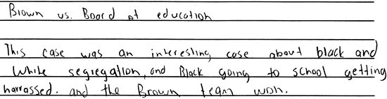

**Score 1:** This response demonstrates a minimal understanding of the topic. The response is largely inaccurate and incomplete. The student mentions that *Brown v. Board of Education* dealt with segregation. However, an explanation of the main issues and their relevance to the Fourteenth Amendment is absent. The student also erroneously suggests that the case involved harassment. The logic and reasoning are very simplistic and flawed.

**Sample 308-4 #2 of 3**

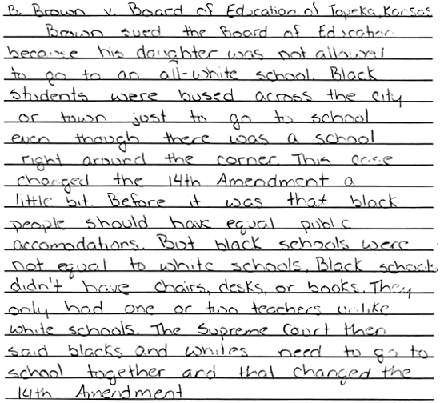

**Score 2:** This response demonstrates some understanding of the topic. The response is partially accurate but incomplete. A brief explanation of the case and its relevance to the Fourteenth Amendment is provided; however, the response lacks clarity, and the treatment of the Fourteenth Amendment is inadequate. The student possesses only a partial understanding of the topic.

**Sample 308-4 #3 of 3**

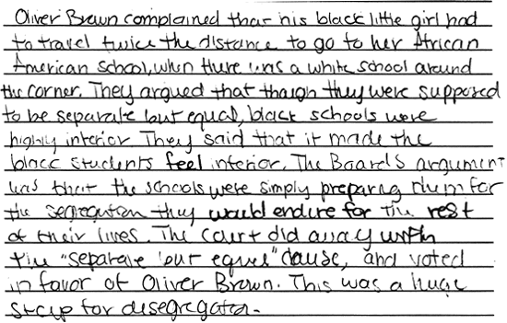

**Score 3:** This response demonstrates an understanding of the topic. The response is generally complete, although the student does not explain the Fourteenth Amendment clause, but rather implies that separate but equal facilities is a violation of the Fourteenth Amendment, leading to policy of desegregation. The response exhibits valid logic and the elaboration of ideas is sufficient to demonstrate understanding.

(Item#:308-05)

23. Define due process and equal protection and briefly explain how equal protection is related to both procedural and substantive due process.

[Scoring Criteria](http://metacat2.com/cssap/sg/308-5sg.html)

**Module: 308  
Item: 5  
Descriptor: Who Is A Citizen?**

**Scoring Criteria**

Scores are based on the student's ability to:

* Define "due process."
* Define "equal protection."
* Briefly explain how equal protection is related to both procedural and substantive due process.

A proficient response will demonstrate an understanding of the meaning of due process and equal protection, and how the latter is related to substantive and procedural due process.

*"Due Process"* is the guarantee that fair and regular procedures will be followed in court. There are two important ways this meaning is applied.

* Due process means that the *procedures* or methods used to conduct hearings and to apply and enforce the law must be fair and reasonable. All branches of the federal and state government must use fair procedures when they are carrying out the responsibilities given to them by the people.
* Due process means that the content, i.e., the *substance* of laws that legislatures pass, must be fair and reasonable. Congress and the state legislatures cannot pass laws that place unfair or unreasonable limitations on people's rights to life, liberty, or property.

*"Equal Protection"* is a guarantee of the protection of the rights of all American citizens against unfair actions by government.

It is the role of government to equally protect all citizens and to ensure their "life, liberty and property" through due process. The Equal Protection and Due Process clauses are in the Constitution to protect citizens against arbitrary and capricious acts and abuses of power by government officials, both in the substance of laws and the procedures of governance.

**Score Level Descriptions**

**NS** Not Scorable (blank, off-topic, hostile, etc.)

**1** A response at this level demonstrates minimal understanding of the meaning of "due process" or "equal protection," and how equal protection is related to both procedural and substantive due process. The response is largely inaccurate or incomplete. The explanations, if provided, are exceedingly vague or inaccurate. Logic and reasoning are very simplistic and/or seriously flawed. The response demonstrates minimal understanding.

**2** A response at this level demonstrates partial understanding of the meaning of "due process" and "equal protection," and how equal protection is related to both procedural and substantive due process. The response is partially accurate, but the explanations are inadequately developed or incomplete. Evidence of rudimentary logic is present, but it contains flaws. The response demonstrates partial understanding.

**3** A response at this level demonstrates an adequate understanding of the meaning of "due process" and "equal protection," and how equal protection is related to both procedural and substantive due process. The explanations are generally complete and accurate, although minor errors may be present. The logic and reasoning employed are justified, but may contain minor flaws. The response is sufficient to demonstrate understanding.

**4** A response at this level demonstrates a superior understanding of the meaning of "due process" and "equal protection," and how equal protection is related to both procedural and substantive due process. The explanations are detailed, thorough, and accurate. The logic and reasoning used are sophisticated. The response demonstrates superior understanding.

[Student Work](http://metacat2.com/cssap/sg/308-5ss.html)

**Sample 308-5 #1 of 2**

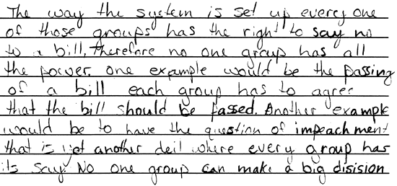

**Score 1:** This response demonstrates minimal understanding of "due process" or "equal protection." The response is inaccurate and incomplete. The student attempts to address the topic, but the information provided is exceedingly vague, undeveloped, and incorrect. Simplistic and flawed logic is employed throughout the response.

**Sample 308-5 #2 of 2**

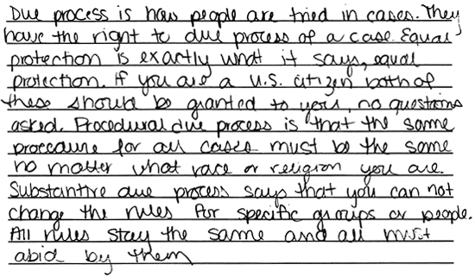

**Score 2:** This response demonstrates partial understanding of the topic. The response is partially accurate, but is incomplete. The explanations for "due process," "equal protection," and "procedural due process" are inadequately developed. The explanation of "substantive due process" is incorrect.

(Item#:308-06)

24. **Introduction**

In 1868, the Fourteenth Amendment was added to the United States Constitution. A key part of the amendment stated that citizens could not be denied "equal protection of the laws." Since 1868, the United States Supreme Court has frequently been asked to interpret the equal protection clause, including those involving Homer Plessy (*Plessy v. Ferguson*--1896) and Linda Brown (*Brown v. Board of Education*--1954).

**Instructions**

**Part A**. Your task is to research the issues involved with these two cases, highlighting the similarities and differences in a VENN diagram that you will present to the class. Make sure to address the following your analysis:

1. Who are Homer Plessy and Linda Brown?
2. What is the context of the issues in each case? (who, what, when, where).
3. What was the constitutional basis in each case?
4. What was the ruling of the court in each case?
5. Were there dissenting opinions in either or both cases? Please explain if there were.
6. In what important way does the Brown case differ from the Plessy case?

**Part B**. Choose one other case, either past or recent, that involves the "equal protection of the law" clause.

1. Describe the context of the issue (who, what, when, where);.
2. What is/was the constitutional basis for the case?
3. If there has been a ruling, what was it, and how was it similar or different from the Brown and Plessy cases?
4. If there has not been a ruling in the case, what would you predict the ruling is going to be? Why?

Score Criteria Not Available

Student Work Not Available

Every government must determine the appropriate balance between attention to foreign and domestic affairs. In an increasingly interdependent world, foreign and domestic affairs are becoming more and more difficult to separate. Global problems such as military aggression, unfair trade practices, environmental threats and disasters, and disease transcend national boundaries and affect life in all countries. Confronted by problems global in scope, nations must work together in determining effective responses to the sources of threat. In this context, it becomes increasingly difficult for the United States to isolate itself from the rest of the world.

(Item#:310-01)

25. Which of the following actions best illustrates a United States policy of isolationism?

      A. The U.S. sends troops to the Middle East during the Gulf War.

      B. The U.S. Senate rejects the proposal to join the League of Nations

      C. The U.S. competes for economic power and influence.

      D. The U.S. establishes peace treaties with European nations.

Answer: B

(Item#:310-02)

26. Which of the following statements best reflects opposition to free trade policies?

      A. The U.S. should play a leading role in the effort to improve living conditions in the developing world.

      B. The U.S. should greatly reduce its overseas spending and authorize more funding for domestic programs.

      C. The U.S. should increase tariffs on products manufactured abroad in an effort to protect American business.

      D. The U.S. should pursue relations with any nation that will open its market to American goods.

Answer: C

(Item#:310-03)

27. Which of the following quotations best represents an activist position regarding the United States role in global environmental policy?

      A. 'As the most powerful nation in the world, the U.S. must lead the world in confronting the environmental challenges of the 21st century.'

      B. 'Concern for the environment may be important, but for now the health of our nation's economy must assume top priority.'

      C. 'For decades, U.S. foreign policy has been burdened by the illusion that the U.S. could change the world.'

      D. 'U.S. trade policy must put the interests of American workers above the naÃ¯ve goal of environmental protection.'

Answer: A

(Item#:310-04)

28. The use of the military as a tool of foreign policy is always subject to debate. Identify and briefly explain at least two rationales for United States military involvement abroad.

[Scoring Criteria](http://metacat2.com/cssap/sg/310-4sg.html)

**Module: 310  
Item: 4  
Descriptor: Foreign Policy**

**Scoring Criteria**

Scores are based on the student's ability to:

* Identify and explain at least two rationales for U.S. military involvement in other countries.

A proficient response will demonstrate an understanding of at least two rationales for U.S. military involvement in other countries. The following are some possible examples:

* Concern for another nation's sovereignty
* Threat to U.S. economic interests
* Humanitarian concerns
* Threat to stability in the Western Hemisphere
* Defense treaty obligations

Accompanying explanations, although brief, should be appropriate and logical, and indicative of an understanding of why the U.S. engages in military activity abroad.

**Score Level Descriptions**

**NS** Not Scorable (blank, off-topic, hostile, etc.)

**1** A response at this level demonstrates minimal understanding of different rationales for U.S. military involvement in other countries. The response is largely inaccurate or incomplete. The examples and explanations are exceedingly vague and/or inaccurate. Logic or reasoning, if in evidence, is exceedingly simplistic and/or seriously flawed. The response demonstrates minimal understanding.

**2** A response at this level demonstrates partial understanding of different rationales for U.S. military involvement in other countries. The examples and explanations are somewhat unclear and inadequately developed. Some evidence of logic or reasoning may be present, but it is incomplete and partially flawed. The response demonstrates partial understanding.

**3** A response at this level demonstrates an understanding of different rationales for U.S. military involvement in other countries. The response is generally complete and generally accurate, although minor errors may be present. The examples and explanations are clear and generally complete and accurate. The response exhibits valid logic and reasoning. The response is sufficient to demonstrate understanding.

[Student Work](http://metacat2.com/cssap/sg/310-4ss.html)

**Sample 310-4 #1 of 3**

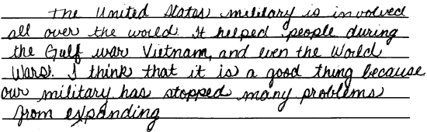

**Score 1:** This response vaguely addresses a rationale for U.S. military involvement as a tool of foreign policy. This student addresses maintaining economic concerns (Gulf War) and protecting a nation's sovereignty (Vietnam), but the ideas lack development. The student provides only one of two required rationales. The response reveals minimal understanding

**Sample 310-4 #2 of 3**

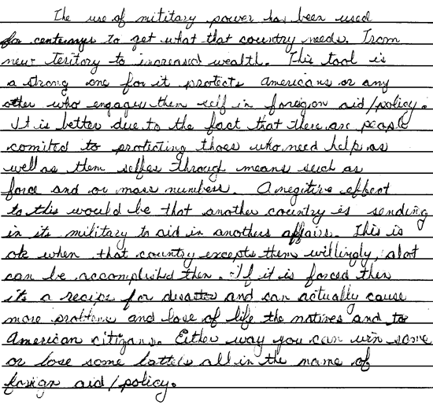

**Score 2:** This response provides an appropriate, albeit underdeveloped, explanation for the use of U.S. military involvement for humanitarian concerns. The student vaguely addresses the use of force to maintain economic concerns. The response is incomplete, vague in parts, and lacks the overall development to demonstrate more than partial understanding.

**Sample 310-4 #3 of 3**

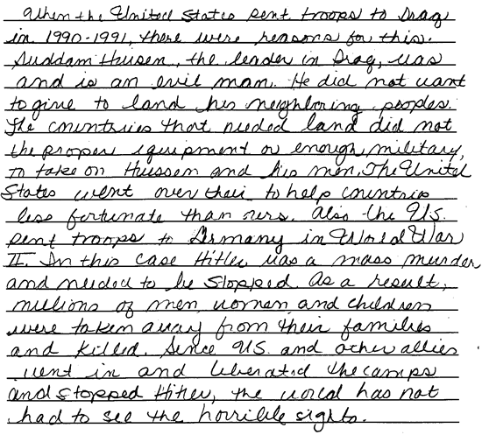

**Score 3:** This response clearly demonstrates understanding. The student provides two detailed, thorough, and well-chosen examples of the use of U.S. military involvement to address humanitarian concerns. The response is complete and accurate. The examples (Gulf War, World War II) might have addressed other aspects of foreign policy, but the student chose to address humanitarian concerns. This essay demonstrates an understanding of the topic. This is a "high" 3.

(Item#:310-05)

29. Consistent with the checks and balances principle, the Constitution provides certain expressed and implied powers to the executive and legislative branches in the area of foreign affairs. For example, in matters of defense, the president is the Commander-in-Chief of the armed forces, but Congress has the sole authority to declare war and appropriate military spending. Despite the authority of Congress, many presidents have deployed United States military forces to areas of conflict without a formal declaration of war by Congress. At the end of Indochina conflict in 1973, Congress passed the War Powers Act. It was intended to provide an additional Congressional check on what was perceived as increasingly unauthorized use of the military by Presidents Lyndon Johnson and Richard Nixon. Nixon vetoed the legislation, declaring it 'both unconstitutional and dangerous to the best interest of our nation.' The Act became law upon the congressional override of Nixon's veto and remains a highly controversial issue.

Using your knowledge of the Constitution, explain the controversy surrounding the constitutionality of the War Powers Act of 1973. Be specific in your discussion of the central issue in dispute.

[Scoring Criteria](http://metacat2.com/cssap/sg/310-5sg.html)

**Module: 310  
Item: 5  
Descriptor: Foreign Policy**

**Scoring Criteria**

Scores are based on the student's ability to:

* Explain the controversy surrounding the constitutionality of the War Powers Act of 1973.

A proficient response will demonstrate a general understanding of the provisions of the War Powers Act of 1973, and provide an explanation of the dispute surrounding the constitutionality of the Act. Although the following description of the Act is much more detailed than necessary in a proficient response, it is provided for the scorer's convenience:

*Main Provisions of the War Powers Act of 1973:*

* Within 48 hours after committing American forces to combat abroad, the president must report to Congress, detailing the circumstances and the scope of his actions.
* The use of American forces in combat must end within 60 days, unless Congress authorizes a longer commitment. The deadline may be extended 30 additional days if the president certifies the extension necessary to the safe withdrawal of the forces involved.
* American forces engaged in combat abroad without a declaration of war or other specific congressional authorization must be withdrawn immediately, should Congress pass a concurrent resolution to that effect.

The essential characteristic of a proficient response will be a focus on the dispute surrounding the War Powers Act relative to its constitutionality:

A number of constitutional questions are raised by the passage of the War Powers Act of 1973. At the heart of the issue is the extent to which the Act alters the existing constitutional *checks and balances between the legislative and executive branches in the area of foreign policy*, and specifically, military affairs. By extension, the question of whether Congress can legislate itself additional power in the area of military affairs, beyond that provided to it in the Constitution, is raised.

**Score Level Descriptions**

**NS** Not Scorable (blank, off-topic, hostile, etc.)

**1** A response at this level demonstrates minimal understanding of the controversy surrounding the constitutionality of the War Powers Act of 1973. The response is largely inaccurate. The explanation of the dispute, if provided, is exceedingly vague or inaccurate. Logic and reasoning are very simplistic and/or seriously flawed. The response demonstrates minimal understanding.

**2** A response at this level demonstrates partial understanding of the controversy surrounding the constitutionality of the War Powers Act of 1973. The response is partially accurate, but the explanation of the dispute is inadequately developed or incomplete. Evidence of rudimentary logic is present, but it contains flaws. The response demonstrates partial understanding.

**3** A response at this level demonstrates an adequate understanding of the controversy surrounding the constitutionality of the War Powers Act of 1973. The explanation of the dispute is generally complete and accurate, although minor errors may be present. The logic and reasoning employed are justified, but may contain minor flaws. The response is sufficient to demonstrate understanding.

**4** A response at this level demonstrates a superior understanding of the controversy surrounding the constitutionality of the War Powers Act of 1973. The explanation of the dispute is detailed, thorough, and accurate. The logic and reasoning used are sophisticated. The response demonstrates superior understanding.

[Student Work](http://metacat2.com/cssap/sg/310-5ss.html)

**Sample 310-5 #1 of 1**

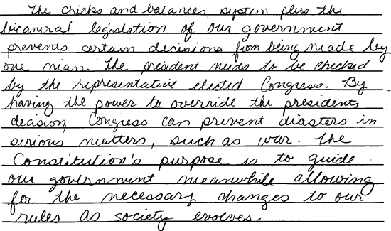

**Score 3:** This response demonstrates understanding of the controversy surrounding the constitutionality of the War Powers Act of 1973. The student integrates information from the stimulus with prior knowledge of constitutional checks and balances. The response is generally complete and accurate, and the logic is sound.

(Item#:310-06)

30. **Introduction**

The national security of the United States has always been the guiding interest of our foreign policy. As a result, our foreign policy varies from region to region, and country to country, depending on the national security interests most prevalent at a given time and place. Whatever those interests, foreign aid has become an increasingly important tool in carrying out foreign policy initiatives. Aid "packages" to foreign countries typically include a combination of loans and grants which might be used for any combination of humanitarian, economic, agricultural, educational, infrastructural, or military purposes.

Policymakers hold a wide range of differing opinions on the use of foreign aid as a tool of foreign policy. Some believe that the provision of foreign aid to assist developing nations is a moral obligation of the United States. Others advocate the provision of more limited, very selective, targeted foreign aid programs that, while they meet certain development needs in the recipient nations, are designed to advance specific United States interests.

**Instructions**

Over the next several weeks you will be working for the United States Agency for International Development (USAID). An independent agency often working in close cooperation with the U.S. Department of State, USAID administers most of the foreign economic aid programs. The Agency was created in 1961 with two central purposes: to respond to the threat of communism and to help poorer nations develop and progress. This twofold mission was grounded in the belief that it was possible to defend our national interests while promoting our national values. With the end of the Cold War, USAID is poised to address the challenges of development directly.

Your task is to develop a persuasive written proposal for inclusion in a package of foreign aid for a developing country (you will choose the country, or your teacher will assign it). The proposal that you develop will be included as part of a larger foreign aid request and will be submitted to the House Appropriations Committee for consideration for funding. You may be asked to appear in person to answer questions about your written proposal. Make sure to complete the following components of the assignment:

* Investigate the need for different types of aid in the foreign country. Consider basic indicators such as population and mortality, annual income per person, gross national product, industrial and agricultural output, literacy and educational attainment, resources and usage, and health and sanitation.
* Identify, in general, national security considerations of importance to the United States relative to the recipient country or the region in which it is located.
* Choose one specific development need that could be impacted through the provision of economic assistance.
* Provide evidence of the country's need, in the form of facts and figures, in support of the specific aid recommendations you propose. Use the most recent figures available.
* Specify the purpose of the funds, if appropriated, i.e., how the aid will be used, or what it will be used for.
* Conclude with a persuasive statement in which you explain:
  + How your specific recommendations relate to the goal of protecting the national security interests of the United States and are necessary and consistent with U.S. foreign policy needs.
  + How failure to pursue those recommendations might result in crisis.
* Your proposal should also include:
  + Maps of the country and region
  + Statistical charts and graphs where appropriate
  + In-text citation or footnotes where appropriate
  + A list of sources done completely and accurately.

Keep in mind that there are many students who will be making similar pleas for aid before the Appropriations Committee. There is not enough money to fund all proposals, so it is very important that you prepare an interesting and *persuasive* report, giving attention to form, style, clarity, and accuracy of information.

Score Criteria Not Available

Student Work Not Available

*We the People of the United States, in Order to form a more perfect Union, establish Justice, ensure domestic Tranquility, provide for the common defense, promote the general Welfare, and secure the Blessings of Liberty to ourselves and our Posterity, do ordain and establish this Constitution for the United States of America.*

--Preamble to the United States Constitution

The Preamble to the United States Constitution sets forth the basic purpose of government, as seen by the Founders.

(Item#:311-01)

31. Which of the following principles does the Preamble state?

      A. A republic is the best form of government.

      B. The legislative branch of government is supreme.

      C. Ultimate sovereignty resides in the people.

      D. Ultimate sovereignty resides in the states.

Answer: C

(Item#:311-02)

32. According to the Preamble, to whom do we, as Americans, have a responsibility for securing liberty?

      A. Ourselves and future generations

      B. Ourselves as individuals

      C. The majority of the American people

      D. Minorities not represented in government

Answer: A

(Item#:311-03)

33. One purpose of government stated in the Preamble is to "promote the general welfare." Which of the following is an example of promoting the general welfare?

      A. Reducing income taxes

      B. Subsidizing the steel industry

      C. Providing scholarships for math and science students

      D. Passing laws to protect the environment

Answer: D

(Item#:311-04)

34. One of the purposes of government expressed in the Preamble is to 'ensure domestic tranquility.' Explain what 'domestic tranquility' means and give two examples of how government can ensure it.

[Scoring Criteria](http://metacat2.com/cssap/sg/311-4sg.html)

**Module: 311  
Item: 4   
Descriptor: What Does Government Do?**

**Scoring Criteria**

Scores are based on the student's ability to:

* Explain the meaning of "domestic tranquility."
* Provide two examples of how government ensures domestic tranquility.

A proficient response will explain the meaning of "domestic tranquility" and provide two appropriate examples of how domestic tranquility is ensured by government. The student should indicate that domestic tranquility refers to the condition of peace at home. Examples will vary, but each should demonstrate an understanding of how government protects individual rights and maintains order at home.

**NS** Not Scorable (blank, off-topic, hostile, etc.)

**1** A response at this level demonstrates minimal understanding of how government in the United States ensures domestic tranquility. The response is largely inaccurate and incomplete. The explanation is exceedingly vague and/or inaccurate and the examples inappropriate. Logic or reasoning, if in evidence, is exceedingly simplistic and/or seriously flawed. The response demonstrates minimal understanding.

**2** A response at this level demonstrates partial understanding of how government in the United States ensures domestic tranquility. The response is partially accurate but incomplete. The explanation and examples are somewhat unclear and inadequately developed. Some evidence of logic or reasoning may be present, but it is incomplete and partially flawed. The response demonstrates partial understanding.

**3** A response at this level demonstrates an understanding of how government in the United States ensures domestic tranquility. The response is complete and accurate, although minor errors may be present. The explanation is clear and generally complete and accurate, and the examples are appropriate. The response exhibits valid logic and reasoning. The response is sufficient to demonstrate understanding.

[Student Work](http://metacat2.com/cssap/sg/311-4ss.html)

**Sample 311-4 #1 of 3**

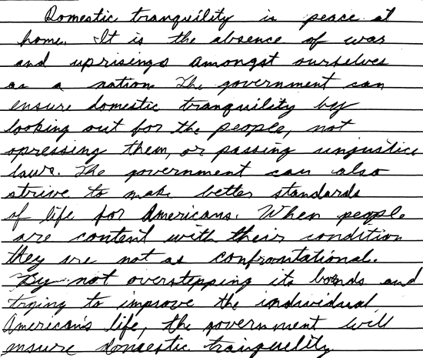

**Score 1:** This response demonstrates minimal understanding of how the government in the U.S. ensures domestic tranquility. Although it begins with an appropriate statement, "...peace at home," it shifts to global confrontations, demonstrating flawed logic. There does appear a second explanation that encompasses some truth, but, again, the reasoning is exceedingly vague and leads to an inaccurate conclusion.

**Sample 311-4 #2 of 3**

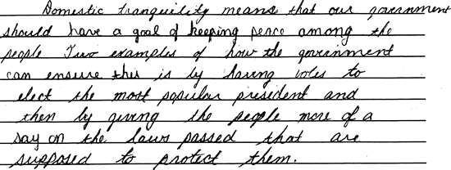

**Score 2:** This response demonstrates partial understanding of what "domestic tranquility" means, but is unclear about the role the U.S. government plays in ensuring it. "Having votes to elect the most popular president" is somewhat vague and inadequately developed. The reasoning is incomplete, revealing only partial understanding of the topic.

**Sample 311-4 #3 of 3**

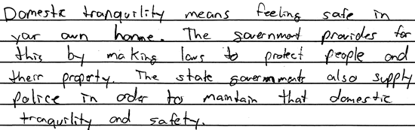

**Score 3:** This response is generally complete and accurate, demonstrating valid logic and providing examples of how government can ensure domestic tranquility. The examples are appropriate and sufficiently demonstrate understanding that the condition of peace at home is ensured by "laws to protect" and "police to maintain that domestic tranquility and safety." The response is sufficient to demonstrate understanding.

(Item#:311-05)

35. When the Preamble states as a goal "to form a more perfect union," it acknowledges that the task of perfecting government is a never-ending one. Identify ways in which American society has moved closer to the goal of 'a more perfect union.' Explain how each has benefited the United States as a whole.

[Scoring Criteria](http://metacat2.com/cssap/sg/311-5sg.html)

**Module: 311  
Item: 5   
Descriptor: What Does Government Do?**

**Scoring Criteria**

Scores are based on the student's ability to:

* Provide three examples illustrating how American society has moved toward "a more perfect union."
* Explain how the examples have benefited the United States as a whole.

A proficient response will demonstrate an understanding of how United States' society has evolved toward the goal of "a more perfect union." The student will provide three examples, explaining how each has contributed toward that goal. Examples will vary, but each should be accompanied by an explanation demonstrating an understanding of how it has contributed to a more perfect union among the states and the citizens of the United States.

**Score Level Descriptions**

**NS** Not Scorable (blank, off-topic, hostile, etc.)

**1** A response at this level demonstrates minimal understanding of how American society has moved toward "a more perfect union." The response is largely inaccurate or incomplete. The explanation and examples, if provided, are exceedingly vague or inaccurate. Logic and reasoning are very simplistic and/or seriously flawed. The response demonstrates minimal understanding.

**2** A response at this level demonstrates partial understanding of how American society has moved toward "a more perfect union." The student will provide a partially accurate response. The student may provide two appropriate examples, but the explanations are inadequately developed or incomplete. Evidence of rudimentary logic will be present, but it will contain flaws. The response demonstrates partial understanding.

**3** A response at this level demonstrates an adequate understanding of how American society has moved toward "a more perfect union." The student will provide three appropriate examples. The explanations are generally complete and accurate, although minor errors may be present. The logic and reasoning employed are justified, but may contain minor flaws. The response is sufficient to demonstrate understanding.

**4** A response at this level demonstrates a superior understanding of how American society has moved toward "a more perfect union." The student will provide three appropriate examples. The explanations are detailed, thorough, and accurate, and may go beyond that which is required in the question. The logic and reasoning used are sophisticated. The response demonstrates superior understanding.

[Student Work](http://metacat2.com/cssap/sg/311-5ss.html)

**Sample 311-5 #1 of 1**

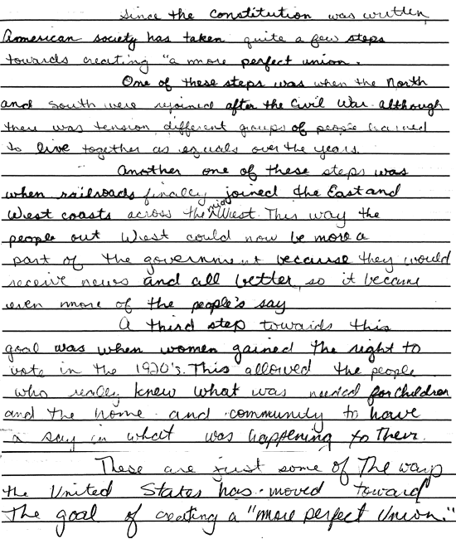

**Score 2:** This response identifies two examples of how the American society has moved to a goal of a "more perfect union." The end of the Civil War and the achievement of women's right to vote are appropriate examples, but they are inadequately developed. Identifying the East-West railroad as an example reveals an incomplete understanding of governmental endeavors toward "a more perfect union." This response reveals partial understanding of the topic.

(Item#:311-06)

36. **Introduction**

As we go about our daily lives, we seldom pause to consider how our freedoms are a product of, and dependent on, the guarantees embodied in the Constitution of the United States. Indeed, one of the remarkable aspects of the Constitution is the simultaneously subtle but powerfully binding guarantee of individual rights that it provides to all citizens. Without these guarantees, our lives would be considerably different.

If we were to pause and reflect upon our daily lives in relation to the Constitution, we would discover that every aspect of our lives is, in some way, related to the Constitution and the protections it affords to citizens of the United States. These protections are integral to the opportunities we have and the choices we make. The Constitution lives in each and every one of our daily experiences.

**Instructions**

During the next few weeks, you will develop an increased awareness of how the Constitution lives in the experiences of your daily life. During the first week, you will reflect upon the variety of your daily experiences, contemplating them in relation to the Constitution and the guarantees of individual rights it provides. You will create a journal in which you clearly explain, using specific examples, how the Constitution lives through your daily experiences.

**Journal Entries**

At the end of each day, reflect upon the many things you did. For example:

* Did you select a book to read?
* Did you gather and socialize with a group of friends?
* Did you choose a particular brand of something to purchase?
* Did you watch a certain television program?
* Did you make your position known on some issue?

Focus on one thing that you *especially* value having had the opportunity to do. Use this as an example for your journal. Analyze the example you have chosen and determine what specific provision(s) of the Constitution relates to the example.

Your journal should consist of seven entries, i.e., one for each day of the week. Each journal entry should:

* provide a description of at least one example of an experience from that day.
* relate that example experience to one or more specific and relevant provisions (Article or Amendment, and Section) of the Constitution.
* describe clearly how the provision(s) of the Constitution applies to the example experience.

**Conclusion**

In addition to the seven entries, you will develop a conclusion that communicates the meaning of your journal. The conclusion you write must convey a clear understanding and appreciation, based on the experiences reflected in your journal, of the Constitution's powerful role in guaranteeing your individual rights. You may wish to consider the use of poems, illustrations, or other devices to supplement the written conclusion. Careful and creative thought will be necessary in developing an effective conclusion.

[Scoring Criteria](http://metacat2.com/cssap/sg/311-6sg.html)

**Module: 311  
Item: Task  
Descriptor: The Constitution and Your Individual Rights**

**Scoring Criteria**

Scores are based on the student's ability to:

* Explain how the freedoms provided by the Constitution affect everyday life.

A proficient response will demonstrate an understanding of how the Constitutionally guaranteed freedoms affect everyday life. Responses will vary, but should be in journal format. The journal should include at least seven entries. The following elements should be present in the response:

* A description of an experience from the day and its relation to a specific and relevant provision of the Constitution
* A conclusion based on experiences in the journal that illustrates the impact of the Constitution on everyday life

**Score Level Descriptions**

|  |  |
| --- | --- |
| **NS** | Not Scorable (blank, off-topic, hostile, etc.) |
| **1** | Performance at this level demonstrates minimal understanding of how the freedoms provided by the Constitution affect everyday life. The response is largely inaccurate or incomplete. The explanations, if provided, are exceedingly vague or inaccurate. Logic and reasoning are very simplistic and/or seriously flawed. The required presentation elements are seriously deficient. The response demonstrates minimal understanding. |
| **2** | Performance at this level demonstrates partial understanding of how the freedoms provided by the Constitution affect everyday life. The response is partially accurate. The explanations are inadequately developed or incomplete. Evidence of rudimentary logic is present, but it contains flaws. Some presentation elements are present. The response demonstrates partial understanding. |
| **3** | Performance at this level demonstrates an adequate understanding of how the freedoms provided by the Constitution affect everyday life. The explanations are generally complete and accurate, although minor errors may be present. The logic and reasoning employed are justified, but may contain minor flaws. The required presentation elements are generally present. The response is sufficient to demonstrate understanding. |
| **4** | Performance at this level demonstrates superior understanding of how the freedoms provided by the Constitution affect everyday life. The explanations are detailed, thorough and accurate. The logic and reasoning used are sophisticated. All required presentation elements are present. The response demonstrates superior understanding. |

[Student Work](http://metacat2.com/cssap/sg/pt311-sg.html)

**Item:**311-6, Sample #1 of 4

1.

**Monday, January 29, 1999**  
Simple relaxing day. I get up, go to school, come home watch Transformers, nap, and then go to sleep. My freedom to relax is tested. Me vs. the Constitution round one, I win!

**Tuesday, January 30, 1999**  
After school I wind my way home, watch Transformers and listen to music. After a few hours it hits me (my history book ) then I start to work on reading those chapters. Do a little more lounging and go to bed. Another great day! My right to a lazy day is unchallenged, thank you Constitution! Round 2 goes to me as well.

**Wednesday, December 1, 1999**  
Ok, today was a fairly bad day. Miss the bus to the slow tech ( and will probably get an after school ) get home put a desk and shelf together, and sit down to do this journal thing. Well I dislike today but I guess it could be worse (Nazi death camps or a day without naps) so the Constitution wins today. The currant score is two to one, me.

**Thursday, December 2, 1999**  
After waking up today I go to school and there I was feeling all hot and groggy. So I took your History test handed you what I had of my journal and then tried to get home. Dad had the Astro Van and Mom can't drive a clutch, hence I have to call my grandmother at my great grandfather's house and have her come and get me. I get home take some painkillers and watch a little television with Mom.

**Friday, December 3, 1999**  
Ok, though I didn't go to school and I got to nap a bit today, I found out that Ms. Stuck is probably going to give me an after school. First of all I have to be here for my sister so I can't take it second of all my mother told me that she didn't want me getting an after school for missing the slow-tech bus.

**Saturday, December 4, 1999**  
Not much got done today. I watch the morning cartoons and slept through the day. Thinking, though, what does after school detention accomplish, besides giving me less time to work on projects and such? It seems counterproductive.

**Sunday, December 5, 1999**  
Going down to Cumberland to buy and chair today. I guess the Constitution helps with that state to state commerce thing.

Well, ok, I don't get this assignment but I did it so here it is.

**Monday, January 29, 1999**  
Simple relaxing day. I get up, go to school, come home watch Transformers, nap, and then go to sleep. My freedom to relax is tested. Me vs. the Constitution round one, I win!

**Tuesday, January 30, 1999**  
After school I wind my way home, watch Transformers and listen to music. After a few hours it hits me (my history book ) then I start to work on reading those chapters. Do a little more lounging and go to bed. Another great day! My right to a lazy day is unchallenged, thank you Constitution! Round 2 goes to me as well.

**Wednesday, December 1, 1999**  
Ok, today was a fairly bad day. Miss the bus to the slow tech (and will probably get an after school ) get home put a desk and shelf together, and sit down to do this journal thing. Well I dislike today but I guess it could be worse (Nazi death camps or a day without naps ) so the Constitution wins today. The currant score is two to one, me.

**Score:** 1   
**Score Justification:**   
This response demonstrates minimal understanding of how the freedoms provided by the Constitution affect everyday life. The response is exceedingly vague, and the explanations and logic seriously flawed. The student provides very little in the way of relating daily experiences to the Constitution. An admission of non-understanding is made in the December 5th entry.

**Item:** 311-6, Sample #2 of 4

2.

***The Constitution and your Individual Rights***

Monday, Nov. 29, 1999

The preamble of the constitution gave me the right to go to the doctor. Then I drove to school, the tenth amendment of the constitution provides me this right, it leaves the decision to the states which leaves the decision to the school. After school I went to work until 10 o'clock, the first article section eight of the Constitution allows the government to collect federal income tax from my daily earnings.

Tuesday, Nov. 30, 1999

I drove to school the tenth amendment of the constitution provides me this right, it leaves the decision to the state, which leaves the decision to the school. After school I went to work until 10 o'clock, the first article section eight of the Constitution allows the government to collect federal income tax from my daily earnings.

Wednesday Dec. 1 1999

I drove to school the tenth amendment of the constitution provides me this right it leaves the decision to the state, which leaves the decision to the school. After school I went to work until 10 o'clock, the first article section eight of the Constitution allows the government to collect federal income tax from my daily earnings.

Thursday Dec. 2, 1999

I drove to school the tenth amendment of the constitution provides me this right, it leaves the decision to the state, which leaves the decision to the school. I organized and helped run a blood drive at school this is a right given in the preamble and amendment ten determine the age regulations. After school I went to work until 10 o'clock the first article section eight of the Constitution allows the government to collect federal income tax from my daily earnings.

Friday Dec. 3, 1999

I drove to school the tenth amendment of the constitution provides me this right, it leaves the decision to the state, which leaves the decision to the school. I watched television and rented a movie this is given by the first amendment freedom of speech.

Saturday, Dec. 4, 1999

I went to work the first article section eight of the Constitution allows the government to collect federal income tax from my daily earnings. I went to a school dance, and socialized with numerous friends this right is provided by the right to assemble.

Sunday, Dec.5 1999

I went to church this right is provided by the first amendment of the Constitution. I went to work at the Polish Pines and then to work at Powertel, the first article section eight of the Constitution allows the government to collect federal income tax from my daily earnings.

In conclusion the Constitution mainly regulates the laws for government. The Bill of Rights and the Preamble of the constitution give me the rights that I enjoy day by day.

**Score:** 2  
**Score Justification:**   
This response demonstrates partial understanding of how the freedoms provided by the Constitution affect everyday life. The student relates some experiences to the Constitution, but the analysis is quite weak. The response is partially accurate but incomplete.

**Item:** 311-6, Sample #3 of 4

3.

Entry 1

12/03/99

Today I received my paycheck. Being a hardworking person and having to buy virtually everything myself, I know the value of a dollar. Out of every paycheck a percentage is taken for federal taxes. This is thanks to amendment XVI, in which congress is given the power to lay and collect taxes on income. In this case, it was my income being taxed. It sickens me that my pay is reduced, but I'm looking forward to my tax return.

Entry 2

12/04/99

Today I went to work at my construction job. Six in the morning I was out roofing, and like most construction jobs I used a variety of tools and materials. Everything I used from pneumatic nail guns, to shingles all were copyrighted and patented. Article I, section VII permits the issuing of patents and copyrights on such items like I used today.

Entry 3

12/05/99

Sunday, a day of relaxing and reflection, but not for me. While most people are going to church I went to work over my grandparents. Thanks to freedom of religion, or no religion I was able to go to my grandparents. While over there I also worked on my car, using patented tools and parts (Article I, section VII).

Entry 4

12/06/99

Another long boring day of school, but I had a good time earlier. I just got back from a concert. The first amendment made the concert possible. Thousands of people gathered to watch the band. The concert was also used as a platform to speak out against the government. The band believes a grave injustice has occurred against a convicted cop killer. The band as well as protesters spoke to free the cop killer. Without the first amendment, freedom of speech, neither the concert nor the protest could have happened.

Entry 5

12/07/99

I have often pleaded the Fifth Amendment to my parents, when they ask what happened at school or where I had been. There is no point in incriminating myself, so why say anything. Although pleading the fifth in this case is not legally binding, it serves its purpose. If I get in trouble I'm not going to rat myself out, who would? The fifth has come in pretty handy.

Entry 6

12/08/99

I heard about a party over the weekend that reminded me of a party I went to. It was loud of course and not exactly legal. The cops showed up after the neighbors complained. Needless to say if the police came in we would have all been in a lot of trouble. But thanks to some fast-talking and the fourth amendment the party kept going. The cop did not have a reason to search the house or at least he though he didn't have a reason. We all were lucky that night.

Entry 7

12/09/99

Recently I heard in the news about a thirty-year-old women, who was taken from her home, and forced to drive her assailant south. After a few days of searching the assailant was captured a few states away in North Carolina. So article IV, section II will be implemented. North Carolina will surrender the fugitive to the state in which he committed the crime. He will be put to justice where he destroyed some ones life.

Conclusion:  
The constitution plays a very big role in the everyday lives of the individual. It guarantees each of us rights, that which with out, we would not be able to function well nor be able to prosper. The constitution is always around, protecting the individual whether they know it or not.

**Score:** 3  
**Score Justification:**   
This response demonstrates adequate understanding of how the freedoms provided by the Constitution affect everyday life. The response is generally complete and accurate. The student does a reasonably good job of relating daily experiences to the relevant provisions in the Constitution. The explanations are generally complete and the logic is substantiated. While not profoundly insightful, the conclusion demonstrates an understanding of the importance of the Constitution in our daily lives.

**Item:** 311-6, Sample #4 of 4

4.

Friday and Saturday Journals

Today I had to babysit a six year old girl who resides in the same apartment complex as I. Her mother had to respond to a very important errond: picking the child's older brother up from the police station and paying a kind of bail. (Basically, he was fined and a portion of this had to be paid or he couldn't be released, he'd go to jail.) The brother is eighteen years old and was charged with driving under the influence of alcohol. From talking to his mother, she would not tell me the exact amount she paid, but she said is was reasonable considering his offense. He was also not held in jail for an excessive period of time, or harmed in any way. This is an example of the eight amendment.

The eight amendment declares excessive fines and punishments unconstitutional. The boy (Derek) was only on his first offense. Because he was drinking underage he lost his driving privileges but one can hardly consider that inappropriate. In the past (had this been a common offense) he may have been fined excessively, beaten or worse. However, thanks to the eight amendment he was treated very humanly, even though the interests of others clearly wasnt on his mind when he got behind the wheel.

Saturday Journal

I went to a barbecue at my boyfriend's cousin's girlfriend's mother's house( I k now it sounds odd but its true) because the weather was so nice considering the time of year. The people here were all drinking margaritas and beer. They were able to freely go into a store, purchase the beverages and bring them home. This can be considered the right of the twenty first amendment.

The twenty first amendment repeals the eighteenth amendment which prohibited alcohol. In other words, their right to purchase and consume alcoholic beverages was in no way infringed upon due to constitutional right.

Sunday and Monday Journals

Many people practice different religions in our country today. Many of my friends are currently attending church, as it is Sunday and they are Christian. I on the other hand, am not Christian or Jewish or any religion similar; I am New Age Metaphysical. I learned of the Melchesadek Order rather than the worship of God and many other distinct differences. We work with energy, the auric, chakra, and harmonic systems to which most people are foreign. I , and my family, am able to practice this religion on account of the first amendment. The first amendment guarantees each person the rights of freedom of speech, religion, assembly, and petition.

Years ago, the belief system in which I was raised would be strictly forbidden. I would be condemned, and depending on the time frame, dubbed a witch. I would not be able to assemble with the others with my beliefs without getting into severe trouble.

Now, however, there are many religions in exsistence that are acceptable, many of which would never be allowed to practice freely without the first amendment.

Monday Journal

Today, I sat down and watched the news on television. I purposely gained insight on what is going on in society and in politics. As the months pass I will try to increase this awareness so I am able to make decisions accordingly.

I am seventeen years old, and in less than six months I will be eighteen. This means that I will be able to vote next election day. This is completely due to the twenty sixth amendment, which lowered the voting age from twenty one to eighteen. Now, young people are able to voice their opinion about what happens in the future and who will be representing this country.

Tuesday Journal

I collected all my change today and brought the rolls of pennies and nickels to Wawa to exchange them for bills. I used change at the payphone, in the store, and gave a quarter to a little girl wanting a piece of candy. What does this have to do with anything? The fact that it is an example of Congress doing one of its jobs: coining money.

Congress's right to coin money is granted by article two section eight which states that congress may coin money as well as do many other things. Without this article (or section) we would not be very organized as far as coins are concerned. States might create their own coinage, or even individuals and complete unorganization would arise.

Because Congress is granted this right, we have a relatively organized and nationally universal coinage system.

Wednesday and Thursday Journals

I went to work today, and came home around nine-thirty p.m. At ten, I sat down to watch "Law and Order" on television. In this episode, the main lawyer, Mr. Macoy, had his evidence against the "criminal" thrown out due to a violation of the person's fourth amendment rights. He had obtained a warrant to search the man's house, but that did not apply to the man's garage, a separate building. He found the murder weapon in the man's garage and it was inadmissible in court.

The fourth amendment protects a person from unreasonable searches and seizures. In other words, a lawyer, or any other authoratative person, must first obtain a warrant describing the place exactly, to be searched or seized. This amendment is part of the Bill of Rights and has protected many people from invasion of privacy.

Thursday Journal

This woke up this morning and my boyfriend went to get a bowl of cereal. The only thing is, I got up before him and finished it so there was none when he awoke. He asked me where it was and rather than incriminate myself, I "plead the fifth," or took the fifth amendment as a reason for not answering the question.

The fifth amendment is also part of the Bill of Rights, and guarantees many rights to the accused. The part of this amendment that I have addressed and used is not incriminating myself. This may be a rather insignificant example, however, it has been used countless times in more important issues such as in the courtroom. By law, Americans do not have to be placed on the stand and say something that may incriminate themselves though they are required to tell the truth about what they know.

Conclusion

The Constitution is a very powerful document in exsistence for a considerable amount of time. In my journal, the Bill of Rights played a major role, as it does in court cases, and even insignificant situations all over the country.

My mother has been protected by this document, and my grandmother, and my great grandmother as well. Most importantly, so have I and so will my children. The Constitution has given the United States organization and justice. It has protected the accused, minors, women, people of different races and religions and so much more. It has limited the power of government so we, as the people, still have some control and can prevent a dictatorship or totalitarian way of governing.

From a young age, children in this country are at least made aware of this document. And they should be increasingly made aware of it for the simple reason that it is one of the most important documents that will ever effect their lives. And in some way, it definitely will.

**Score:** 4  
**Score Justification:**   
This response demonstrates superior understanding of how the freedoms provided by the Constitution affect everyday life. The student provides a detailed and thorough account of daily experiences and does a sophisticated job of analyzing those experiences relative to the Constitution. The treatment of the topic demonstrates superior understanding.

|  |
| --- |
| *We hold these truths to be self-evident, that all men are created equal, that they are endowed by their Creator with certain unalienable Rights, that among these are Life, Liberty, and the pursuit of Happiness. That to secure these rights, Governments are instituted among Men, deriving their just powers from the consent of the governed.*  --Thomas Jefferson, Declaration of Independence |

|  |
| --- |
| *In the state of nature--all men are created equal, but they cannot continue in this equality. Society makes them lose it, and they recover it only by the protection of laws.*  --Montesquieu, Spirit of Laws |

Living with others in an orderly society requires one's freedoms to be limited, often through laws made on behalf of the majority. However, limiting freedoms does not eliminate them. We have a written guarantee of basic rights or freedoms in our Constitution. Throughout our nation's history, the Courts have interpreted the balance between individual rights, minorities, and majorities.

(Item#:312-01)

37. The First Amendment guarantees the right to assemble peaceably. In which case would it most likely be legal to limit that right under United States constitutional law?

      A. Citizens crowd into a courtroom to prevent the trial of a man who is very popular.

      B. Citizens picket their company to protest against being required to work many hours of overtime.

      C. Citizens gather in a park one block from the White House to protest the President's economic policy.

      D. Citizens conduct a parade on a street with police escort to demonstrate support for their political party.

Answer: A

(Item#:312-02)

38. In which of the following situations has the United States Supreme Court ruled that a student's individual freedom can be limited?

      A. A student decides to attend a private school.

      B. A student wears clothing likely to disrupt instruction.

      C. A student writes a letter to the editor of her school newspaper.

      D. Two students quietly say grace in the school cafeteria before eating.

Answer: B

(Item#:312-03)

39. Which of the following freedoms is an absolute right in the United States?

      A. Freedom of Speech

      B. Freedom of religious belief

      C. Freedom of assembly

      D. Freedom of the press

Answer: B

(Item#:312-04)

40. Some states will not grant a driver's license until a person is sixteen years of age. Why is this not an unconstitutional limitation on freedom?

[Scoring Criteria](http://metacat2.com/cssap/sg/312-4sg.html)

**Module: 312  
Item: 4  
Descriptor: The Limits of Freedom**

**Scoring Criteria**

Scores are based on the student's ability to:

* Explain the distinction between a freedom and a privilege.

A proficient response will indicate that the state is under no obligation to grant a driver's license to any person, as a license to drive is a privilege, not a right. States reserve the right to regulate licensure, including particular restrictions and even denial, on the basis of the legislature's consideration of public safety and the well-being of its citizens.

**Score Level Descriptions**

**NS** Not Scorable (blank, off-topic, hostile, etc.)

**1** A response at this level demonstrates minimal understanding of the distinction between a freedom and a privilege. The response is incomplete or inaccurate. The explanation, if provided, is ambiguous or seriously flawed. The response is insufficient to demonstrate understanding.

**2** A response at this level demonstrates an understanding of the distinction between a freedom and a privilege. The response is generally complete and accurate. The explanation is clear and generally accurate. Although minor flaws may be present, the response is sufficient to demonstrate understanding.

[Student Work](http://metacat2.com/cssap/sg/312-4ss.html)

**Sample 312-4 #1 of 2**

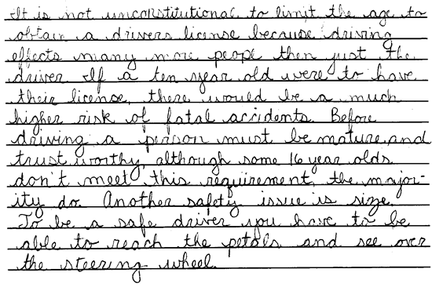

**Score 1:** This response accurately identifies the safety concern behind why there is an age limitation on driver licensure, but fails to address constitutionality. The student does not address the argument over whether the age limit on driver's licenses is unconstitutional, nor is the distinction between a right and a privilege addressed. The response reveals minimal understanding.

**Sample 312-4 #2 of 2**

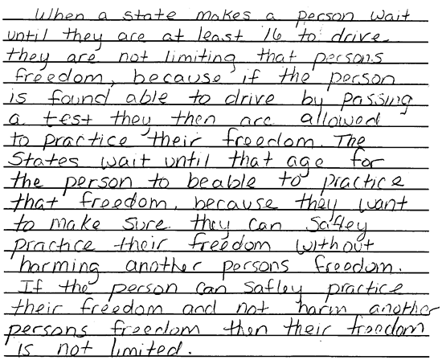

**Score 2:** This response demonstrates an understanding of the constitutionality of age limits on drivers. Although the student does not draw the distinction between a right and a privilege, the explanation provided is plausible, i.e., based on a conception of the public welfare relative to the youth driving age. The discussion of freedom relative to the issue of safety is generally complete and accurate. This is a "low" 2.

(Item#:312-05)

41. The Supreme Court has ruled government may not require any association to reveal its membership lists. Explain how this is an important limitation on the power of government and how it protects the freedom of the individual.

[Scoring Criteria](http://metacat2.com/cssap/sg/312-5sg.html)

**Module: 312  
Item: 5  
Descriptor: The Limits of Freedom**

**Scoring Criteria**

Scores are based on the student's ability to:

* Explain the importance of the limitation on government power to compel associations to reveal their membership lists.

A proficient response will demonstrate an understanding of how United States' citizens enjoy freedom of association. The explanation will be clear and accurate, demonstrating an understanding of how individual freedoms would be impacted in the absence of this important limitation on government power.

**Score Level Descriptions**

**NS** Not Scorable (blank, off-topic, hostile, etc.)

**1** A response at this level demonstrates minimal understanding of the importance of the limitation on government power to compel associations to reveal their membership lists. The response is largely inaccurate or incomplete. The explanation, if provided, is exceedingly vague or inaccurate. Logic and reasoning are very simplistic and/or seriously flawed. The response demonstrates minimal understanding.

**2** A response at this level demonstrates partial understanding of the importance of the limitation on government power to compel associations to reveal their membership lists. The student will provide a partially accurate response. The explanation is inadequately developed or incomplete. Evidence of rudimentary logic will be present, but it will contain flaws. The response demonstrates partial understanding.

**3** A response at this level demonstrates an adequate understanding of the importance of the limitation on government power to compel associations to reveal their membership lists. The explanation is generally complete and accurate, although minor errors may be present. The logic and reasoning employed are justified, but may contain minor flaws. The response is sufficient to demonstrate understanding.

**4** A response at this level demonstrates a superior understanding of the importance of the limitation on government power to compel associations to reveal their membership lists. The explanation is complete, detailed, thorough, and accurate, and may go beyond that which is required in the question. The logic and reasoning used are sophisticated. The response demonstrates superior understanding.

[Student Work](http://metacat2.com/cssap/sg/312-5ss.html)

**Sample 312-5 #1 of 4**

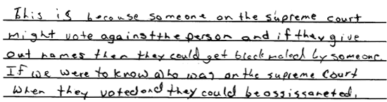

**Score 1:** This response exhibits exceedingly flawed logic regarding the Supreme Court, blackmail, and assassination as a result of being compelled to reveal membership in associations. The response is largely inaccurate and demonstrates minimal understanding.

**Sample 312-5 #2 of 4**

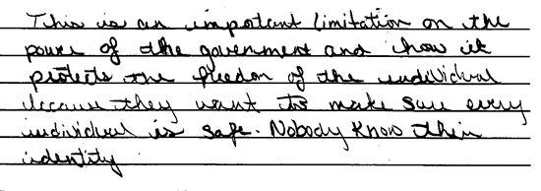

**Score 2:** This student demonstrates partial understanding of the importance of the limitation on government from compelling associations to reveal their membership lists. The response is inadequately developed regarding how individual freedoms would be impacted; simply addressing safety and anonymity reveals only partial understanding of the topic.

**Sample 312-5 #3 of 4**

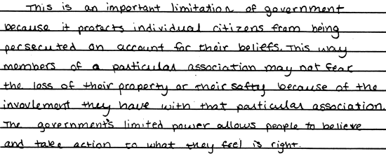

**Score 3:** This response adequately explains how individual freedoms might be impacted from being compelled to reveal membership listings. The explanation is clear, accurate, and generally complete. The response is sufficient to demonstrate understanding.

**Sample 312-5 #4 of 4**

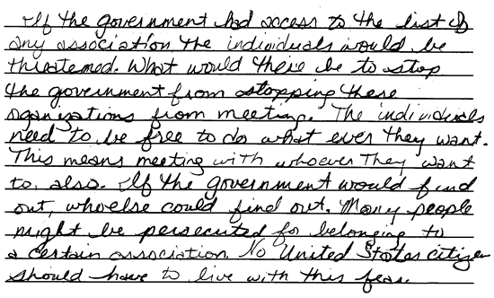

**Score 4:** This response clearly and accurately demonstrates an understanding of how individual freedoms would be impacted in the absence of protected membership lists. The detail and reasoning are sophisticated, demonstrating a superior understanding of the topic.

(Item#:314-06)

42. **Introduction**

While the Constitution guarantees certain individual rights, it also charges the courts with the responsibility of interpreting the extent of those rights. For example, Supreme Court Justice Oliver Wendell Holmes wrote in *Schneck v. U.S.* (1919) that no person had the right to yell 'Fire!' in a crowded theatre unless there was a fire. This decision is an example of a limitation placed on individual rights in the interest of preserving order and the welfare of the public.

Over the next few weeks, your task will be to choose one of the following cases pertaining to the extent of individual rights of students in schools. You will research the case and evaluate the enduring impact of the Court's decision on the lives of students in the United States.

**Instructions**

Choose one of the following cases:

* *West Virginia State Board of Education v. Barnette* (1943) 319 U.S. 1
* *Tinker v. Des Moines* (1969) 393 U.S. 503
* *New Jersey v. T.L.O.* (1985) 469 U.S. 325
* *Hazelwood School District v. Kuhlmeier* (1988) 484 U.S. 260

To complete this task you will have to do the following:

1. Identify the rights at issue in the case.
2. Present pertinent facts of the case and arguments on both sides.
3. Explain the Court's decision and its rationale for the decision.
4. Briefly explain the rationale behind the dissenting opinion.
5. Evaluate the lasting importance of the Court's ruling on the lives of students in the United States.
6. Be sure to use either footnotes or endnotes to cite all of your information.
7. Include a bibliography at the end of the paper.

[Scoring Criteria](http://metacat2.com/cssap/sg/314-6sg.html)

**Module: 314  
Item: Task  
Descriptor: The Rule of Law**

**Scoring Criteria**

Scores are based on the student's ability to:

* Explain a limitation to individual rights of students in schools with respect to one of the following court cases: *West Virginia Board of Education v. Barnette, Tinker v. Des Moines, New Jersey v. T.L.O, Hazelwood School District v. Kuhlmeier.*

A proficient response will demonstrate an understanding of the Supreme Court's limitation of individual rights to protect the general welfare. Responses will vary, but should:

* Identify the rights at issue in the case
* Provide pertinent facts of the case
* Provide the arguments for and against
* Explain the Court's decision and the rationale for it
* Briefly explain the dissenting opinion
* Evaluate the lasting importance of the ruling on the lives of US students
* Include footnotes
* Provide a bibliography

**Score Level Descriptions**

|  |  |
| --- | --- |
| **NS** | Not Scorable (blank, off-topic, hostile, etc.) |
| **1** | Performance at this level demonstrates minimal understanding of the Supreme Court's limitation of individual rights to protect the general welfare. The response is largely inaccurate or incomplete. The explanations, if provided, are exceedingly vague or inaccurate. Logic and reasoning are very simplistic and/or seriously flawed. The required presentation elements are seriously deficient. The response demonstrates minimal understanding. |
| **2** | Performance at this level demonstrates partial understanding of the Supreme Court's limitation of individual rights to protect the general welfare. The response is partially accurate. The explanations are inadequately developed or incomplete. Evidence of rudimentary logic is present, but it contains flaws. Some presentation elements are present. The response demonstrates partial understanding. |
| **3** | Performance at this level demonstrates an adequate understanding of the Supreme Court's limitation of individual rights to protect the general welfare. The explanations are generally complete and accurate, although minor errors may be present. The logic and reasoning employed are justified, but may contain minor flaws. The required presentation elements are generally present. The response is sufficient to demonstrate understanding. |
| **4** | Performance at this level demonstrates superior understanding of the Supreme Court's limitation of individual rights to protect the general welfare. The explanations are detailed, thorough and accurate. The logic and reasoning used are sophisticated. All required presentation elements are present. The response demonstrates superior understanding. |

[Student Work](http://metacat2.com/cssap/sg/pt314-sg.html)

**Item:**314-6, Sample #1 of 4

1.

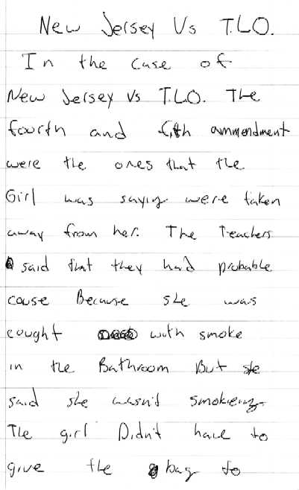

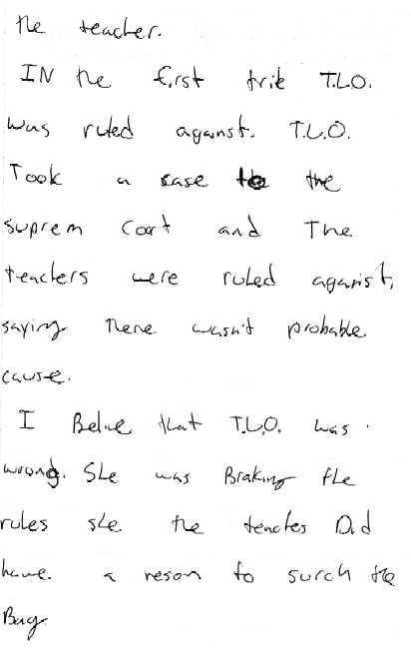

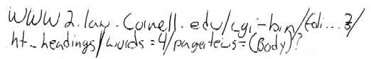

**Score:** 1   
**Score Justification:**   
This response demonstrates minimal understanding of the Supreme Court's limitation of individual rights to protect the general welfare. The student provides an exceedingly simplistic explanation of the case, and concludes with a subjective opinion devoid of serious analysis. No attempts to address the conceptual basis of the topic is made.

**Item:** 314-6, Sample #2 of 4

2.

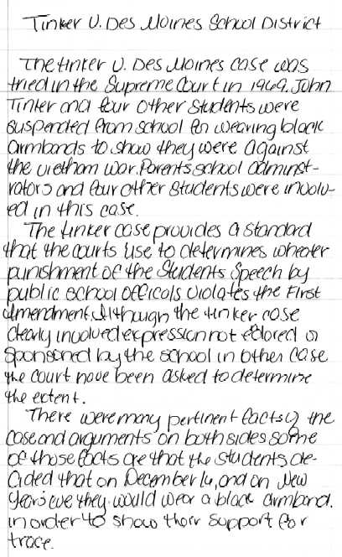

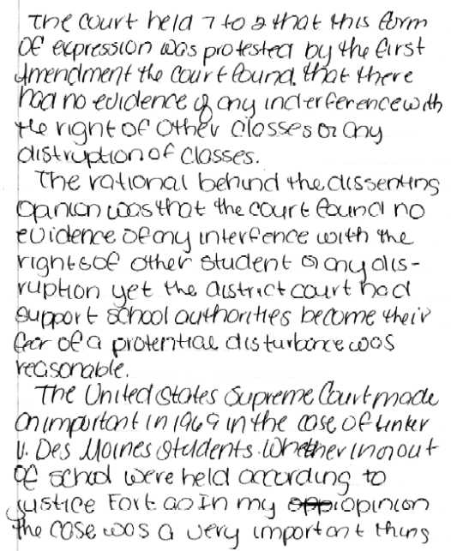

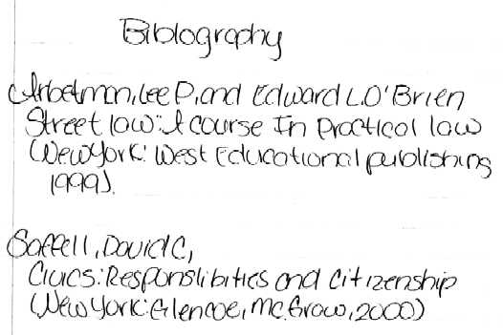

**Score:** 2  
**Score Justification:**   
This response demonstrates partial understanding of the Supreme Court's limitation of individual rights to protect the general welfare. This is a "low 2" response. The description of the Tinker case is poorly rendered and incomplete. Some points appear to be substantively "borrowed" from sources. The description of the Tinker case contains enough accuracy to demonstrate some understanding, but the conclusion is quite weak. The response demonstrates partial understanding.

**Item:** 314-6, Sample #3 of 4

3.

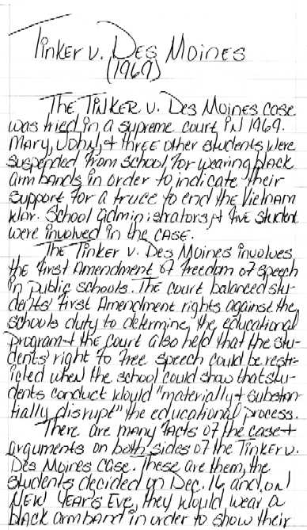

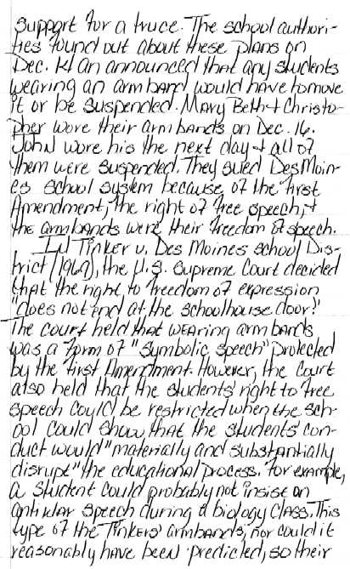

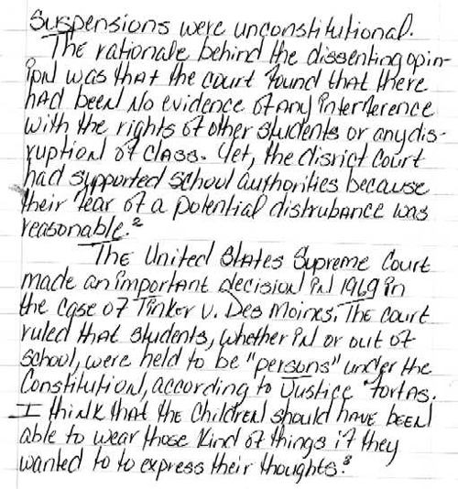

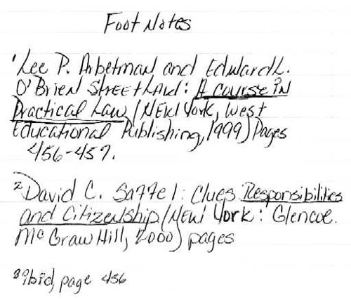

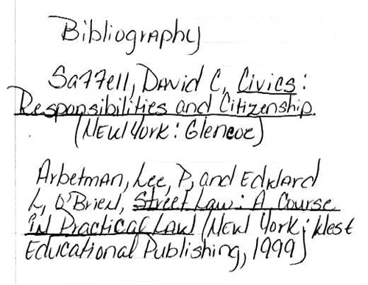

**Score:** 3  
**Score Justification:**   
This response demonstrates adequate understanding of the Supreme Court's limitation of individual rights to protect the general welfare. The description of the Tinker case is clear, but largely rendered from sources, albeit documented. The required presentation elements are present. The concluding analysis, although somewhat weak, addresses the essential meaning of the case.

**Item:** 314-6, Sample #4 of 4

4.

**New Jersey vs. T.L.O., 1985**

In the year of 1980, at Piscataway High School in Middlesex County, New Jersey, a teacher found T.L.O. and another girl smoking in the bathroom. Smoking is prohibited in the bathroom, so the girls were taken to the vice principle's office, where T.L.O. denied smoking in the bathroom and claimed that she did not smoke at all. T.L.O.'s companion confessed that she was smoking. The vice principle, Mr. Choplick, searched T.L.O.'s purse and found a pack of cigarettes. When Mr. Choplick took the cigarettes out he also found rolling paper which is usually used with marijuana. He proceeded to search her purse when he found small bags that were usually used for storing marijuana, a small portion of marijuana, an index card with a list of names that owed T.L.O. money, and two letters that discussed T.L.O.'s transactions with the marijuana. T.L.O. then confessed that she was a dealer of marijuana.

Because of the search of her purse, T.L.O. pleaded that her 4th and 14th amendments were violated. The 4th amendment protects us from unreasonable searches or seizures. The definition of unreasonable was dependent on the Supreme Court justices. The 14th amendment ensures us that not only the United States government, but also the State governments can not deprive us from life, liberty, or property without due process.

New Jersey argues that school officials act for the parents of students and like parents, they do not need a warrant to make searches or seize evidence. Also, school officials must have broad powers to control student conduct, including the powers of search and seizure. Another argument that New Jersey presented was that T.L.O.' s behavior furnished a reasonable basis for the search of her purse; therefore, the exclusionary rule does not apply.1 New Jersey also reported that since a teacher told Mr. Choplick that T.L.O. was smoking in the bathroom, that is reasonable enough information to search T.L.O.'s purse for cigarettes, since her purse would be the most logical place to keep the cigarettes.

T.L.O. argues or rather her lawyers, that public school officials are employees of the State, not representatives of parents; they have no right to act as parents. Also, school officials are public employees and so are obligated to respect every student's rights, including hid of her right to privacy. Furthermore, the search of T.L.O. 's purse and the seizure of its contents were unreasonable acts, and they led to her confession; therefore, the exclusionary rule does apply.2 T.L.O. adds that an issue of a warrant would have been necessary and appropriate to conduct a search such as this.

1William A. McClenaghan, Magruder's American Government (Prentice Hall, Simon and Schuster Education Group, 1997) p.467.  
2William A. McClenaghan, Magruder's American Government (Prentice Hall, Simon and Schuster Education Group, 1997) p.467.

The Supreme Court ruled 6-3 in favor of New Jersey. The Court decided that "the rights of children and adolescents are not the same as those of adults, and that school officials have a responsibility to maintain the discipline necessary for education."3 Justice Byron White wrote the Court's opinion in which he noted, "the school setting requires some modification of the level of suspicion of illicit activity needed to justify a search. The rights of a student must be balanced against the needs of a school setting."4

The Court reported that the fourth amendment did apply to searches carried out by school officials, but it held that "a school official may properly conduct a search of a student's person if the official has a reasonable suspicion that a crime has been or is in the process of being committed, or reasonable case to believe that the search is necessary to maintain school discipline or enforce school policies." (Id., at 341, 238 A. 2d, at l333)5 "With respect to the question of the legality of the search before it, the court agreed with the Juvenile Court that a warrantless search by a school official does not violate the Fourth Amendment so long as the official 'has reasonable grounds to believe that a student possesses evidence of illegal activity or activity that would interfere with school discipline and order.' (Id., at 341,463 A. 2d, at 941-942.)6

Justice Byron White stated in the Court's opinion that, "a school official may properly conduct a search of a student's person if the official has a suspicion that a crime has been committed, or reasonable cause to believe that the search is necessary to maintain school discipline."7 "In his partial dissent, Justice William Brennan wrote that, decision sanctions school officials to conduct full-scale searches on a 'reasonableness' standard whose only definite content is that it is not the same test as the 'probable cause' standard found in the test of the Fourth Amendment."8 In other words, Justice Byron White decided that the reason for Mr. Choplick was reasonable enough for him to search T.L.O.'s purse. Justice William Brennan said that the school has a right to search people for probable cause and this probable cause is not violating the Fourth Amendment.

3William A. McClenaghan, Magruder's American Government (Prentice Hall, Simon and Schuster Education Group, 1997) p.767.  
4William A. McClenghan, Magruder's Amencan Government (Prentice Hall, Simon and Schuster Education Group, 1997) p.767.  
5Find Law United States Case Law Supreme Court "New Jersey vs. T.L.O.. 469 U.S. 325 (1985)" wysiwyg://20/http://caselaw.findla…case.pl?court=US&vol=469&invol=325 (Nov.19, 1999)  
6Find Law United States Case Law Supreme Court "New Jersey vs. T.L.O.. 469 U.S. 325 (1985)" wysiwyg//20/http://caselaw.findla…case.pl?court=US&vol=469&invol=325 (Nov. 19,1999)  
7William A. McClenghan, Magruder's American Government (Prentice Hall, Simon and Schuster Education Group, 1997) p.767.

The Supreme Court wrote, "the incident that gave rise to this case actually involved two separate searches, with the first- the search for cigarettes- providing the suspicions that gave rise to the second- [469 U.S. 325,344] the search for marijuana. Although it is the fruits of the second search that are at the issue here, the validity of the search for marijuana must depend on the reasonableness of the initial search for the cigarettes, as there would have been no reason to suspect that T.L.O. possessed marijuana had the first search not taken place. Further review led the Supreme Court to conclude that the search was in no sense unreasonable for Fourth Amendment purposes."9

This case's ruling has restated the school's ability to search student' lockers, backpacks, purses, and other personal belongings. It proves that the Fourth Amendment was not violated but the school officials at the high school by searching T.L.O. 's purse. This will make it harder for students to declare that their constitutional rights were reason for them and the officials will overlook that because of this case's ruling.

In conclusion, the Fourth Amendment is not violated unless there is not a probable cause for the search. Mr. Choplick had a reasonable purpose to search T.L.O.'s purse for cigarettes; it was what was found after the cigarettes that was questionable. Therefore, the search of T.L.O.'s purse was within the rights of the vice principle, Mr. Choplick.

8William A. McClenghan, Magruder's American Government (Prentice Hall, Simon and Schuster Education Group, 1997) p.767.  
9Find Law United States Case Law Supreme Court "New Jersey vs. T.L.O.. 469 U.S. 325 (1985)" wysiwyg://20/http://caselaw.findla...case.pl?court=US&vol=469&invol=325 (Nov. 19,1999)

**Work Cited Page**

1. McCleghan, William A. Magruder's American Government. Needham, Massachusetts: Prentice Hall, 1997.

2. FindLaw: United States Case Law: Supreme Court. "New Jersey vs. T.L.O., 469 at U.S. 325 (1985).  
Wysiwyg://20/http://caselaw.flndla... case.pl?court=US&vol=469&invol=325

**Score:** 4  
**Score Justification:**   
This response demonstrates superior understanding of the Supreme Court's limitation of individual rights to protect the general welfare. The response is detailed and thorough, for the most part. All required presentation elements are present. The student does an excellent job of utilizing footnotes and citing sources. The conclusion falls somewhat short of a thorough analysis, but the overall sophisticated treatment of the topic demonstrates superior understanding.

(Item#:316-06)

43. **Introduction**

On January 16, 1991, the United States, in concert with a coalition of Pan-Arab, British, and French forces, responded with military action against Iraq's movement into Kuwait. Code-named 'Desert Storm,' this action was endorsed by the United Nations. However, U.S. participation was still subject to Congressional approval.

Over the next few weeks, you will be responsible for preparing a research paper identifying the national security interests underlying U.S. action in Desert Storm and the U.S. political process leading up to that action.

**Instructions**

In order to complete this task, you must do the following:

1. Consult sources from the period 1990-91 to identify the purported economic and political interests that provided a rationale for U.S. action in Desert Storm.
2. Identify and explain the relevant constitutional provisions (Article, Section) that address the role of the executive and legislative branches of government relative to military affairs.
3. Describe how those provisions of the Constitution were enacted in the political process leading up to U.S. participation in Desert Storm.
4. Explain how the example of the political process leading up to Desert Storm reflects the Constitution as a 'living' document, i.e., how the Constitution 'worked,' in practice.

Your paper should address each of the points above. Use footnotes and provide a bibliography to identify the sources you used in your research.

[Scoring Criteria](http://metacat2.com/cssap/sg/316-6sg.html)

**Module: 316  
Item: Task  
Descriptor: Desert Storm: A Case Study in United States Intervention**

**Scoring Criteria**

Scores are based on the student's ability to:

* Explain the national security interests underlying the US action in Desert Storm and the US political process leading up to that action.

A proficient response will demonstrate an understanding of the national security interests underlying the US action in Desert Storm and the US political process leading to it. Responses will vary, but should include the following elements:

* Identification the economic and political interests that provided a rationale for US action
* Identification and explanation of the relevant Constitutional provisions that address the roles of the executive and legislative branches relative to military affairs
* Description of how those provisions were enacted leading up to the US participation in Desert Storm
* Explanation of how the political process leading up to Desert Storm reflects the Constitution as a "living" or "working" document
* Footnotes
* Bibliography

**Score Level Descriptions**

|  |  |
| --- | --- |
| **NS** | Not Scorable (blank, off-topic, hostile, etc.) |
| **1** | Performance at this level demonstrates minimal understanding of the national security interests underlying the US action in Desert Storm and the US political process leading to it. The response is largely inaccurate or incomplete. The explanations, if provided, are exceedingly vague or inaccurate. Logic and reasoning are very simplistic and/or seriously flawed. The required presentation elements are seriously deficient. The response typically exhibits minimal development. |
| **2** | Performance at this level demonstrates partial understanding of the national security interests underlying the US action in Desert Storm and the US political process leading to it. The response is partially accurate. The explanations are inadequately developed or incomplete. Evidence of rudimentary logic is present, but it contains flaws. Some presentation elements are present. The response demonstrates partial understanding. |
| **3** | Performance at this level demonstrates an adequate understanding of the national security interests underlying the US action in Desert Storm and the US political process leading to it. The explanations are generally complete and accurate, although minor errors may be present. The logic and reasoning employed are justified, but may contain minor flaws. The required presentation elements are generally present. The response is sufficient to demonstrate understanding. |
| **4** | Performance at this level demonstrates superior understanding of the national security interests underlying the US action in Desert Storm and the US political process leading to it. The explanations are detailed, thorough and accurate. The logic and reasoning used are sophisticated. All required presentation elements are present. The response demonstrates superior understanding. |

[Student Work](http://metacat2.com/cssap/sg/pt316-sg.html)

**Item:**316-6, Sample #1 of 4

1.

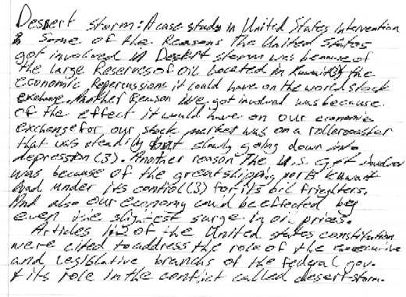

**Score:** 1   
**Score Justification:**   
This response demonstrates minimal understanding of the national security interests underlying the US action in Desert Storm and the US political process leading to it. The response is largely incomplete, and required presentation elements are seriously deficient. The student provides a brief explanation of some of the economic interests underlying US action, but the event in relation to the political process as embodies in the Constitution is essentially ignored. The student demonstrates little or no understanding of how the Constitution functioned as a "living" document during Desert Storm.

**Item:** 316-6, Sample #2 of 4

2.

**Desert Storm: A Case Study in United States Intervention**

George Bush involved the United States in Desert Storm for some various economic and political reasons. The U.S. became involved due to economic reasons that would suit them. The world stack and currency market gyrated nervously in response to the news of Iraq's invasion. Even a slight surge in prices could nudge America's sluggish economy into Recession.1 Congressional sources predicted that the flap will damage efforts to secure support increased arms sales to Saudi Arabi.2 A political reason why the U.S. entered the war was because many people believed that Bush administration was not committed to its predecessors toward upholding the traditional relationship between the United States and Israel. In the best interest of the Bush administration to keep his republicans from loosing the nations support felt pressure to enter the Persian Gulf War.

The roles of the executive and the legislative branches according to the constitutional provisions are in Article 1 Section 8 and Article 2 Section 2. In Article 1 Section 8 the legislative branch is given the power to war. The article and section gives only congress the power to declare war with a letter of marquee. A letter of marquee is a formal document of war. In Article 2 Section 2 the rights of the executive branch is given. The president can declare war without a formal letter marquee. He is also the Commander and Chief of the army and Navy.

The above provisions were in acted into the leading up to Desert Storm were that the president exercised his constitutional right to enter Desert Storm. According to article 2 Section 2 the president of the United States may declare war if he feels the need. Congress felt that it was not important at that time to enter the war. Even though many members were ready for the declaration of war none would declare it, because the voting poll on it was more in favor of not entering war.

The constitution as a living document lived in practice during the decision to enter Desert Storm. How? Well the Commander and Chief (president)George Bush declared war on Saddam Hussein using His constitutional right in Article 2 Section 2.

1. William Dowell. (1990). Iraq's Power Grab. *Time.* Side Bar 2. 16  
2. C.J. Doherty. (1991). Don't Intervene in Gulf Crisis, Baker Tells Committee. *EBSCOhost*. 29. 4

**Works Cited**

1. Beyer, Lisa (August 13, 1990). Cover Story: "Iraq's Power Grab". TIME. 16-20

2. Talbott, Strobe (August 13, 1990). America Abroad: "The Deterrence Vacuum".  
TIME. 24

3. Walsh, Kenneth T. (March 4, 1991). Bush's Toughening Views: "Evolution of the hard line". U.S.News and World Report. 30

4. (December 28, 1991). government policy in the U.S.: "Economy, Events Overseas Drive '91 Confrontations". Congressional Quarterly Weekly Report. 3764

**Score:** 2  
**Score Justification:**   
This response demonstrates partial understanding of the national security interests underlying the US action in Desert Storm and the US political process leading to it. The explanations are somewhat accurate but incomplete, however the student does manage to make the essential distinctions in the constitutional powers vested in the legislative and executive branches relative to the declaration of war. The treatment of the Constitution as a "living" document is exceedingly brief, largely ignoring that important question.

**Item:** 316-6, Sample #3 of 4

3.

Desert Storm: A Case Study in United States Intervention

On January 16, 1991, the United States, in alliance with Pan-Arab, British, and French forces, rose in opposition to the Iraqis invasion of Kuwait. The United Nations endorsed this action, code-named "Desert Storm." The United States, under President George Bush, realized that an Iraqi takeover would greatly affect its economy. American economists became nervous with prospects of an Iraqi monopolization of the world's oil industry. Iraq would control roughly 44% of the worlds oil reserves if it succeeded in over taking Kuwait, which supplied the U.S. with much of its imported oil (1). With all their newly acquired control, Iraq would have the power to raise the prices of oil. Even a slight surge in prices could nudge America's sluggish economy into recession (1).

There were also several political reasons for United States involvement in Desert Storm. The United States has struggled since about the 1950's to improve the political status in middle-eastern countries (2). Regulating Saddam Hussein, and therefore Iraqi power, has been the self-appointed duty of the United States. This has been the cause of a deep-rooted dislike between the two countries. Public opinion may also have swayed the outcome of the political process leading to U.S. participation. Americans in general don't approve when a larger, stronger country, like Iraq, attempts to engulf smaller, weaker countries, like Kuwait. As a strong and militarily sound country, the U.S. has felt obligated to help these countries in need.

The United States Constitution expressly delegates powers regarding military affairs to both the Executive and Legislative branches of government. In Article 2, section 2, clause 1, the duties of the Executive branch:

"The President shall be Commander in Chief of the army and navy of the United States, and of the militia of the several States, when called in to the actual service of the United States"

President George Bush exercised this power through executive action on August 6, 1991, when he ordered American troops to protect Saudi Arabia from the advancing Iraqi forces (3). However, only Congress has the power to declare war - Article 1, section 8) clause 11 - and approval or disapproval of Bush's actions was needed. Congress is also given the power to raise and support armies, to provide and maintain a navy, to provide for organizing, arming, and disciplining the militia, and many other powers concerning military affairs in Article 1, section 8, clauses 12-16 of the Constitution. So it was that on January 12, 1992, Congress approved a resolution (HJRes77) authorizing President Bush to use military force to reverse Iraqis occupation of Kuwait (4). Four days later, Bush ordered the aerial bombardment of Iraq. On February 27, 1992, after six weeks of devastating air strikes and a brief ground campaign, Bush announced: "Our military objectives are met." Kuwait was liberated and Iraq had been defeated, Bush said (4). So, the basic political process was this, Bush ordered the troops in, the Senate later approved a war resolution, the House voted for HJRes77, an identical resolution that authorized the president to use military force in accordance with U.N. Security Council Resolution 678. The U.N. resolution, approved November 1990, had authorized member states "to use all necessary means" to force Iraq out of Kuwait by January 15 of the following year (4). The Constitution is reflected as a living document through the political process that led up to U.S. participation in Desert Storm. One of the main ways the Constitution proved its ability to work in practice is the allowance it provides for executive action to be taken before war is actually declared. This allowed the United States to take an early stand, and let its power be known without waiting for the sometimes tedious and lengthy process of legislation. The president's ability to act on behalf of the nation before Congress declares war may have greatly benefited in the downfall of Hussein, and Iraqi power.

**Works Cited**

1. Beyer, Lisa (August 13, 1990). Cover Story: "Iraq's Power Grab". TIME. 16-20

2. Talbott, Strobe (August 13, 1990). America Abroad: "The Deterrence Vacuum". TIME. 24

3. Walsh, Kenneth T. (March 4, 1991). Bush's Toughening Views: "Evolution of the hard line". U.S.News and World Report. 30

4. (December 28, 1991). government policy in the U.S.: "Economy, Events Overseas Drive '91 Confrontations". Congressional Quarterly Weekly Report. 3764

**Score:** 3  
**Score Justification:**   
This response demonstrates adequate understanding of the national security interests underlying the US action in Desert Storm and the US political process leading to it. The response is generally complete and accurate, although the explanation of the political reasons underlying US action in the Gulf is somewhat underdeveloped. However, the student does address an important point in the conclusion regarding the Constitution as a living document and the political process that was reflected in the events surrounding the Gulf War.

**Item:** 316-6, Sample #4 of 4

4.

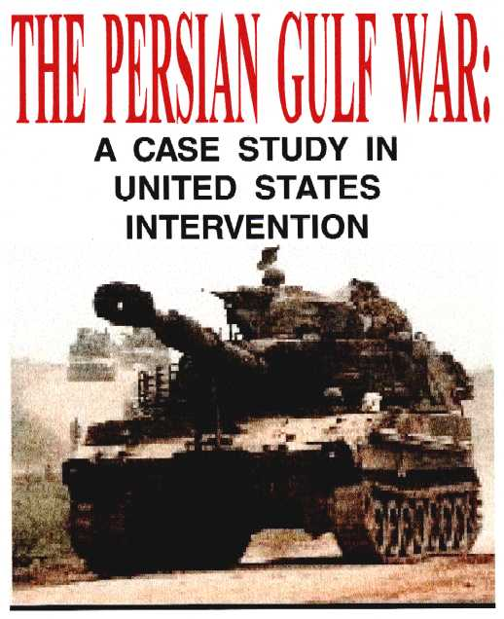

**THE PERSIAN GULF WAR: A CASE STUDY IN  
UNITED STATES INTERVENTION**

The Persian Gulf War was fought with a passionate fervor to cease the endless terror Iraqi President Saddam Hussein had imposed upon the powerless country of Kuwait and the rest of the sovereign world in his attempt at sole domination of the Middle East. The United States had assumed the role of mediator in the beginning to avoid a gruesome conflict with Iraq, but in order to protect substantial assets in the Persian Gulf the United States eventually had to resort to alternative means of force and intimidation. The desire to end the War along with Hussein's tyrannical rule in the Middle East in a quick and effective manner was apparent as the United State's military effort forced Iraqi troops to withdraw from Kuwait. The rationale behind the United State's involvement in the Persian Gulf War had much to do with economic and political reasons concerning substantial oil investments in Saudi Arabia, preventing Saddam Hussein from gaining control of the ample oil supply within the various countries of the Middle East, and terminating any likelihood or probability of having history repeat itself with Saddam Hussein reenacting Hitler's quest to conquer the world. Former President Franklin D. Roosevelt stated via national broadcast to the American public during the elementary stages of World War II that, "We must admit that there is a risk in any course we take. But backing America's natural ally involves the least risk now and the greatest hope for world peace in the future." President George Bush had the same intentions of achieving world peace when he sent United States troops into the Middle East.

Saddam Hussein's hostile takeover of the small, but extremely wealthy country of Kuwait posed as a serious threat to the welfare of worldwide oil interests in Kuwait and the Persian Gulf. Kuwait, an easy target for the watchful and trained eyes of Saddam Hussein, contained enormous oil reserves, an excellent port system on the Persian Gulf for commerce, and many viable liquid assets." To Saddam, the little oil-rich country of Kuwait would prove to be an enormous profit if obtained. Moreover, Kuwait was entirely incapable of defending itself against Iraq's dexterous war machines, and was consequently for Saddam's taking. By acquiring Kuwait, Saddam doubled the oil under his control to 20% of the world's known reserves; only Saudi Arabia with 25% had more." The Iraqi President's sudden incorporation of Kuwait aroused concern and anxiety in Washington DC due to conclusions being drawn that Hussein was going to move into nearby Saudi Arabia to control the region's oil supplies. The United States dependency on Saudi Arabia for a tremendous amount of oil, for Saudi Arabia is the source of 15% of the United State's oil supply, makes it the largest overseas supplier, and therefore the most vulnerable to potential attack by Hussein's troops.

"There's great nervousness in the whole region because it would be a direct threat to the security of this country" if Saudi Arabia were invaded, stated Senate Intelligence Committee Chairman David Boren.1 The United State's dependence on oil from the dynamic Persian Gulf has grown substantially over recent years as American production has gradually come to a decline. Dependency on the Gulf countries for oil has become so drastic that the United States now imports one-half of all its oil supplies from abroad.' The United State's impending state of vulnerability in regards to Saddam closing in on Saudi Arabia led President Bush to dispatch American forces to Saudi Arabia to take up a defensive position in order to deter further aggression by Iraq.2 Furthermore, President Bush has been pushing for a United Nations trade embargo against Iraq to induce some economic discomfort for the power hungry country.2 Key oil pipelines had already been shut down as the demand for Iraqi oil plummeted around the world since the territorial invasion. President Bush, in his hopes to increase the production of oil in other countries to alleviate some of the impact of the Iraqi embargo, was also willing to tap into U.S. reserve supplies if deemed necessary.2 President Bush further endorsed his actions to protect U.S. oil interests in Saudi Arabia by maintaining that, "The sovereign independence of Saudi Arabia is of vital interest to the United States. America will stand by her friends."2

The U.S. strategy to send troops into Saudi Arabia to deter any contingency of Iraqi invasion and to expand an economic embargo of Iraqi oil by the U.S. and other nations in an effort to convince Saddam to withdraw from Kuwait, wasn't without any support from Congress and local oil companies. Members of Congress were willing to offer their unconditional and immediate support to the President to send troops into a potential combat situation.2 U.S. oil companies also supported the President by increasing exploration budgets and incorporating new drilling and exploration techniques to bring about the discovery of regional oil.3 But the country was still hesitant about the increase in oil prices brought about by the Persian Gulf crisis and the impending economic oil shock.8 If Saddam was permitted further advancement into Saudi Arabia and control of its oil reserves, the United States would only be able to watch helplessly as Hussein became the imperial leader of the majority of the world's oil supply. To prevent such a calamity from taking place, the United States sent troops into Saudi Arabia to protect the sovereign world's oil interests.

Saddam Hussein's encroachment upon the country of Kuwait not only posed as a threat to nearby opulent Saudi Arabia, but also to the entire oil-rich Middle East. House Armed Services Chairman Les Aspin scrupulously stated, "Essentially the fight is to really prevent one rather demented soul, this fellow Saddam Hussein, from gaining control over the bulk of the world's oil reserves."2 In order to prevent Hussein and his oppressive military from gaining control of the extensive oil supply in the Middle East, the world's powers had to act as one in order to ensure global sovereignty.

As noted from past experience in 1973, when the Middle East had previously erupted in war, petroleum prices soared, energy shortages developed, inflation mounted, and the world's economies sank into recession.6 But in the occurrence of a true oil crisis, the industrialized nations are far better prepared than they were in the 1970s. Consequently, the contracting of the oil market could still cause an increase in prices which would send a damaging ripple effect through the world's economies. Since then, the dependency on Middle Eastern oil has decreased somewhat, but not significantly enough. As a result, the entire world's economy suffers from instability in the Middle East. 6 Saddam's surge on the Middle East is an unexpected test on whether nations around the world will pay the necessary price to assure peace and stability in the new global climate."

Saddam Hussein's desire for power and control in the Organization for Petroleum Exporting Countries (OPEC) and in the Middle East was the principal cause of the invasion of Kuwait. Hussein's bitterest complaint against Kuwait had been that the gulf state had been grossly overproducing oil in violation of OPEC quotas, and had therefore depressed the average price of an OPEC barrel to nearly $7. Iraq, which relies heavily on oil for 95% of it export revenues claimed that every $1 drop in the price of a barrel of oil cost the country $1 billion a year. Saddam took this decrease in price personally, for as he saw it, Kuwait might as well have been stealing from Iraq's treasury. Saddam also wanted to settle a quarrel over the rich Rumaila oil fields, a finger-shaped deposit whose tip reaches just into boundary territory claimed by both Iraq and Kuwait, with Kuwait.4 Finally, to satisfy his need for territorial oil domination, Saddam took Kuwait by military force.

By gaining control of Kuwait, Suddam could compensate for his disadvantages as an oil exporter. Essentially landlocked, for Iraq only has 18 miles of shoreline most of which is blocked by Kuwait's Bubiyan Island, Iraq now controlled Kuwait's rich expanse of ports on the Persian Gulf Saddam also pocketed the profits of Kuwait's oil wells and also managed to manipulate the production levels of Kuwait's oil to ensure a high price for himself No country that shared a border with Iraq could rest comfortably because it was highly likely that Saddam had the military force to seize more territory in the Gulf and move into Jordan, Syria, and even Israel as well. Even if Saddam were only to seize Saudi Arabia, he would still control more than 44% of the world's proven oil reserves and be infringing upon many nation's "vital interests." Therefore, global support must be congregated to halt a regional war.4

With this in mind, the two global superpowers, the United States and the Soviet Union, called upon all nations to join in an arms embargo against Iraq. The U.S. froze Iraqi assets and imposed a boycott on Iraqi oil. The European Community also adopted those measures by banning arms sales to Baghdad and adding on a boycott of Kuwaiti oil. The U.S. and European countries also proceeded to freeze Kuwaiti assets to keep the Iraqis from getting them. Japan also followed suit.4 History has unfortunately shown that when sanctions are insinuated and put into effect, someone usually cheats. Oil is especially easy to sneak through secret channels. Therefore, the United States officials thought that keeping Iraqi oil contained within its wells would be more effective. By cutting off the three outlets through which Iraq exports it crude, two pipelines through Saudi Arabia, another leading to Turkeys, and ships in the Persian Gulf, the U.S. and many experts were confident that Iraq would collapse under such pressure in a few months or a year. Hence, giving up its quest of territorial domination of the Middle East. Unless all the sovereign countries could unite, by putting their political differences to one side in order to stand up to Iraq, history threatened to repeat itself.8

As Saddam Hussein's quest at the domination of the Middle East became evident, comparisons of Saddam Hussein and Adolf Hitler grew. In many ways, Hussein was much like Hitler--a man hungry for power and regional domination. Both men had viewed themselves as indestructible and omnipotent, thinking that nobody would dare to cross their paths for fear of the resulting consequences. This overconfident and impudent line of thinking lead to the demise of Hitler in World War II and the triumphant military victory of the United States and her allies in the Persian Gulf War. But for a fleeting moment, as Hussein began to conquer the Middle East, the rest of the world was reminded of the destructive path Hitler wove when conquering Europe about 60 decades ago. In order to prevent history from repeating itself, the world had to take action against Saddam Hussein.

Saddam Hussein, by no means a crazy man, is a man willing to do almost everything in his power to get what he wants-and what he covets the most is the domination of the Middle East just as Nebuchadnezzar once had. Human life bears no value to Saddam Hussein.5 As one diplomat stated, "He does what he thinks is expedient. He is not driven by ideology or whim. He coldly calculates every move. He is simply brutal and a very clever pragmatist." *TIME* correspondent Dan Goodgame adds, "His are the eyes of a killer."5

Hussein has always desired and in recent years strengthened his claim to the position of overlord of the Arab world. He has also succeeded in making the rest of the world quake, weak-kneed, at his raw power."4 Saddam had enough audacity and nerve to provoke the first major military conflict of the post-cold war era, bringing to question in the minds of many-will he stop at nothing to get what he wants? Saddam also posses a threat to many nation's oil interests in the Middle East and also forces other countries to evaluate if they really want to let the Saddams of the world shape the new global power structure."4

Iraq's land grab drew inevitable comparisons with the 1930s, when Hitler began to devour Europe in pieces small enough not to provoke a military response by the other global powers. Fear instantly grew among the nations that Iraq, having taken Kuwait would turn next to other vulnerable Gulf nations-especially Saudi Arabia, the wealthiest of all the Middle Eastern countries. The extent to which the NATO countries, the Soviet Union, and the threatened Arab states moved to block Saddam would determine whether they had learned the lesson of history or were cursed to repeat it.4

Saddam, much like Hitler at the apex of his power in the 1930s, is not easily intimidated, and is convinced that no nation has the audacity to take him on. But unlike Hitler, Saddam also has chemical technology on his side. Already one of the world's largest producers of chemical weapons, Saddam has shown a willingness to use them to subdue his external enemies and to intimidate and overpower his own fellow countrymen.4 A man willing to go those lengths for regional and possibly global domination is not one to be taken lightly but rather to be taken in with close attention and alertness. In order to prevent history from repeating its dark past, the United States and its allies must learn from past mistakes and apply them to recent times. Otherwise Saddam Hussein may succeed in doing what Adolf Hitler so narrowly failed to do.

The triumph of the United States military victory in the Persian Gulf War allowed for sovereign countries to assess the effect one man had on the rest of the free world. Saddam Hussein had posed a threat to the economy and stability of many nations around the world by threatening considerable oil investments throughout the Middle East-especially in the oil affluent country of Saudi Arabia. Saddam's attempt at conquest and domination of the Middle East also lead to the reevaluation of the sovereign communities' ideology of whether one man should be able to control all the oil within the Persian Gulf, and what means should be taken to stop him. And most significantly off all, were the nations of the free world willing to reenact history by allowing Saddam Hussein to become the next power-hungry Adolf Hitler, set on world domination? The Persian Gulf War and United States intervention in the political affairs of the Middle East enabled the world not to make the mistake of allowing history to repeat its dark and desolate past.

United States intervention in the Persian Gulf War and political interference in the affairs of the Middle East were not decisions made solely by President George Bush. The President, under the direct ordinance of the Constitution, the living democratic document of the people of the United States, was required to have Congressional support and approval for the role of the U.S. in the Persian Gulf War. Article I and Article II, dealing with the Legislative and Executive Departments, respectively, of the Constitution of the United States address the role of the latter branches of government in regards to military affairs. The Persian Gulf War served as a prime example to ensure the relevance and applicable importance of the Constitution as a "living" document, for it reflected upon the core morals of the United States government as a democracy.

The Constitution of the United States was designed to ensure justice and peace, a defense against foreign enemies, and the general well-being of the people of this great country. As part of the governmental system to guarantee equality throughout the three branches of government, each branch was given specific powers that would assist in keeping the other two under specific checks and balances. The legislative powers were vested in Congress, the lawmaking, bicameral body of the U.S. Under the Constitution, Article I, Section 8, Clauses 11, 12, 13, 14, 15, and 16, respectively, Congress was given the power to declare war, grant letters of marque and reprisal, and make rules concerning captures on land and water; to raise and support armies; to provide and maintain a navy; to make rules for the government and regulation of the land and naval forces; to provide for calling forth the militia to execute the laws of the Union, suppress insurrections, and repel invasions; and to provide for organizing, arming, and disciplining the militia. Therefore, the Constitution only gives Congress the authorization to declare war.7

Although only Congress has the right to declare war, the President, as commander in chief of the armed forces can make war without a formal declaration because Congress has given the President the power to call on any or all units into federal service when deemed necessary. Article II, Section 2, Clauses 1 and 2, state the President's powers and duties within the Executive Department. Derived from the latter, the President, a civilian, shall be the Commander in Chief of the army and navy of the United States, and of the militia of several States. The President shall also have the power, with advice and consent from the Senate, to make treaties, provided that two-thirds of the Senators present approval of the treaty. In essence, the President can also make executive agreements with foreign governments on routine matters without the consent of the Senate. The Constitutional requirement of the cooperation between the Legislative and Executive branches thereby proves the role the Constitution plays in affairs concerning military involvement.7

The latter provisions of the Constitution were specifically enacted by Congress and President Bush in the political process leading to the United States' involvement in the Persian Gulf War. As Commander in Chief of the armed forces, President Bush had presumed it necessary for American troops to protect Saudi Arabia from Saddam Hussein's imposing army at the Saudis' request. He also created an international coalition to secure Kuwait's liberation by imposing an economic embargo upon Iraq. By powers received from Article II of the Constitution, President Bush also authorized American ships to fire upon ships suspected of breaking the existent embargo. The President also took command of his military powers by leashing 230,000 American troops to Saudi Arabia to put the U.S. in a strong defensive position against Iraq in August of 1990, and then deployed an additional 200,000 troops to prepare for an offensive operation against Iraq's impending buildup of troops in November. When a deadline of January 15, 1991, was given to Saddam Hussein for the withdrawal of Iraqi troops from Kuwait, and disregarded by the tyrannical leader, Congress supported President Bush's plea for war by confirming his position in both chambers. With Congressional approval and UN support, the President launched a massive air campaign against Iraqi military targets code-named Operation Desert Storm on January 16, 1991. On April 11, 1991, the UN Security Council officially declared an end to the Persian Gulf War, and the triumphant military victory of the United States and the international coalition against Saddam Hussein.10

The political process enacted through the Persian Gulf War reflects that the Constitution is a "living" and "working" document. The President of the United States and Congress had worked in collaboration on the termination of Saddam Hussein's attempt at Middle East domination by implementing the powers given to each by the Constitution, and by not abusing those given powers in order to secure a victory in the Persian Gulf The right given to the President to recognize a state of war, including the infringement of political and economical interests by other foreign powers, and acting upon it with the deployment of American troops to the specified area was done with the consent of Congress. Therefore proving that the Constitution is very much in effect, for it keeps each branch of government in its rightful place, and is still the document that ensures the rights of the people will not be trampled upon or violated.

The Persian Gulf War has been an invaluable lesson in reference to United States intervention. From the Persian Gulf crisis and Saddam Hussein's attempt at regional domination. the people of the United States have seen that the Constitution is indeed a vital contract between the people and the government in ensuring that basic human rights are not taken for granted. The Persian Gulf War also allowed the world to remain free and independent from the imperial and harsh rule of Iraqi leader Saddam Hussein. For without United States intervention, the great hope for world peace would be nonexistent.

ENDNOTES

1. Associated Press. (3 Aug. 1990). "Officials Worry Iraq May Aim Next at Saudi Arabia." The Rhinelander Daily News: 2.

2. Associated Press. (8 Aug. 1990). "Bush Dispatches Forces to Saudi Arabia." The Rhinelander Daily News: 2.

3. Associated Press. (8 Aug. 1990). "Iraq Invasion Could be Boom to U.S. Oil Industry." The Rhinelander Daily News: 2.

4. Beyer, Lisa. (13 Aug. 1990). "Iraq's Power Grab." Time: 16-20.

5. Friedrich, Otto. (13 Aug. 1990). "Master of His Universe." Time: 23-24

6. Hillenbrand, Barry. (13 Aug. 1990). "For the Moment, the Shock is Limited." Time: 22.

7. McClenaghan, William A. (1995). Magruder's American Government: 726-733.

8. Nelan, Bruce W. (13 Aug. 1990). "Can the U.S. Turn off Iraq's Oil?" Time: 21-22.

9. Schauer, Susan. (3 Aug. 1990). "Roth Fears Iraq's Invasion of Kuwait May Hurt Gas Price." The Rhinelander Daily News: 3.

10.Walsh, Kenneth T. (4 Mar. 1991). "Bush's Toughening Views: Evolution of the Hard Line." U.S. News & World Report: 30.

**WORKS CITED**

1. Associated Press. (3 Aug. 1990). "Officials Worry Iraq May Aim Next at Saudi Arabia." The Rhinelander Daily News: 2.

2. Associated Press. (8 Aug. 1990). "Bush Dispatches Forces to Saudi Arabia." The Rhinelander Daily News: 2.

3. Associated Press. (8 Aug. 1990). "Iraq Invasion Could be Boom to U.S. Oil Industry." The Rhinelander Daily News: 2.

4. Beyer, Lisa. (13 Aug. 1990). "Iraq's Power Grab." Time: 16-20.

5. Friedrich, Otto. (13 Aug. 1990). "Master of His Universe." Time: 23-24

6. Hillenbrand, Barry. (13 Aug. 1990). "For the Moment, the Shock is Limited." Time: 22.

7. McClenaghan, William A. (1995). Magruder's American Govermnent: 726-733.

8. Nelan, Bruce W. (13 Aug. 1990). "Can the U.S. Turn off Iraq's Oil?" Time: 21-22.

9. Schauer, Susan. (3 Aug. 1990). "Roth Fears Iraq's Invasion of Kuwait May Hurt Gas Price." The Rhinelander Daily News: 3.

l0.Walsh, Kenneth T. (4 Mar. 1991). "Bush's Toughening Views: Evolution of the Hard Line." U.S. News & World Report: 30.

**Score:** 4  
**Score Justification:**   
This response demonstrates superior understanding of the national security interests underlying the US action in Desert Storm and the US political process leading to it. The response is complete and accurate, and the treatment of the topic is detailed and thorough. The student does an excellent job describing the context leading to and surrounding Desert Storm. Equally well done is the treatment of the central question of the role of the Constitution as a "living" document during the conflict. The logic is very sophisticated. Despite the peculiar approach employed in footnoting the varied sources consulted, the overall treatment of the subject demonstrates superior understanding.

(Item#:319-06)

44. **Introduction**

**Table 1  
Presidential Vetoes: 1789-1996**

|  |  |  |  |  |  |
| --- | --- | --- | --- | --- | --- |
| **Time Period** | **President** | **Regular Vetoes** | **Pocket Vetoes** | **Total Vetoes** | **Vetoes Overridden** |
| 1789-1797 | George Washington | 2 | 0 | 2 | 0 |
| 1797-1801 | John Adams | 0 | 0 | 0 | 0 |
| 1801-1809 | Thomas Jefferson | 0 | 0 | 0 | 0 |
| 1809-1817 | James Madison | 5 | 2 | 7 | 0 |
| 1817-1826 | James Monroe | 1 | 0 | 1 | 0 |
| 1825-1829 | John Q. Adams | 0 | 0 | 0 | 0 |
| 1829-1837 | Andrew Jackson | 5 | 7 | 12 | 0 |
| 1837-1841 | Martin Van Buren | 0 | 1 | 1 | 0 |
| 1841-1841 | W. H. Harrison | 0 | 0 | 0 | 0 |
| 1841-1845 | John Tyler | 8 | 4 | 10 | 1 |
| 1845-1849 | James K. Polk | 2 | 1 | 3 | 0 |
| 1849-1850 | Zachary Taylor | 0 | 0 | 0 | 0 |
| 1850-1853 | Millard Fillmore | 0 | 0 | 0 | 0 |
| 1853-1857 | Franklin Pierce | 9 | 0 | 9 | 5 |
| 1857-1861 | James Buchanan | 4 | 3 | 7 | 0 |
| 1861-1865 | Abraham Lincoln | 2 | 5 | 7 | 0 |
| 1865-1869 | Andrew Johnson | 21 | 8 | 29 | 15 |
| 1869-1877 | Ulysses S. Grant | 45 | 48 | 93 | 4 |
| 1877-1881 | Rutherford B. Hayes | 12 | 1 | 13 | 1 |
| 1881-1881 | James A. Garfield | 0 | 0 | 0 | 0 |
| 1881-1885 | Chester A. Arthur | 4 | 8 | 12 | 1 |
| 1885-1889 | Grover Cleveland | 304 | 110 | 414 | 2 |
| 1889-1893 | Benjamin Harrison | 19 | 25 | 44 | 1 |
| 1893-1897 | Grover Cleveland | 42 | 126 | 170 | 5 |
| 1897-1901 | William McKinley | 6 | 36 | 42 | 0 |
| 1901-1909 | Theodore Roosevelt | 42 | 40 | 82 | 1 |
| 1909-1913 | William H. Taft | 30 | 9 | 39 | 1 |
| 1913-1921 | Woodrow Wilson | 33 | 11 | 44 | 9 |
| 1921-1923 | Warren G. Harding | 5 | 1 | 6 | 0 |
| 1923-1929 | Calvin Coolidge | 20 | 30 | 50 | 4 |
| 1929-1933 | Herbert Hoover | 21 | 16 | 37 | 3 |
| 1933-1945 | Franklin D. Roosevelt | 372 | 293 | 636 | 9 |
| 1945-1953 | Harry S. Truman | 180 | 70 | 250 | 12 |
| 1953-1961 | Dwight D. Eisenhower | 73 | 108 | 181 | 2 |
| 1961-1963 | John F. Kennedy | 12 | 9 | 21 | 0 |
| 1963-1969 | Lyndon B. Johnson | 16 | 14 | 30 | 0 |
| 1969-1974 | Richard M. Nixon | 26 | 17 | 43 | 7 |
| 1974-1977 | Gerald R. Ford | 48 | 18 | 66 | 12 |
| 1977-1981 | Jimmy Carter | 13 | 18 | 31 | 2 |
| 1981-1989 | Ronald Reagan | 39 | 39 | 78 | 9 |
| 1990-1993 | George Bush | 29 | 17 | 46 | 1 |
| 1993-1996 | Bill Clinton | 17 | 0 | 17 | 1 |
| -- From *Presidential Vetoes, 1789-1996.* Congressional Research Service, Library of Congress, 1997. | | | | | |

Since the presidency of George Washington in the late 1700s, chief executives have vetoed more than 2,500 measures passed by Congress. Although most vetoes stand, some presidents are noted for the large number of vetoes with relatively few overrides during their administrations. Other presidents experienced greater number of overrides. What conclusions can you draw regarding vetoes and veto overrides? What predictions can you make about the current presidential administration? What predictions can you make about the use of veto power?

**Instructions**

Over the next three weeks, you and your group will be responsible for researching the presidential administrations to determine the common political, social, and/or economic factors that contributed to their veto override problems.

You will need to do the following steps to complete this task:

1. Using Table 1, select three presidents:
   * One who used the veto power sparingly and had relatively few overrides
   * One who made relatively extensive use of veto power with relatively few overrides
   * One who made relatively extensive use of the veto with a large proportion of overrides
2. After you have selected three presidents to investigate, meet in your group to discuss the social, political and economic circumstances that might account for the experiences of the various administrations. Consider the following:
   * The circumstances surrounding their becoming President
   * The situation surrounding the Presidential vetoes
   * The situation surrounding veto overrides
3. Based upon your findings, what conclusions can you draw about the use of Presidential vetoes?
4. Based upon your conclusions, what predictions can you make about the current President and his/her use of veto power?
5. Each person will present his/her findings in a written report. Consider the use of graphic organizers to present your comparisons.

Score Criteria Not Available

Student Work Not Available

The men who drafted the United States Constitution considered the rights of the individual to be very important. Soon after the Constitution was ratified, a Bill of Rights was adopted. Among other rights, the First Amendment dealt with freedom of assembly. The following are some important Supreme Court cases interpreting the right to peaceably assemble.

|  |  |
| --- | --- |
| **Supreme Court Cases Involving the Right to Assemble** | |
| *Cox v. New Hampshire* (1941) | The Court held that cities and states may require permits for assemblies. |
| *Adderly v. Florida* (1966) | The Court held that demonstrators could not enter jail grounds -- even though it is public property. |
| *Graymed v. City of Rockford* (1972) | The Court upheld a ban on demonstrations near schools that were intended to disrupt classes. |
| *Police Department of Chicago v. Mosley* (1972) | The Court declared a law that banned demonstrations near schools, except for picketing, unconstitutional. |

(Item#:304-01)

45. Why can governments regulate parades?

      A. The Constitution makes no mention of parades.

      B. The Supreme Court has ruled that parades are allowed unless others object.

      C. There are relatively few parades, so they are easily regulated.

      D. The courts have ruled that parades are subject to time, place, and manner restrictions.

Answer: D

(Item#:304-02)

46. Several Supreme Court cases are summarized in the introduction. What conclusion can be drawn regarding how the Supreme Court has shaped and defined the right to peaceably assemble?

      A. The right to peaceably assemble has been approved or expanded in each case.

      B. The right to peaceably assemble has been denied without any justification.

      C. The right to peaceably assemble can be limited if it interferes with the rights of others.

      D. The right to peaceably assemble is protected for all people and in all situations.

Answer: C

(Item#:304-03)

47. Which of the following actions is an example of the exercise of the freedom to assemble?

      A. Students refuse to say the Pledge of Allegiance at a school assembly.

      B. The president of the student body meets with the principal to object to a policy.

      C. Students disrupt the School Board meeting when they are not allowed to speak.

      D. Students gather after school to protest the cafeteria food.

Answer: D

(Item#:304-04)

48. In a 1965 decision, the Supreme Court upheld a law that banned demonstrations near a courthouse that had the intention of disrupting a trial. Identify a constitutional right the Court protected in this decision and briefly explain the Court's rationale.

[Scoring Criteria](http://metacat2.com/cssap/sg/304-4sg.html)

**Module: 304  
Item: 4   
Descriptor: The Right to Peaceably Assemble**

**Scoring Criteria**

Scores are based on the student's ability to:

* Identify a constitutional right the Court was protecting in their decision in *Cox v. Louisiana* (1965).
* Briefly explain the Court's rationale.

A proficient response will demonstrate an understanding that the right to due process or a fair trial is guaranteed under the Constitution, and that the right to assemble or free speech is subject to limitations relative to considerations of time, place, and manner. For example, certain forms of speech such as, picketing, marching on streets are not afforded the same level of protection under the First and Fourteenth Amendments as is pure speech. Moreover, due process considerations of a fair trial supercede those of the right to assemble. Although not required in the student response, the following is a synopsis of the relevant case, *Cox v Louisiana* for the benefit of the scorer's background.

Rev. B. Elton Cox was arrested and convicted for breach of the peace in Baton Rouge, La., for leading a demonstration of 2,000 black college students from the state capitol to the courthouse to protest the jailing of 23 other students for attempting to integrate white lunch counters.

The high court overturned his conviction, 7-to-2, and declared that the state had deprived the defendant of his rights of free speech and free assembly. The Court held that the state's "breach of the peace" law was overly broad and unconstitutionally vague. In addition, it held that the practice of allowing local officials unfettered discretion to regulate the use of streets for peaceful parades and meetings abridged Cox's right to freedom of speech and assembly, and was in violation of the First and Fourteenth Amendments.

However, in so doing the Court also upheld the constitutionality of a statute that prohibited parades near a courthouse, reasoning that the special nature of courthouses justified the statute. This dimension of the ruling asserted that the rights of free speech and assembly do not mean that everyone may address a group at any public place at any time. Rather, communication of ideas by picketing and marching on streets is not afforded the same kind of protection under the First and Fourteenth Amendments as is *pure* speech.

In essence, the court upheld a defendant's right to a fair trial as defined under the Sixth Amendment. Students may also indicate the importance of an impartial jury; in the scenario upon which this case was based, the jury might have been influenced by the raucous nature of the demonstration outside the courthouse.

**Score Level Descriptions**

**NS** Not Scorable (blank, off-topic, hostile, etc.)

**1** A response at this level demonstrates minimal understanding of the significance of the Supreme Court's ruling relative to the right to a fair trial. The response is incomplete or inaccurate. The explanation, if provided, is ambiguous or seriously flawed. The response is insufficient to demonstrate understanding.

**2** A response at this level demonstrates an understanding of the significance of the Supreme Court's ruling relative to the right to a fair trial. The response is generally complete and accurate. The explanation is clear and generally accurate. Although minor flaws may be present, the response is sufficient to demonstrate understanding.

[Student Work](http://metacat2.com/cssap/sg/304-4ss.html)

**Sample 304-4 #1 of 2**

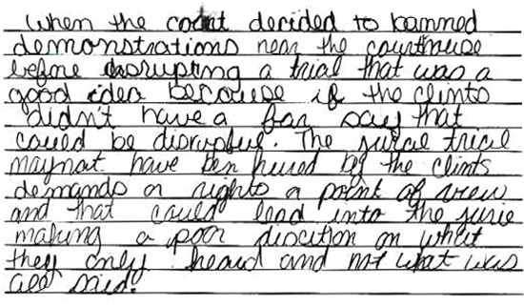

**Score 1:** This response demonstrates minimal understanding of the significance of the Supreme Court's decision relative to the right to a fair trial. The response is unclear, exceedingly vague, and seriously flawed. In the absence of addressing the Constitution explicitly, the response is insufficient to demonstrate understanding.

**Sample 304-4 #2 of 2**

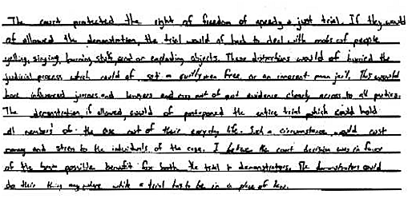

**Score 2:** This response demonstrates an understanding of the significance of the Supreme Court's decision relative to the right to a fair trial. The response addresses the possible disruptions of due process that such demonstrations might lead to, and offers no pertinent ideas about the demonstrators' right to assemble as subject to the time, place, and manner consideration.

(Item#:304-05)

49. The freedom to peaceably assemble is guaranteed by the First Amendment; however, it is not an absolute freedom. Using the chart, write an essay in which you discuss two restrictions on the freedom of assembly. Provide one reason why some people are critical of these restrictions and one reason why others support those restrictions.

[Scoring Criteria](http://metacat2.com/cssap/sg/304-5sg.html)

**Module: 304  
Item: 5   
Descriptor: The Right to Peaceably Assemble**

**Scoring Criteria**

Scores are based on the student's ability to:

* Discuss two restrictions on the freedom of assembly.
* Provide one reason why some people are critical of these restrictions, and one reason why others support them.

Although proficient responses will vary, the response will typically address time, place and manner considerations. In addition, students should explain one rationale for, and one against, each restriction. For example:

*Rationales for restriction:*

* The rights of the public must come before the right to assemble.
* The safety of the public must come before the right to assemble.

*Rationales against restriction:*

* Anytime that personal freedom is restricted, there is cause for concern, as it may lead to other restrictions.
* If we do not follow the letter of the Bill of Rights, then changes can be made that could ultimately lead to its collapse.
* There is a dilemma in relation to understanding when to make the decision to restrict the right to assemble, i.e., someone in power may decide to halt the right to assemble when it is convenient for him or her to do so.

In evaluating student responses, the scorer should give special consideration to the logic underlying the rationale given for each example.

**Score Level Descriptions**

**NS** Not Scorable (blank, off-topic, hostile, etc.)

**1** A response at this level demonstrates minimal understanding of the nature of restrictions on the right to peaceably assemble, and the arguments for and against such restrictions. The response is largely inaccurate or incomplete. The student may provide one example, but the explanation of the rationale in support or against restrictions, if provided, is exceedingly vague or inaccurate. Logic and reasoning are very simplistic and/or seriously flawed. The response demonstrates minimal understanding.

**2** A response at this level demonstrates partial understanding of the nature of restrictions on the right to peaceably assemble, and the arguments for and against such restrictions. The student will provide a partially accurate response (one or two examples), but the explanations of the rationales for and against restrictions are inadequately developed or incomplete. Evidence of rudimentary logic will be present, but it will contain flaws. The response demonstrates partial understanding.

**3** A response at this level demonstrates an adequate understanding of the nature of restrictions on the right to peaceably assemble, and the arguments for and against such restrictions. The student will provide two appropriate examples. The explanations of the rationales for and against restrictions are generally complete and accurate, although minor errors may be present. The logic and reasoning employed are justified, but may contain minor flaws. The response is sufficient to demonstrate understanding.

**4** A response at this level demonstrates a superior understanding of the nature of restrictions on the right to peaceably assemble, and the arguments for and against such restrictions. The student will provide two appropriate examples. The explanations of the rationales for and against restrictions are detailed, thorough, and accurate, and may go beyond that which is required in the question. The logic and reasoning used are sophisticated. The response demonstrates superior understanding.

[Student Work](http://metacat2.com/cssap/sg/304-5ss.html)

**Sample 304-5 #1 of 4**

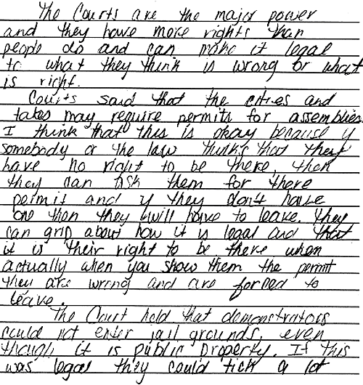

**Score 1:** This response demonstrates minimal understanding of the issue of restriction of right to assemble. The student provides two examples of restrictions, but provides only reasons supporting them, and offers no arguments critical of the restrictions. The reasoning is simplistic and largely ignores constitutional issues. The argument in favor of requiring permits for assembly completely lacks consideration of the basic rationale for requiring permits.

**Sample 304-5 #2 of 4**

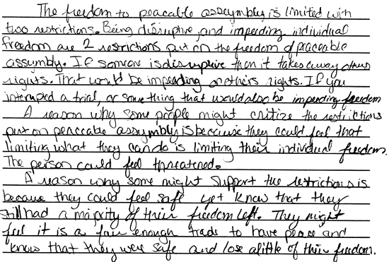

**Score 2:** This response demonstrates partial understanding of the issue of restrictions on the right to assemble. The student provides a rather vague, partially accurate description of two restrictions on the right to peaceably assemble that have been enacted. The reasons for and against the restrictions are inadequately developed. The student does make the important point that interpretations of the right involve a "trade" between safety concerns and concerns of freedom to assemble.

**Sample 304-5 #3 of 4**

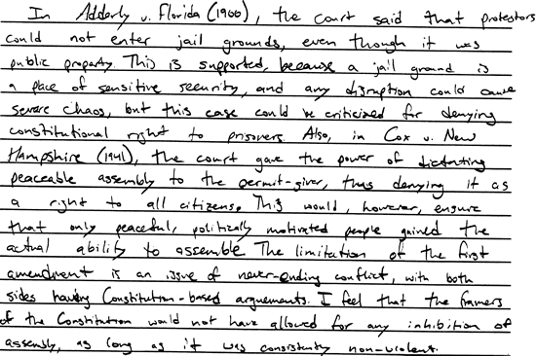

**Score 3:** This response demonstrates an adequate understanding of the issue of restrictions on the right to peaceably assemble. Two examples of cases providing specific restrictions are described, and a pro and a con argument for each restriction is stated. The reasoning is slightly flawed (for example, the power of a "permit-giver" to arbitrarily deny the right to assemble is exaggerated considerably), but is sufficiently well developed to demonstrate an understanding of the legal and constitutional issues that are involved.

**Sample 304-5 #4 of 4**

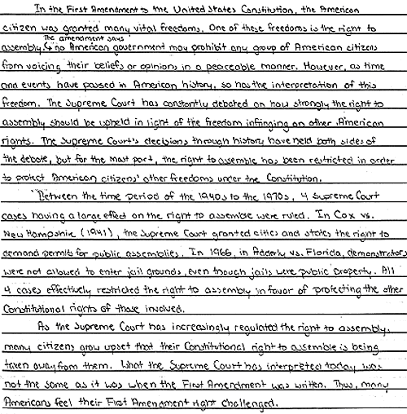

**Score 4:** This response demonstrates a superior understanding of the concept of restrictions on the right to peaceably assemble. The examples and the pro and con arguments are presented in an exceptionally clear, accurate, and well-written fashion. The response exhibits a thoughtful treatment of the notion of "sacrifice" of aspects of one right in order to safeguard other rights. The response seems to fall just short of being a strong level "4" response, however, in that the argument could be more extensive, taking into account issues such as the possibility for arbitrary use of restrictions in order to deny First Amendment rights unfairly.

Political parties are an important feature of the political system in the United States. Political parties serve as a vital link between people and government. They minimize conflict by representing the views of different interests and groups, acting as a mechanism through which compromise can be reached. During the very early years of our nation, however, there was concern about the possibility that parties would actually increase conflict. This view was apparent in Washington's Farewell Address:

"Let me... warn you in the most solemn manner against the baneful [very harmful] effects of the spirit of party... This spirit, unfortunately, is inseparable from our nature.... It exists under different shapes in all governments... and is truly their worst enemy. It serves always to distract the public councils and enfeeble the public administration. It agitates the community with ill-founded jealousies and false alarms; kindles the animosity of one part against another; foments occasionally riot and insurrection."

--From President Washington's Farewell Address, September 17, 1796

(Item#:305-01)

50. Why did George Washington believe that "the spirit of party" is government's worst enemy?

      A. Parties will cause too many serious disputes.

      B. Parties generally pick poor candidates.

      C. In Washington's time, parties excluded certain people.

      D. Parties had been invented by the British government.

Answer: A

(Item#:305-02)

51. What disagreement during the early years of the United States led to the first political parties?

      A. The disagreement over representation in Congress

      B. The disagreement over what to include in a Bill of Rights

      C. The disagreement over the extent of the powers and role of the federal government

      D. The disagreement over whether or not to allow slavery into new territories

Answer: C

(Item#:305-03)

52. In what important way are political parties different from interest groups?

      A. They try to influence Congress.

      B. They raise money for candidates.

      C. They have a set of beliefs that they want to pursue.

      D. Their central goal is to win political office.

Answer: D

(Item#:305-04)

53. Despite Washington's warning about political parties in his Farewell Address, they have become an essential part of the American political system. Political parties on all levels (local, state, and national) perform several important functions. Respond to George Washington's warning by describing at least two of these functions.

[Scoring Criteria](http://metacat2.com/cssap/sg/305-4sg.html)

**Module: 305  
Item: 4   
Descriptor: Political Parties**

**Scoring Criteria**

Scores are based on the student's ability to:

* Describe two functions that political parties play in the American political system.

A proficient response will demonstrate an understanding of two important functions of political parties in the American political system. For example, political parties serve the following functions:

* *Recruiting Candidates:* Political parties seek men and women to run for political office who appear to have a good chance of being elected. Once selected, the candidate is presented to the voter for approval. This is the most important function of political parties. Each party tries to avoid disagreements by uniting behind one candidate.
* *Educating the Public:* Although they try to avoid division, political parties bring important issues to the attention of the public. Each party expresses its position on issues of the day in pamphlets, press conferences, speeches, and advertisements. This helps citizens form opinions about important topics and allows them to choose between alternative approaches.
* *Operating the Government:*Political parties play a key role in running government. National, state, and local governments are organized and carry out their work on the basis of party affiliation. Party leaders try to unite their members in support of the party's position on legislation. The party also acts as a link between the legislative branch and the chief executive.
* *Dispensing Patronage:* Political parties give rewards for party loyalty. Favors can include jobs, contracts, and appointments to government positions. A group who contributes to a political party, may expect sympathy toward their problems if that party gains power. Although limits have been placed on patronage, the practice continues as a way parties reward their supporters.
* *Loyal Opposition:* The party out of power in the legislative or executive branch acts in the role of a "watch dog" over government. As loyal opposition, the party out of power watches the party in power, criticizes it, and offers alternative solutions to political problems. If it does this job well, public opinion may turn in its favor and return it to power.
* *Reduction of Conflict:*In our complex society there are conflicting ideas between groups. To win an election, political parties must attract support from many different groups. Political parties encourage groups to work together and compromise. Political parties serve to maintain political stability through peaceful transfer of power.

Other responses are possible, i.e., channeling public opinion, nominating candidates, allowing people to act together within an organizational structure, campaigning, training future leaders, etc.

**Score Level Descriptions**

**NS** Not Scorable (blank, off-topic, hostile, etc.)

**1** A response at this level demonstrates minimal understanding of the functions of political parties in the American political system. The response is largely inaccurate or incomplete. The description of functions is exceedingly vague and/or inaccurate. The response demonstrates minimal understanding.

**2** A response at this level demonstrates partial understanding of the functions of political parties in the American political system . The response is partially accurate but incomplete. The descriptions are somewhat unclear and inadequately developed. The response demonstrates partial understanding.

**3** A response at this level demonstrates an understanding of the functions of political parties in the American political system. The response is complete and accurate, although minor errors may be present. The descriptions are clear and generally complete and accurate. The response is sufficient to demonstrate understanding.

[Student Work](http://metacat2.com/cssap/sg/305-4ss.html)

**Sample 305-4 #1 of 3**

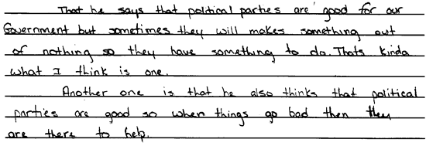

**Score 1:** This response demonstrates minimal understanding of the functions of political parties in the American political system. It conveys little of what political parties actually do, and the explanation provided is exceedingly vague, exhibiting minimal response.

**Sample 305-4 #2 of 3**

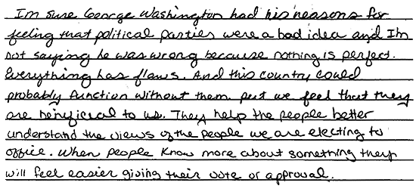

**Score 2:** This response demonstrates partial understanding of the functions of political parties in the American political system. The response is partially accurate but incomplete. It addresses the question indirectly, but exhibits an insufficient understanding of the topic.

**Sample 305-4 #3 of 3**

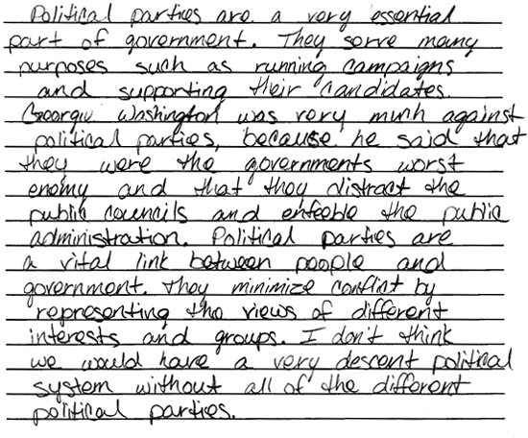

**Score 3:** This response demonstrates an understanding of the functions of political parties in the American political system. It provides a context and accurately asserts two functions. The response is sufficient to demonstrate understanding.

(Item#:305-05)

54. Explain two advantages and two disadvantages of having two or more strong political parties that oppose one another.

[Scoring Criteria](http://metacat2.com/cssap/sg/305-5sg.html)

**Module: 305  
Item: 5   
Descriptor: Political Parties**

**Scoring Criteria**

Scores are based on the student's ability to:

* Explain two advantages and two disadvantages of having two or more strong political parties that oppose one another.

A proficient response will demonstrate an understanding of the advantages and disadvantages of a political system in which two or more strong political parties oppose one another. Responses will vary; in scoring, special consideration must be given to the logic underlying each point expressed by the student.

*Some advantages of two or more strong political parties:*

* Prevent one group from assuming totalitarian control over the machinery of government
* Exert a "moderating" influence upon each other
* Provide citizens with opportunities for choice in and participation with the political organization most analogous to their values
* Provide a venue for the spectrum of public opinion, enabling most to identify, to some degree, with the political system
* Function as a forum for discourse on issues of importance to society
* Generate alternative ideas and policy approaches to national concerns
* Facilitate debate and compromise in effecting resolutions on public policy

*Some disadvantages of two or more strong political parties:*

* Creation of policy entails much time and compromise, often limiting the government's ability to respond swiftly and efficiently to urgent issues.
* Parties embody the potential to polarize society on issues of national importance.
* Majority elected party in power can obstruct dialogue or policy initiatives of the other party or parties, essentially disenfranchising those they represent.

**Score Level Descriptions**

**NS** Not Scorable (blank, off-topic, hostile, etc.)

**1** A response at this level demonstrates minimal understanding of the advantages and disadvantages of a strong two-party system of government. The response is largely inaccurate or implausible (three or four errors). The explanations, if provided, are exceedingly vague or inaccurate. Logic and reasoning are very simplistic and/or seriously flawed. The response demonstrates minimal understanding.

**2** A response at this level demonstrates partial understanding of the advantages and disadvantages of a strong two-party system of government. The student will provide a partially accurate response (two or three plausible points), but the explanations are inadequately developed or incomplete. Evidence of rudimentary logic will be present, but it will contain flaws. The response demonstrates partial understanding.

**3** A response at this level demonstrates an adequate understanding of the advantages and disadvantages of a strong two-party system of government. The student will explain two advantages and two disadvantages. The explanations are generally complete and accurate, although minor errors may be present. The logic and reasoning employed are justified, but may contain minor flaws. The response is sufficient to demonstrate understanding.

**4** A response at this level demonstrates a superior understanding of the advantages and disadvantages of a strong two-party system of government. The student will explain two advantages and two disadvantages. The explanations are detailed, thorough, and accurate, and may go beyond that which is required in the question. The logic and reasoning used are sophisticated. The response demonstrates superior understanding.

[Student Work](http://metacat2.com/cssap/sg/305-5ss.html)

**Sample 305-5 #1 of 3**

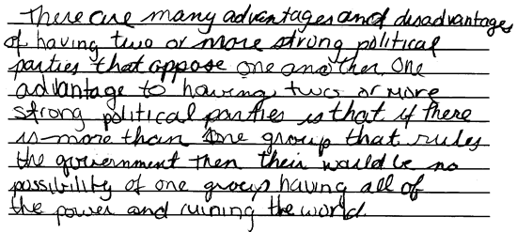

**Score 1:** This response demonstrates minimal understanding of the advantages and disadvantages of a strong two-party system of government. One vague reason for political parties is offered, but the student does not give any other specific argument regarding advantages or disadvantages.

**Sample 305-5 #2 of 3**

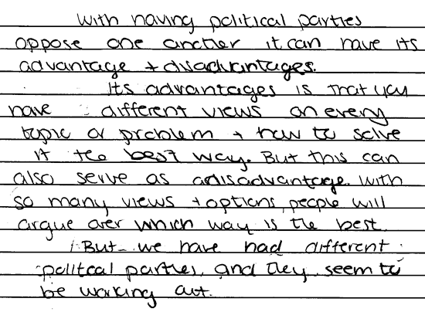

**Score 2:** This response demonstrates partial understanding of the advantages and disadvantages of a strong two-party system of government. The student only provides one advantage and one disadvantage, both of which, although accurate, are somewhat vague. The response demonstrates partial understanding.

**Sample 305-5 #3 of 3**

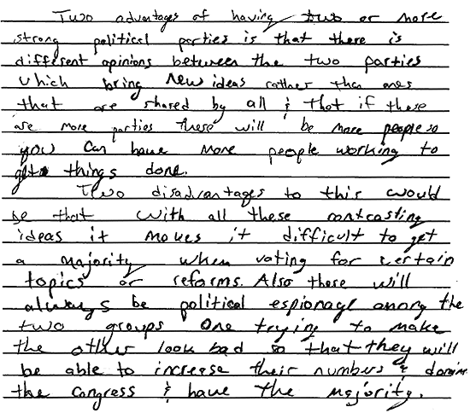

**Score 3:** This response demonstrates an adequate understanding of the advantages and disadvantages of a strong two-party system of government. Two reasonable advantages and disadvantages are offered, exhibiting a sufficient understanding of the topic.

The United States Constitution provides for a number of individual liberties which, subject to responsible exercise, distinguish this nation as a "land of freedom." Individual rights are not, however, absolute. The maintenance of those rights entails certain civic responsibilities and legal obligations.

(Item#:313-01)

55. Which of the following constitutional provisions requires that a judge determine if a prisoner is being held lawfully?

      A. Bills of attainder

      B. Unreasonable searches

      C. Habeas corpus

      D. Ex post facto laws

Answer: C

(Item#:313-02)

56. In which of the following situations is a citizen's constitutionally protected right violated?

      A. The government arrests a citizen for storing live hand grenades in his house.

      B. The government arrests a citizen for criticizing the president on a radio talk show.

      C. A company requires its sales people to dress according to the company's dress code.

      D. A parent requires his fifteen-year-old daughter to attend church on a Sunday morning.

Answer: B

(Item#:313-03)

57. Which of the following is a civic responsibility that is **NOT** required by law?

      A. Staying at the scene of an accident until the police arrive

      B. Testifying in court, if subpoenaed

      C. Carrying a driver's license and auto registration when driving

      D. Voting in a local election

Answer: D

(Item#:313-04)

58. Describe two situations in which a person's exercise of First Amendment rights may conflict with some other rights of another citizen.

[Scoring Criteria](http://metacat2.com/cssap/sg/313-4sg.html)

**Module: 313  
Item: 4   
Descriptor: The Rights and Responsibilities of a Citizen**

**Scoring Criteria**

Scores are based on the student's ability to:

* Describe two situations in which a person's exercise of First Amendment rights may conflict with some other rights of another citizen.

A proficient response will demonstrate an understanding of First Amendment rights, and how peoples' exercise of these rights can sometimes conflict. The student will describe two situations, either real or hypothetical, that demonstrate how two individuals' rights can sometimes come into conflict with each other. For example, the exercise of freedom of speech by one individual may interfere with another person's privacy rights.

**Score Level Descriptions**

**NS** Not Scorable (blank, off-topic, hostile, etc.)

**1** A response at this level demonstrates minimal understanding of how the exercise of First Amendment rights can sometimes come into conflict with the rights of other people. The response will be incomplete or inaccurate. The student may provide one example. Descriptions, if provided, are ambiguous or seriously flawed. The response is insufficient to demonstrate understanding.

**2** A response at this level demonstrates an understanding of how the exercise of First Amendment rights can sometimes come into conflict with the rights of other people. The response is generally complete and accurate. The student will provide two examples. The descriptions are clear and generally accurate. Although minor flaws may be present, the response is sufficient to demonstrate understanding.

[Student Work](http://metacat2.com/cssap/sg/313-4ss.html)

**Sample 313-4 #1 of 2**

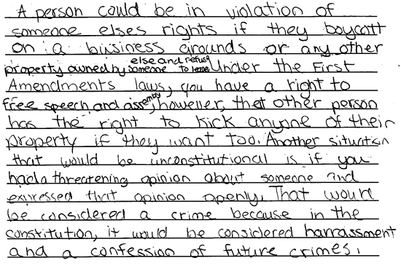

**Score 1:** This response demonstrates minimal understanding of how the exercise of one person's First Amendment rights can sometimes come into conflict with the rights of other people. The student provides one appropriate example, but the explanation of the right to assemble is vague. The second example lacks development, and its explanation is ambiguous. This response is insufficient to demonstrate an understanding of the topic.

**Sample 313-4 #2 of 2**

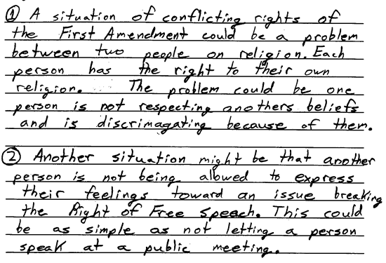

**Score 2:** This response demonstrates an understanding of how the exercise of First Amendment rights can sometimes come into conflict with the rights of other people. The first situation described, though vague in part, is generally complete and accurate in depicting a First Amendment right with regard to religion. The second situation provides the explanation before the example, but accurately addresses freedom of speech in a public forum. The student provides sufficient evidence of understanding the conflicts that may arise from the exercise of First Amendment rights.

(Item#:313-05)

59.

"If the meanest [i.e., poorest] man in the republic is deprived of his rights, then every man in the republic is deprived of his rights."

--Jane Addams (1903)

Explain what Jane Addams meant by that statement.

[Scoring Criteria](http://metacat2.com/cssap/sg/313-5sg.html)

**Module: 313  
Item: 5   
Descriptor: The Rule of Law**

**Scoring Criteria**

Scores are based on the student's ability to:

* Explain how the Watergate case illustrates the rule of law over the rule of man.

A proficient response will demonstrate an understanding of the concept of the rule of law, in contrast to the rule of man. The response will indicate that the rule of law, an essential element of limited government, maintains that a society is governed according to widely known and accepted rules that are applicable to the governed, as well as those in authority (Nixon, the man in authority, was not "above" the law). The response will explain how the Watergate case relates to that distinction.

*Brief synopsis of the Watergate affair:*

Congress was investigating whether the executive branch used its power to cover up illegal actions in the 1972 presidential election. When the existence of a tape recording system became known, Congress was interested in learning whether any evidence of illegal activities were on the tapes. Nixon argued that "executive privilege" allowed the president to withhold the tapes from Congress. The Supreme Court ruled that the tapes must be turned over because they were made in the White House at government expense. The president could not keep evidence of criminal activity private. Nixon's resignation from office resulted from the tradition in the United States of the rule of law.

**Score Level Descriptions**

**NS** Not Scorable (blank, off-topic, hostile, etc.)

**1** A response at this level demonstrates minimal understanding of the concept of the rule of law, in contrast to the rule of man, and how the Watergate case illustrates the distinction. The response is largely inaccurate or incomplete. The explanation, if provided, is exceedingly vague or inaccurate. Logic and reasoning are very simplistic and/or seriously flawed. The response demonstrates minimal understanding.

**2** A response at this level demonstrates partial understanding of the concept of the rule of law in contrast to the rule of man, and how the Watergate case illustrates the distinction. The student will provide a partially accurate response, but the explanation is inadequately developed or incomplete. Evidence of rudimentary logic will be present, but it will contain flaws. The response demonstrates partial understanding.

**3** A response at this level demonstrates an adequate understanding of the concept of the rule of law in contrast to the rule of man, and how the Watergate case illustrates the distinction. The explanation is generally complete and accurate, although minor errors may be present. The logic and reasoning employed are justified, but may contain minor flaws. The response is sufficient to demonstrate understanding.

**4** A response at this level demonstrates a superior understanding of the concept of the rule of law in contrast to the rule of man, and how the Watergate case illustrates the distinction. The explanation is detailed, thorough, and accurate, and may go beyond that which is required in the question. The logic and reasoning used are sophisticated. The response demonstrates superior understanding.

[Student Work](http://metacat2.com/cssap/sg/313-5ss.html)

**Sample 313-5 #1 of 4**

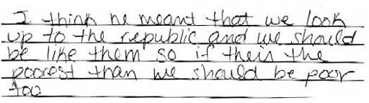

**Score 1:** This response demonstrates minimal understanding of the Jane Addams statement. The response is inaccurate and confusing. The student seems to suggest that the statement means that the poor are the Republic, and that we should emulate them.

**Sample 313-5 #2 of 4**

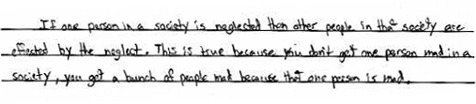

**Score 2:** This response demonstrates partial understanding of the quote by Jane Addams. Although the literal interpretation is inaccurate, some understanding of the general nature of the statement is apparent in the first sentence of the response. There is some understanding that we share a common condition and that all are affected by the "neglect" of any other. The student fails to connect the quote to its civic context, however, and demonstrates only partial understanding. The response is partially accurate but incomplete, and demonstrates only partial understanding.

**Sample 313-5 #3 of 4**

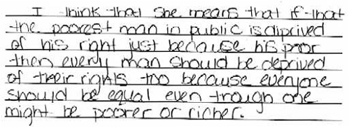

**Score 3:** This is a "low 3" response. The student clearly connects the quote to its civic implications, and in a peculiar way addresses the concept of equality of rights. The response is somewhat flawed in that the student suggests that a deprivation of the rights of one should entail a deprivation of the rights of others, regardless of wealth or status. This is clearly not what Addams was advocating.

**Sample 313-5 #4 of 4**

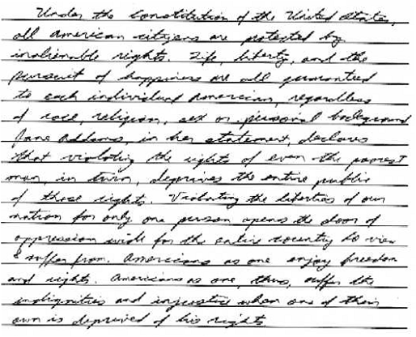

**Score 4:** This response demonstrates superior understanding of the meaning of the statement by Jane Addams. The student provides a thorough, sophisticated, and insightful treatment of the topic. The student recognizes that the violation of one person's rights "opens the door of oppression wide," precisely the meaning inherent in Addams" statement.

"Wherever Law ends, Tyranny begins."

--John Locke, *An essay concerning the true original  
extent and end of civil government* (1690)

"In framing a government which is to be administered by men over men, the great difficulty lies in this: you must first enable the government to control the governed; and in the next place oblige it to control itself."

--James Madison, *Federalist #51* (1788)

The political philosophy of Enlightenment thinkers, such as John Locke, had great influence on the Founders. Fundamental to that thought was the idea of the rule of law instead of the rule of men. This principle safeguards our liberties from the arbitrary excesses of individuals or groups who might deny our liberties. The Fifth and Sixth Amendments are very important to the rule of law.

(Item#:314-01)

60. Which of the following situations illustrates the rule of law?

      A. A political leader uses the military to stop a peaceful protest.

      B. A court rules that an elected official must obey the law.

      C. An elected official offers money to influence a judge's decision.

      D. The president declares a national emergency and suspends free speech.

Answer: B

(Item#:314-02)

61. What does the Fifth Amendment concept of "double jeopardy" mean?

      A. A person cannot be tried twice for the same crime.

      B. A person has to commit two felonies before serving jail time.

      C. A person will not be punished for committing the same type of crime more than once.

      D. A person cannot be put on trial for similar crimes committed in two states.

Answer: A

(Item#:314-03)

62. In what important way does the Constitution establish the rule of law?

      A. It gives law enforcement agencies broad powers to maintain order.

      B. It enables the Supreme Court to amend the Constitution.

      C. It gives Congress the authority to veto laws it thinks are unfair.

      D. It provides for limited government by prohibiting certain powers.

Answer: D

(Item#:314-04)

63. The Fifth and Sixth Amendments express several rights guaranteed to one accused of a criminal offense. Briefly explain two of those rights.

[Scoring Criteria](http://metacat2.com/cssap/sg/314-4sg.html)

**Module: 314  
Item: 4   
Descriptor: The Rule of Law**

**Scoring Criteria**

Scores are based on the student's ability to:

* Briefly explain two rights guaranteed under the Fifth and Sixth Amendments.

A proficient response should include two of the following points:

*Fifth Amendment rights:*

* Shall not be subject to the same offense twice
* Shall not be compelled in a criminal case to witness against oneself
* Shall not be deprived of life, liberty, or pursuit of happiness without due process of law
* Shall not have private property taken for public use without compensation

*Sixth Amendment rights:*

* Right to speedy and public trial by an impartial jury
* Right to confront witness against oneself
* Right to assistance of counsel

**Score Level Descriptions**

**NS** Not Scorable (blank, off-topic, hostile, etc.)

**1** A response at this level demonstrates minimal understanding of rights guaranteed under the Fifth and Sixth Amendments. The response will be incomplete or inaccurate (one or no appropriate examples). The explanation, if provided, is ambiguous or seriously flawed. The response is insufficient to demonstrate understanding.

**2** A response at this level demonstrates an understanding of rights guaranteed under the Fifth and Sixth Amendments. The response is complete and accurate (two appropriate examples). The explanation is clear and generally accurate. Although minor flaws may be present, the response is sufficient to demonstrate understanding.

[Student Work](http://metacat2.com/cssap/sg/314-4ss.html)

**Sample 314-4 #1 of 2**

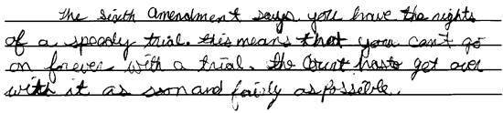

**Score 1:** This response employs simplistic logic to provide an incomplete explanation of the "speedy trial" in the Sixth Amendment. No explanation of the Fifth Amendment is provided. The response reveals minimal understanding of the topic.

**Sample 314-4 #2 of 2**

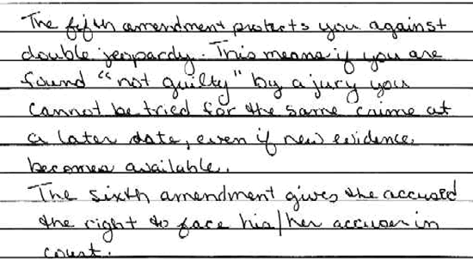

**Score 2:** This response provides sufficient explanation of the Fifth and Sixth Amendments. The explanations are generally clear and accurate, demonstrating an understanding of the topic.

(Item#:314-05)

64. In the 1974 case of *U.S. v. Nixon*, the Supreme Court ruled that President Richard Nixon had to turn over to Congress recordings of conversations he had in the Oval Office. Nixon had argued that Congress did not have the power to order him to turn over the recordings because he was the president.

Explain how this case illustrates the "rule of law" over the "rule of men."

[Scoring Criteria](http://metacat2.com/cssap/sg/314-5sg.html)

**Module: 314  
Item: 5   
Descriptor: The Rule of Law**

**Scoring Criteria**

Scores are based on the student's ability to:

* Explain how the Watergate case illustrates the rule of law over the rule of man.

A proficient response will demonstrate an understanding of the concept of the rule of law, in contrast to the rule of man. The response will indicate that the rule of law, an essential element of limited government, maintains that a society is governed according to widely known and accepted rules that are applicable to the governed, as well as those in authority (Nixon, the man in authority, was not "above" the law). The response will explain how the Watergate case relates to that distinction.

*Brief synopsis of the Watergate affair:*

Congress was investigating whether the executive branch used its power to cover up illegal actions in the 1972 presidential election. When the existence of a tape recording system became known, Congress was interested in learning whether any evidence of illegal activities were on the tapes. Nixon argued that "executive privilege" allowed the president to withhold the tapes from Congress. The Supreme Court ruled that the tapes must be turned over because they were made in the White House at government expense. The president could not keep evidence of criminal activity private. Nixon's resignation from office resulted from the tradition in the United States of the rule of law.

**Score Level Descriptions**

**NS** Not Scorable (blank, off-topic, hostile, etc.)

**1** A response at this level demonstrates minimal understanding of the concept of the rule of law, in contrast to the rule of man, and how the Watergate case illustrates the distinction. The response is largely inaccurate or incomplete. The explanation, if provided, is exceedingly vague or inaccurate. Logic and reasoning are very simplistic and/or seriously flawed. The response demonstrates minimal understanding.

**2** A response at this level demonstrates partial understanding of the concept of the rule of law in contrast to the rule of man, and how the Watergate case illustrates the distinction. The student will provide a partially accurate response, but the explanation is inadequately developed or incomplete. Evidence of rudimentary logic will be present, but it will contain flaws. The response demonstrates partial understanding.

**3** A response at this level demonstrates an adequate understanding of the concept of the rule of law in contrast to the rule of man, and how the Watergate case illustrates the distinction. The explanation is generally complete and accurate, although minor errors may be present. The logic and reasoning employed are justified, but may contain minor flaws. The response is sufficient to demonstrate understanding.

**4** A response at this level demonstrates a superior understanding of the concept of the rule of law in contrast to the rule of man, and how the Watergate case illustrates the distinction. The explanation is detailed, thorough, and accurate, and may go beyond that which is required in the question. The logic and reasoning used are sophisticated. The response demonstrates superior understanding.

[Student Work](http://metacat2.com/cssap/sg/314-5ss.html)

**Sample 314-5 #1 of 4**

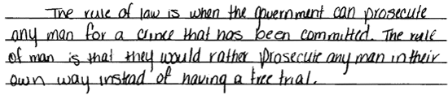

**Score 1:** This student provides a vague definition of the rule of law, while the definition of the rule of man is largely inaccurate. The response exhibits minimal understanding of the topic.

**Sample 314-5 #2 of 4**

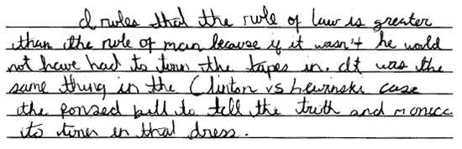

**Score 2:** This response demonstrates partial understanding by stating "the rule of law is greater than the rule of man." Although the examples cited are accurate and logical, they do not relate to the Watergate case. The response is incomplete, underdeveloped, and demonstrates partial understanding of the topic.

**Sample 314-5 #3 of 4**

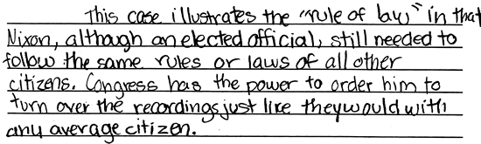

**Score 3:** This response adequately addresses the equality inherent in the "rule of law." An explicit contrast of rule of law and rule of man is not provided, but the concept of the rule of law is developed sufficiently to demonstrate understanding.

**Sample 314-5 #4 of 4**

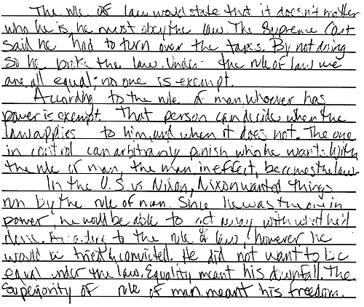

**Score 4:** This response demonstrates a superior understanding of how the case *U.S. v. Nixon* illustrates the "rule of law" over the rule of man. The student provides a thorough explanation of the essence of the distinction between the rule of man and rule of law. A sufficient level of detail from the case is incorporated to illustrate the distinction. The treatment of the "power" aspect is particularly well done, and the relation of the case to the issue of equality demonstrates insight.

When the current United States government was created, there was a variety of opinions as to how much power the president should possess. Because of their experience with the British monarchy prior to independence, the delegates attending the Constitutional Convention deemed it necessary to specify the powers of government. They had experienced what they believed to be executive tyranny under the British monarchy and wanted no more of that political structure; however, there was little doubt that strong leadership was needed in the new nation.

(Item#:317-01)

65. Why were "checks and balances" included in the United States Constitution?

      A. To protect citizens from abuses of governmental powers

      B. To separate the responsibilities of local and state government

      C. To divide the legislative responsibilities among three branches

      D. To guarantee the preservation of states' rights

Answer: A

(Item#:317-02)

66. Which of the following presidential actions would exceed the powers granted the president by the United States Constitution?

      A. Nominating individuals to serve on the U.S. Supreme Court

      B. Negotiating a treaty with a foreign government

      C. Refusing to sign a bill approved by Congress

      D. Declaring war without congressional approval

Answer: D

(Item#:317-03)

67. In the event that both the president and vice-president die, which of the following is designated by the Constitution to assume the office of president?

      A. Speaker Pro-Tem of the Senate

      B. Secretary of State

      C. Speaker of the House of Representatives

      D. Chief Justice of the Supreme Court

Answer: C

(Item#:317-04)

68. Although there are formal, constitutional limitations on the power of the presidency, there are also informal controls on presidential powers. Identify and briefly explain two of these informal limitations on the power of the presidency.

[Scoring Criteria](http://metacat2.com/cssap/sg/317-4sg.html)

**Module: 317  
Item: 4  
Descriptor: The Powers of the Presidency**

**Scoring Criteria**

Scores are based on the student's ability to:

* Identify and briefly explain two informal limits on the president's power.

A proficient response will identify and briefly explain two informal limits on the president's power. Appropriate examples will vary, but following are some anticipated responses:

* Public opinion (Citizens may oppose a president's proposals or ideas.)
* Pressure from a political party (These may be either from his own or the opposing political party.)
* Economic considerations (The president may decide an idea will have too great a negative economic impact to justify its support.)
* Media considerations (The president may take into account how print and non-print media outlets will interpret and comment upon his actions.)

**Score Level Descriptions**

**NS** Not Scorable (blank, off-topic, hostile, etc.)

**1** A response at this level demonstrates minimal understanding of informal limits on the president's power. The response is incomplete or inaccurate. The student may provide one appropriate example, but the explanation, if provided, is ambiguous or seriously flawed. The response is insufficient to demonstrate understanding.

**2** A response at this level demonstrates an understanding of informal limits on the president's power. The response is generally complete and accurate. The examples are appropriate and the explanations are clear and generally accurate. Although minor flaws may be present, the response is sufficient to demonstrate understanding.

[Student Work](http://metacat2.com/cssap/sg/317-4ss.html)

**Sample 317-4 #1 of 2**

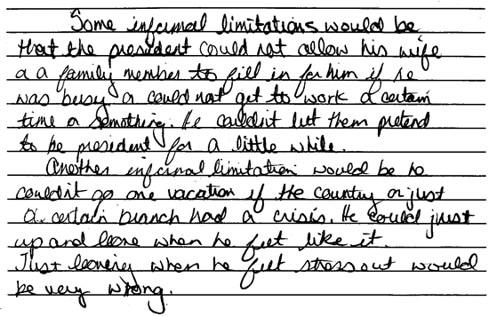

**Score 1:** This response utilizes exceedingly simplistic logic and provides inaccurate (although entertaining and fanciful) explanations of limitations on presidential power. Minimal understanding is exhibited by this response.

**Sample 317-4 #2 of 2**

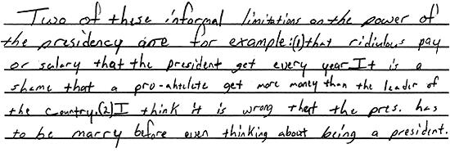

**Score 2:** This response demonstrates an understanding of the informal limits on a president's power. Although the examples provided are not among the anticipated responses, citing the low salary and unspoken marriage requirement exhibits an insight on the presidency; the response demonstrates understanding.

(Item#:317-05)

69. Suppose that the president has proposed establishing "citizenship boot camps" for all young people between the ages of 15 and 17. These camps would last for three weeks during the summer and attendance would be required. They would cost approximately $35 million per year, but the president thinks the improved citizenship they would promote would be worth the expense.

Write an essay that identifies and explains two actions the legislature could take and two actions the judiciary could take to stop this presidential action. Be sure that your suggestions are based on constitutional powers afforded each branch of government.

[Scoring Criteria](http://metacat2.com/cssap/sg/317-5sg.html)

**Module: 317  
Item: 5   
Descriptor: Separation of Powers**

**Scoring Criteria**

Scores are based on the student's ability to:

* Identify two judicial challenges and two legislative actions that can be taken in response to a hypothetical example of the abuse of executive power.

A proficient response will demonstrate an understanding of appropriate legislative and judicial actions that could be taken in response to executive misuse of authority. The student should provide two examples for each. The examples should demonstrate an awareness of checks and balances relative to the extent and limitations of authority. For example:

*Some judicial challenges:*

* Lawsuits can be filed, claiming infringement on civil rights.
* Judicial review can be used to assess the constitutionality of such a program.

*Some legislative challenges:*

* Congress can elect not to fund the camps. (Congress must authorize government spending.)
* Congress can fail to introduce or pass the legislation necessary to establish the camps. (Only Congress, not the president, may introduce establishing legislation.)
* Congress may change and pass the proposal, resulting in a presidential veto. That veto can be overridden. (The changed legislation would be law, not be president’s proposal.)
* Other logical answers should be accepted.

**Score Level Descriptions**

**NS** Not Scorable (blank, off-topic, hostile, etc.)

**1** A response at this level demonstrates minimal understanding of judicial challenges and legislative actions that can be taken in response to an abuse of executive power. The response is largely inaccurate or incomplete (two or more errors). The examples or explanations, if provided, are exceedingly vague or inaccurate. Logic and reasoning are very simplistic and/or seriously flawed. The response demonstrates minimal understanding.

**2** A response at this level demonstrates partial understanding of judicial challenges and legislative actions that can be taken in response to the abuse of executive power. The student will provide a partially accurate response (two or three appropriate examples), but the explanations are inadequately developed or incomplete. Evidence of rudimentary logic will be present, but it will contain flaws. The response demonstrates partial understanding.

**3** A response at this level demonstrates an adequate understanding of judicial challenges and legislative actions that can be taken in response to the abuse of executive power. The student will provide four appropriate examples. The explanations are generally complete and accurate, although minor errors may be present. The logic and reasoning employed are justified, but may contain minor flaws. The response is sufficient to demonstrate understanding.

**4** A response at this level demonstrates a superior understanding of judicial challenges and legislative actions that can be taken in response to the abuse of executive power. The student will provide four appropriate examples. The explanations are detailed, thorough, and accurate, and may go beyond that which is required in the question. The logic and reasoning used are sophisticated. The response demonstrates superior understanding.

[Student Work](http://metacat2.com/cssap/sg/317-5ss.html)

**Sample 317-5 #1 of 4**

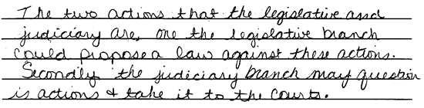

**Score 1:** This response provides one appropriate legislative action to block the president's proposal, and one vague action for the judicial branch. The response is largely incomplete, and demonstrates minimal understanding.

**Sample 317-5 #2 of 4**

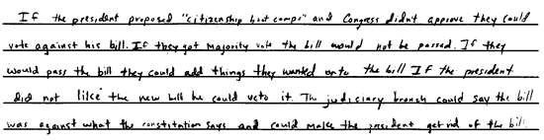

**Score 2:** This student provides three explanations, but fails to explain how each idea would work in practice. The response is somewhat vague, but demonstrates partial understanding.

**Sample 317-5 #3 of 4**

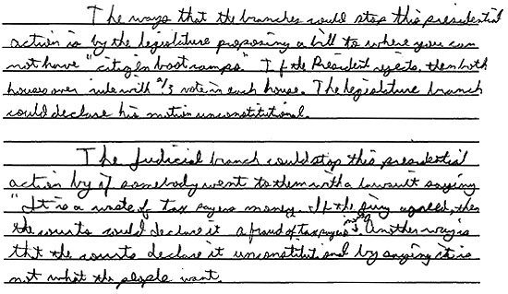

**Score 3:** This response provides the requisite examples of ways the legislature and judicial branches could block the president's proposal. Although there are minor flaws regarding constitutionality, the response is sufficient to demonstrate understanding.

**Sample 317-5 #4 of 4**

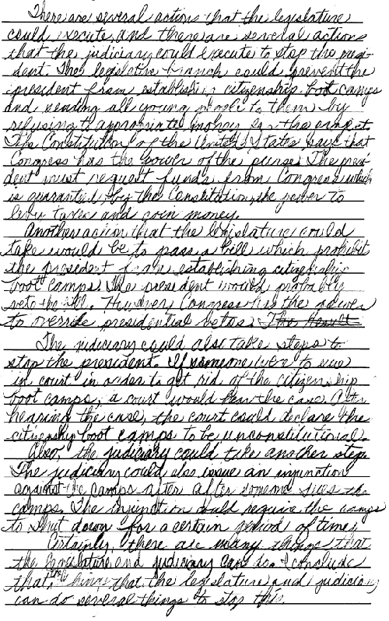

**Score 4:** This response accurately identifies four distinct reasons why the hypothetical boot camps might prove problematic. The student demonstrates a superior understanding of the different powers of the legislative and judicial branches using effective language, specific terms, and sound reasoning. Although the development of points could be stronger, the student provides enough detail and demonstrates enough insight to reveal superior understanding.

Citizens participate in elections to select individuals to represent them at all levels of government. Regardless of who wins an election, all citizens are the "constituents" of those elected to represent them. Constituents are often not unified in their values and beliefs on issues of political importance.

(Item#:301-01)

70. Which of the following phrases best describes the commitment of interest groups

      A. Dedicated to the common good

      B. Committed to a specific political party

      C. Focused on a particular issue

      D. Unconcerned about politics

Answer: C

(Item#:301-02)

71. Suppose some members of Congress chose to vote in favor of a dam even though polls indicate that most of their constituents do not want the dam. Given how members of Congress tend to vote on such matters, what is the **LEAST** likely reason why they chose to vote for the dam?

      A. They may believe the dam would be beneficial for their state.

      B. They may want to publicize the fact that they disagree with their constituents.

      C. They may be receiving campaign contributions from interests in favor of the dam.

      D. They may be choosing to vote along the lines of their political party, which favors the dam.

Answer: B

(Item#:301-03)

72. Which of the following groups would most likely be the **LEAST** influential constituency in a national election?

      A. Labor union members

      B. Farmers

      C. Environmental advocates

      D. Newly-arrived immigrants

Answer: D

(Item#:301-04)

73. "The great measure of representative government in a participatory democracy lies in the extent to which its citizens participate on Election Day." Given that statement, explain why some might argue that a democratically-elected government in the United States is not fully representative.

[Scoring Criteria](http://metacat2.com/cssap/sg/301-4sg.html)

**Module: 301  
Item: 4  
Descriptor: Constituents Speak Out**

**Scoring Criteria**

Scores are based on the student's ability to:

* Explain why some might argue that democratically elected government in the United States is not fully representative.

A proficient response will demonstrate an understanding that voter apathy or non-participation results in government less representative that it otherwise could be. The nature of an electoral unit's representation is a direct reflection of the political ideals of the majority *of those who actually vote*; limited participation by voters in any election results in limited representation, for the outcome is merely a reflection of those who participated. To the extent that citizens do not participate in the election of representatives, their views are not necessarily reflected in the outcome.

Alternatively, others might argue that minorities are, often times, not fully represented in government because minority groups, by virtue of their numbers, cannot muster adequate electoral power to institute minority representatives in government.

**Score Level Descriptions**

**NS** Not Scorable (blank, off-topic, hostile, etc.)

**1** A response at this level demonstrates minimal understanding of why democratically elected government in the United States is not fully representative. The response is incomplete or inaccurate. The explanation, if provided, is ambiguous or seriously flawed. The response is insufficient to demonstrate understanding.

**2** A response at this level demonstrates an understanding of why democratically elected government in the United States is not fully representative. The response is generally complete and accurate. The explanation is clear and generally accurate. Although minor flaws may be present, the response is sufficient to demonstrate understanding.

Student Work Not Available

(Item#:301-05)

74. A candidate running for public office is trying to gain the support of constituents in his or her electoral district. Provide at least two examples of special interest groups that might exist among the constituents within the district. Explain two reasons why the candidate might be influenced by them.

[Scoring Criteria](http://metacat2.com/cssap/sg/301-5sg.html)

**Module: 301  
Item: 5   
Descriptor: Constituents Speak Out**

**Scoring Criteria**

Scores are based on the student's ability to:

* Provide at least two examples of constituent groups that might exist in an electoral district
* Explain two reasons why a political candidate might be influenced by constituencies within an electoral district.

A proficient response will demonstrate an understanding of the nature of interest groups, such as organized political action committees, minority groups, etc., in relation to their influence on a political candidate's views. The student should identify two principal reasons a candidate might be influenced by such groups, e.g., *financial contributions* and *votes.*

The organizational power of some special interest groups can have a significant influence on a candidate's views. For example, one or more special interest groups may coalesce and organize around one or two issues, forming a "voting block" with considerable power to influence the outcome of an election. In other cases, the financial resources of some groups, including businesses or industries, can influence candidates' position on issues. Such constituents may provide important financial support to candidates in an attempt to ensure representation that is favorable to their interests.

**Score Level Descriptions**

**NS** Not Scorable (blank, off-topic, hostile, etc.)

**1** A response at this level demonstrates minimal understanding of the influence of special interest groups on a political candidate. The examples and explanations, if provided, are exceedingly vague or inaccurate. The response demonstrates minimal understanding.

**2** A response at this level demonstrates partial understanding of the influence of special interest groups on a political candidate. The student will provide a partially accurate response. The student will provide one or two appropriate examples, but the explanations are inadequately developed or incomplete. The response demonstrates partial understanding.

**3** A response at this level demonstrates an adequate understanding of the influence of special interest groups on a political candidate. The are appropriate, and the explanations are generally complete and accurate, although minor errors may be present. The logic and reasoning employed are justified, but may contain minor flaws. The response is sufficient to demonstrate understanding.

**4** A response at this level demonstrates a superior understanding of the influence of special interest groups on a political candidate. The examples are appropriate and the explanations are detailed, thorough, and accurate, and may go beyond that which is required in the question. The logic and reasoning used are sophisticated and flawless. The response demonstrates superior understanding.

Student Work Not Available

*Preamble of the U.N. Charter (1945)*

|  |
| --- |
| We the people of the United Nations, determined to save succeeding generations from the scourge of war, which twice in our lifetime has brought untold sorrow to mankind, and  to reaffirm faith in fundamental human rights, in the dignity and worth of the human person, in the equal rights of men and women and of nations large and small, and  to establish conditions under which justice and respect for the obligations arising from treaties and other sources of international law can be maintained, and  to promote social progress and better standards of life in larger freedom,  and for these ends, to practice tolerance and live together in peace with one another as good neighbors, and  to unite our strength to maintain international peace and security, and  to insure, by the acceptance of principles and the institution of methods, that armed force shall not be used, save in the common interest, and  to employ international machinery for the promotion of the economic and social advancements of all peoples,  have resolved to combine our efforts to accomplish these aims.  Accordingly, our respective governments ... have agreed to the present charter of the United Nations and do hereby establish an international organization to be known as the United Nations. |

(Item#:306-01)

75. What is the United Nations body to which all members belong?

      A. Trusteeship Council

      B. General Assembly

      C. International Court of Justice

      D. Economic and Social Council

Answer: B

(Item#:306-02)

76. What power is exclusive to the Security Council?

      A. The power to veto any actions of the General Assembly

      B. The power to refer issues to the General Assembly for open debate

      C. The power to boycott any member nation of the U.N.

      D. The power to impeach the Secretary-General

Answer: A

(Item#:306-03)

77. What is the strongest action, short of military intervention, the United Nations can take to force compliance of a member nation?

      A. Recalling U.N. diplomats

      B. Banning them from the General Assembly

      C. Boycotting an international event

      D. Imposing economic sanctions

Answer: D

(Item#:306-04)

78. Today, there are a number of specialized U.N. agencies that help countries meet their economic, social, and humanitarian needs. Describe one of these U.N. programs that helps to meet the social, economic, or humanitarian needs of member nations.

[Scoring Criteria](http://metacat2.com/cssap/sg/306-4sg.html)

**Module: 306  
Item: 4   
Descriptor: The United Nations**

**Scoring Criteria**

Scores are based on the student's ability to:

* Describe one of the UN agencies or programs and explain what it does to promote the social, economic, or humanitarian needs of member nations.

A proficient response will demonstrate an understanding of one UN program or agency's role in promoting the social, economic, or humanitarian needs of member nations. Students should recognize that programs under UN agencies are active in promoting higher standards of living, full employment, and economic and social progress in an effort to reduce the gap between rich and poor countries. The response will cite one program administered by a UN agency and describe the kind of assistance it offers.

The following examples, while much more detailed than expected, are provided to illustrate some of the important agencies and their activities:

* In the forefront of efforts to bring about social and economic progress is the *UN Development Program (UNDP)*. The UN's largest multilateral provider of grants for sustainable human development, it works in 174 countries and territories to facilitate technical cooperation.
* The *UN Children's Fund (UNICEF)* is the lead UN organization working for the long-term survival, protection and development of children. Working in some 150 countries, UNICEF's programs focus on immunization, primary health care, nutrition, and basic education.
* Many other UN programs work for development, in partnership with governments and non-governmental organizations. The *UN Environment Program (UNEP)* works to encourage sound environmental practices everywhere. The *World Food Program* is the world's largest international food aid organization for both emergency relief and as part of a nation's development program. The *UN Population Fund (UNFPA)* is the largest international provider of population assistance to developing countries. The *UN Center for Human Settlements* (Habitat) works to assist over 600 million people living in health-threatening housing conditions. The *UN Conference on Trade and Development* promotes international trade, particularly by developing countries, seeking to increase their participation in the global economy.

Linked to the United Nations through special agreements, the following separate, autonomous, and specialized agencies of the UN set standards and guidelines, help formulate policies and provide technical assistance and other forms of practical help in virtually all areas of economic and social endeavor:

* *The International Labor Organization (ILO)* formulates policies and programs to improve working conditions and employment opportunities, and defines international labor standards as guidelines for governments.
* *The Food and Agriculture Organization of the UN (FAQ)* works to raise levels of nutrition and standards of living, to improve agricultural productivity and food security, and to better the conditions of rural populations.
* *The UN Educational, Scientific and Cultural Organization (UNESCO)* promotes education for all, cultural development, protection of the worlds natural and cultural heritage, press freedom, and communication.
* *The World Health Organization (WHO)* coordinates programs aimed at solving health problems and the attainment by all people of the highest possible level of health. It works in areas such as immunization, health education, and the provision of essential drugs.
* *The World Bank* group provides loans and technical assistance to developing countries to reduce poverty and advance sustainable economic growth.
* *The International Monetary Fund (IMF)* facilitates international monetary cooperation and financial stability, and provides a permanent forum for consultation, advice, and assistance on financial issues.
* *The International Civil Aviation Organization (ICAO)* sets international standards necessary for the safety, security, efficiency and regularity of air transport, and serves as the medium for cooperation in all areas of civil aviation.
* *The Universal Postal Union (UPU)* establishes international regulations for the organization and improvement of postal services, provides technical assistance, and promotes cooperation in postal matters.
* *The International Telecommunication Union (ITU)* fosters international cooperation for the improvement and use of telecommunications of all kinds, coordinates usage of radio and TV frequencies, promotes safety measures, and conducts research.

**Score Level Descriptions**

**NS** Not Scorable (blank, off-topic, hostile, etc.)

**1** A response at this level demonstrates minimal understanding of UN agencies or programs that promotes the social, economic, or humanitarian needs of member nations. The response is largely inaccurate or incomplete. The explanation is exceedingly vague and/or inaccurate. The response demonstrates minimal understanding.

**2** A response at this level demonstrates partial understanding of UN agencies or programs that promote the social, economic, or humanitarian needs of member nations. The response is partially accurate but incomplete. The explanation is somewhat unclear and inadequately developed. The response demonstrates partial understanding.

**3** A response at this level demonstrates an understanding of UN agencies or programs that promote the social, economic, or humanitarian needs of member nations. The response is complete and accurate, although minor errors may be present. The explanation is clear and generally complete and accurate. The response is sufficient to demonstrate understanding.

[Student Work](http://metacat2.com/cssap/sg/306-4ss.html)

**Sample 306-4 #1 of 3**

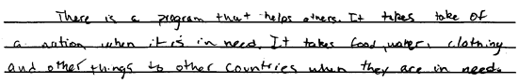

**Score 1:** This response demonstrates minimal understanding of the UN programs or agencies and their function. The student states that "there is a program" which takes care of other nations, but provides no specifics. The response is exceedingly vague and inaccurate.

**Sample 306-4 #2 of 3**

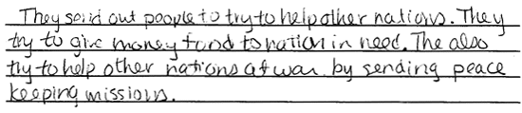

**Score 2:** This response demonstrates partial understanding of the UN programs or agencies and their function. The student generally addresses the issue of humanitarian needs, however it is incomplete. No specific agency or program is cited in conjunction with the humanitarian role. The response reveals partial understanding.

**Sample 306-4 #3 of 3**

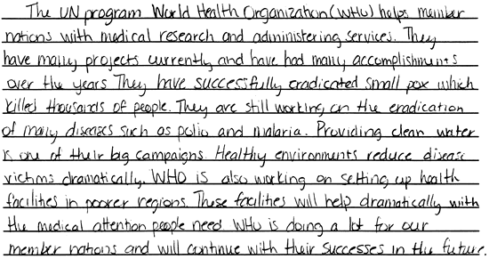

**Score 3:** This response demonstrates an understanding of how the UN works to promote humanitarian needs. The student cites a specific UN agency and explains its role in providing medical assistance to developing nations. The response is detailed and accurate. This is a "high" 3.

(Item#:306-05)

79.

*We the people of the United States, in order to form a more perfect Union, establish justice, ensure domestic tranquility, provide for the common defense, promote the general welfare, and secure the blessings of liberty to ourselves and our posterity, do ordain and establish this Constitution for the United States of America.*

The Preamble to the United Nations Charter states the ideals of the organization with respect to humankind. Choose three of these ideals and discuss their similarities or differences to the goals stated in the Preamble to the United States Constitution.

[Scoring Criteria](http://metacat2.com/cssap/sg/306-5sg.html)

**Module: 306  
Item: 5  
Descriptor: The United Nations**

**Scoring Criteria**

Scores are based on the student's ability to:

* List three of the ideals espoused in the Preamble of the United Nations Charter.
* Compare those ideals to the ideals stated in the Preamble to the United States Constitution.

A proficient response will demonstrate an understanding of the similarities and/or differences in the ideals embodied in the Preamble of the United States Constitution and in the United Nations Charter. To assist in scoring student responses, the text of the United Nations Preamble is provided:

*WE THE PEOPLES OF THE UNITED NATIONS DETERMINED*  
to save succeeding generations from the scourge of war, which twice in our lifetime has brought untold sorrow to mankind, and

to reaffirm faith in fundamental human rights, in the dignity and worth of the human person, in the equal rights of men and women and of nations large and small, and

to establish conditions under which justice and respect for the obligations arising from treaties and other sources of international law can be maintained, and

to promote social progress and better standards of life in larger freedom,

*AND FOR THESE ENDS*

to practice tolerance and live together in peace with one another as good neighbors, and

to unite our strength to maintain international peace and security, and

to ensure by the acceptance of principles and the institution of methods, that armed force shall not be used, save in the common interest, and

to employ international machinery for the promotion of the economic and social advancement of all peoples,

*HAVE RESOLVED TO COMBINE OUR EFFORTS TO ACCOMPLISH THESE AIMS.*

Accordingly, our respective Governments, through representatives assembled in the city of San Francisco, who have exhibited their full powers found to be in good and due form, have agreed to the present Charter of the United Nations and do hereby establish an international organization to be known as the United Nations.

**Score Level Descriptions**

**NS** Not Scorable (blank, off-topic, hostile, etc.)

**1** A response at this level demonstrates minimal understanding of the similarities and/or differences in the ideals espoused in the Preamble of the United States Constitution and the United Nations Charter. The student may provide two examples, but the explanation, if provided, is exceedingly vague or inaccurate. Logic and reasoning are very simplistic and/or seriously flawed. The response demonstrates minimal understanding.

**2** A response at this level demonstrates partial understanding of the similarities and/or differences in the ideals espoused in the Preamble of the United States Constitution and the United Nations Charter. The student will provide a partially accurate response (two or three examples), but the explanations are inadequately developed or incomplete. Evidence of rudimentary logic will be present, but it will contain flaws. The response demonstrates partial understanding.

**3** A response at this level demonstrates an adequate understanding of the similarities and/or differences in the ideals espoused in the Preamble of the United States Constitution and the United Nations Charter. The student will provide three appropriate examples. The explanation is generally complete and accurate, although minor errors may be present. The logic and reasoning employed are justified, but may contain minor flaws. The response is sufficient to demonstrate understanding.

**4** A response at this level demonstrates a superior understanding of the similarities and/or differences in the ideals espoused in the Preamble of the United States Constitution and the United Nations Charter. The student will provide three appropriate examples. The explanation is detailed, thorough, and accurate, and may go beyond that which is required in the question. The logic and reasoning used are sophisticated. The response demonstrates superior understanding.

[Student Work](http://metacat2.com/cssap/sg/306-5ss.html)

**Sample 306-5 #1 of 4**

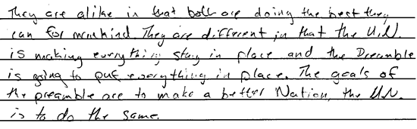

**Score 1:** While the student attempts to compare the Preamble to the U.S. Constitution to the UN Charter, the response is exceedingly vague. The student states that the goals are the same but provides no explanation to substantiate the position. The response exhibits minimal development of ideas, and minimal understanding.

**Sample 306-5 #2 of 4**

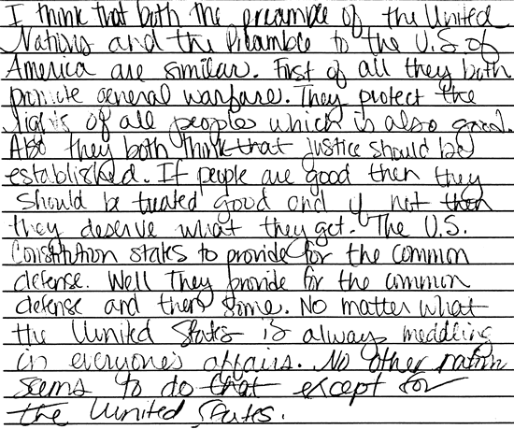

**Score 2:** This response demonstrates partial understanding of the similarities of the Preambles. The student addresses three points in a very general, but partially accurate manner. The explanation of similarities is simplistic, and the logic is flawed, particularly in the concluding remarks. However, some understanding is apparent.

**Sample 306-5 #3 of 4**

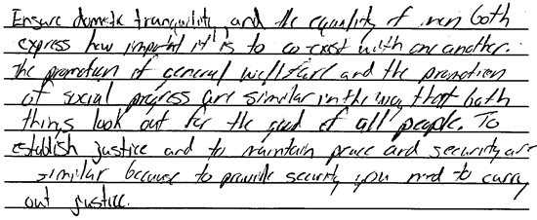

**Score 3:** This response exhibits an understanding of the topic. The student provides three appropriate examples; however, the response would benefit from further explanation. The point, "to provide security you need to carry out justice," is insightful. Although brief, the response is sufficient to demonstrate understanding.

**Sample 306-5 #4 of 4**

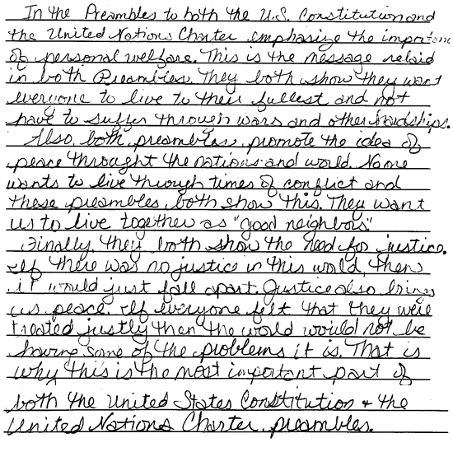

**Score 4:** This response exhibits a superior understanding of the topic. The student methodically outlines the similarities and provides thorough and somewhat insightful justifications. The logic and reasoning are sophisticated and accurate, revealing a superior understanding.

The separation of powers is based on a constitutional principle whereby each branch of government exercises certain controls over the others without acquiring complete dominance. In accordance with the Constitution, each branch of the national government exercises certain expressed and independent powers. The three branches of government share power and oversee one another.

The powers expressed in the Constitution for each branch of government create a checks and balances system. For example, the president can be impeached for high crimes or misdemeanors. In 1974, President Richard M. Nixon resigned from office. He was the first president to do so. The events leading to his resignation began with the arrest of burglars in the Democratic Party headquarters at the Watergate building in Washington, D.C. After newspaper reporters brought to light the fact that members of Nixon's reelection campaign staff had ordered the break-ins, Congress began an investigation. This investigation is an example of a check by the legislative branch of government over the executive branch.

(Item#:309-01)

80. Which of the following statements most accurately describes why the Constitution mandates a balance of power among the branches of government?

      A. The writers of the Constitution wanted to restrict the concentration of power.

      B. The writers of the Constitution wanted to make the states independent of the federal government.

      C. The writers of the Constitution wanted to ensure the power of the judiciary.

      D. The writers of the Constitution wanted to ensure the power of the president.

Answer: A

(Item#:309-02)

81. Which of the following checks could Congress have used against President Nixon if he had not resigned?

      A. Congress would likely have overridden all presidential vetoes.

      B. Congress would likely have sent the case to the Supreme Court.

      C. The president would likely have been put on trial by the Senate.

      D. The president would likely have been put under house arrest.

Answer: C

(Item#:309-03)

82. How is the principle of separation of powers fundamental to the function of checks and balances?

      A. The judicial branch cannot enforce decisions over the other branches.

      B. Each branch of government exercises certain Constitutionally expressed powers not held by the other branches.

      C. Each branch of government can institute amendments to the Constitution.

      D. Separation of powers implies that each branch is free from interference by the others.

Answer: B

(Item#:309-04)

83. Using specific real examples or hypothetical examples, describe how each branch of government has a check upon another.

[Scoring Criteria](http://metacat2.com/cssap/sg/309-4sg.html)

**Module: 309  
Item: 4  
Descriptor: Checks and Balances**

**Scoring Criteria**

Scores are based on the student's ability to:

* Provide examples illustrating how each branch of government has a check upon the other.

A proficient response will demonstrate an understanding of the powers delegated to the three branches of government, and how these powers constitute the system of checks and balances. Although responses will vary, some probable examples include:

* Impeachment proceedings against Presidents A. Johnson and R. Nixon - legislative check on executive branch
* Declaration of war must be approved by Congress - legislative check on executive branch
* Supreme Court may declare laws unconstitutional, e.g., Line-item veto is overturned by Supreme Court - Judicial check on legislative and executive branch
* The president can pardon federal offenders, e.g., case of Oliver North - executive check on judicial branch

**Score Level Descriptions**

**NS** Not Scorable (blank, off-topic, hostile, etc.)

**1** A response at this level demonstrates minimal understanding of how each branch of government has a check upon the others. The response is largely inaccurate or incomplete. The examples and descriptions are exceedingly vague and/or inaccurate. The response demonstrates minimal understanding.

**2** A response at this level demonstrates partial understanding of how each branch of government has a check upon the others. The response is partially accurate but incomplete. The examples and descriptions are somewhat unclear and inadequately developed. The response demonstrates partial understanding.

**3** A response at this level demonstrates an understanding of how each branch of government has a check upon the others. The response is complete and accurate. The examples and descriptions are clear and generally complete and accurate. The response is sufficient to demonstrate understanding.

[Student Work](http://metacat2.com/cssap/sg/309-4ss.html)

**Sample 309-4 #1 of 3**

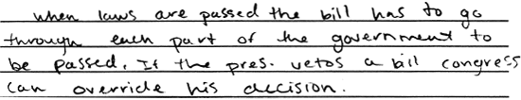

**Score 1:** This response demonstrates minimal understanding of how each branch of government has a check upon the others. The explanation provided is incomplete. No examples specific to each branch of government are offered. The student fails to explain how "Congress can override his (the President's) decision." The response is exceedingly vague.

**Sample 309-4 #2 of 3**

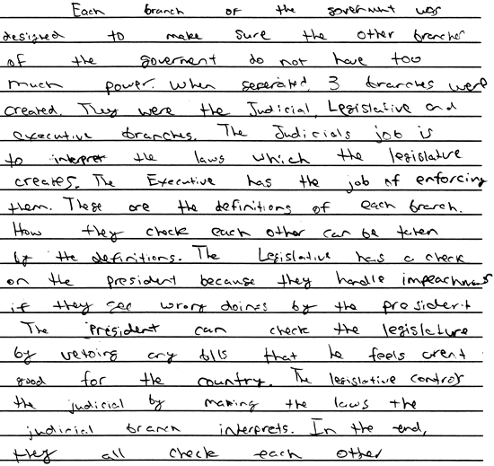

**Score 2:** This response demonstrates partial understanding of checks and balances. The discussion of the checks and balances mechanism is very rudimentary and only partially accurate. The explanation of the legislative check on the judicial is flawed. Specific examples are not provided. Only partial understanding is demonstrated.

**Sample 309-4 #3 of 3**

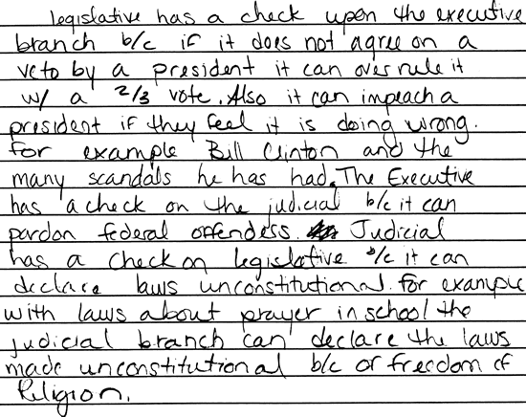

**Score 3:** This response demonstrates an understanding of how each branch of government has a check upon the others. The ideas are logical and the examples generally appropriate. Referencing freedom of religion in regard to the debate concerning prayer in school exhibits a sufficient understanding of the topic.

(Item#:309-05)

84. Explain how the system of checks and balances functions in limiting government and preventing the abuse of power against citizens. Use two actual examples to support your explanation.

[Scoring Criteria](http://metacat2.com/cssap/sg/309-5sg.html)

**Module: 309  
Item: 5  
Descriptor: Checks and Balances**

**Scoring Criteria**

Scores are based on the student's ability to:

* Explain how the system of checks and balances functions in limiting government and preventing the abuse of power against citizens.
* Use two actual examples to illustrate this function.

A proficient response will demonstrate an understanding of the principles of checks and balances. Although examples will vary, the student will provide two examples to illustrate the checks and balances function relative to the prevention of the abuse of government power against citizens.

**Score Level Descriptions**

**NS** Not Scorable (blank, off-topic, hostile, etc.)

**1** A response at this level demonstrates minimal understanding of how the system of checks and balances functions in limiting government and preventing the abuse of power against citizens. The response is largely inaccurate or incomplete. The examples and explanations, if provided, are exceedingly vague or inaccurate. Logic and reasoning are very simplistic and/or seriously flawed. The response demonstrates minimal understanding.

**2** A response at this level demonstrates partial understanding of how the system of checks and balances functions in limiting government and preventing the abuse of power against citizens. The response is partially accurate (one or two appropriate examples), but the examples and explanations are inadequately developed or incomplete. Evidence of rudimentary logic is present, but it contains flaws. The response demonstrates partial understanding.

**3** A response at this level demonstrates an adequate understanding of how the system of checks and balances functions in limiting government and preventing the abuse of power against citizens. The student provides two appropriate examples, and the explanations are generally complete and accurate, although minor errors may be present. The response is sufficient to demonstrate understanding.

**4** A response at this level demonstrates a superior understanding of how the system of checks and balances functions in limiting government and preventing the abuse of power against citizens. The student provides two appropriate examples, and the explanations are detailed, thorough, and accurate. The logic and reasoning used are sophisticated. The response demonstrates superior understanding.

[Student Work](http://metacat2.com/cssap/sg/309-5ss.html)

**Sample 309-5 #1 of 3**

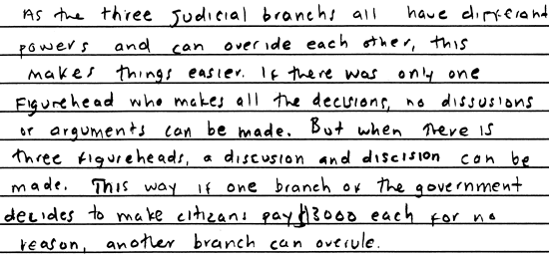

**Score 1:** This response vaguely addresses the checks and balances system in an exceedingly simplistic fashion. Only one of the two examples required is chosen, and it lacks development. This response demonstrates minimal understanding.

**Sample 309-5 #2 of 3**

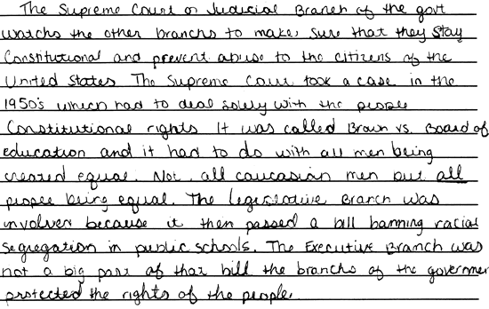

**Score 2:** This response demonstrates some basic understanding of the checks and balances system in preventing the abuse of power against citizens. The example of *Brown v. Board of Education* is one appropriate representation, but the response lacks a second. Logic is apparent in the example, but the final statement is seriously flawed ("the Executive Branch was not a big part of that...") revealing partial understanding of the process.

**Sample 309-5 #3 of 3**

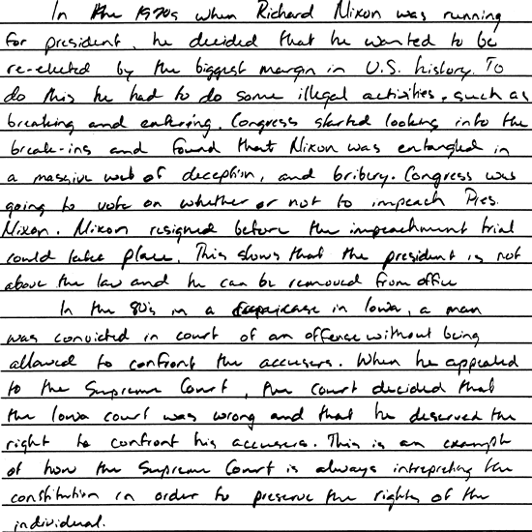

**Score 3:** This response demonstrates adequate understanding of the system of checks and balances. Two appropriate examples (Nixon's pending impeachment/ resignation and the case where the Supreme Court decided a man cannot be convicted if denied the right to confront his accusers) are well developed, complete and accurate, and presented with good logic and appropriate conclusions.

Below are two excerpts from the Declaration of Independence.

When in the Course of human events, it becomes necessary for one people to dissolve the political bands which have connected them with another, and to assume among the powers of the earth, the separate and equal station to which the Laws of nature and of Nature's God entitle them, a decent respect to the opinions of mankind requires that they should declare the causes which impel them to the separation.

We hold these truths to be self-evident, that all men are created equal, that they are endowed by their Creator with certain unalienable Rights, that among these are Life, Liberty and the pursuit of Happiness. That to secure these rights, Governments are instituted among Men, deriving their just powers from the consent of the governed...

--From the *Declaration of Independence,* Congress, July 4, 1776

(Item#:315-01)

85. What was the purpose of the opening sentence of the Declaration of Independence?

      A. To specify the restrictions on liberty created by the king

      B. To provide a justification for breaking with England

      C. To appeal for assistance from France for the revolution

      D. To outline the system of government created by the Constitution

Answer: B

(Item#:315-02)

86. Which of the following best describes John Locke's idea that there is a social contract between a people and their government?

      A. A republic is the best form of government for a new country.

      B. All men and women are created equal and have a right to happiness.

      C. Church and state should be separate in a republic.

      D. Governments derive their just power from the consent of the governed.

Answer: D

(Item#:315-03)

87. Which of the following documents probably served as an influence on the writing of the Declaration of Independence?

      A. Articles of Confederation

      B. The Federalist Papers

      C. English Bill of Rights

      D. Declaration of the Rights of Man

Answer: C

(Item#:315-04)

88. On July 3, 1776, members of the Continental Congress reviewed Thomas Jefferson's draft of the Declaration of Independence. Delegates from South Carolina wanted the following passage, referring to the actions of King George III, removed:

*He has... waged cruel war against human nature itself, violating its most sacred rights of life and liberty in the persons of a distant people, who never offended him, captivating and carrying them into slavery in another hemisphere, or to incur miserable death in their transportation thither.*

Briefly explain why some delegates wanted this passage excluded and why the Continental Congress voted to delete this passage.

[Scoring Criteria](http://metacat2.com/cssap/sg/315-4sg.html)

**Module: 315  
Item: 4   
Descriptor: The Creation of the Declaration of Independence**

**Scoring Criteria**

Scores are based on the student's ability to:

* Briefly explain why some delegates to the Continental Congress objected to the statement in the original draft of the Declaration of Independence describing the actions of King George the III, and why the Continental Congress voted to strike it out.

A proficient response will demonstrate an understanding of how the issue of slavery divided the delegates to the Continental Congress. The student will indicate that the reliance on the slavery system in the southern delegates' states conflicted with the sentiment expressed in the statement quoted from the original draft. The response will address the question of *why* the slavery passage was deleted, i.e., because southern delegates would not have voted for the Declaration if the passage had remained, and there was a need to forge unity and solidarity among the various states.

**Score Level Descriptions**

**NS** Not Scorable (blank, off-topic, hostile, etc.)

**1** A response at this level demonstrates minimal understanding of the rationale underlying objections to the slavery clause in the original Declaration of Independence, and why the Continental Congress voted to strike the clause. The response will be incomplete or inaccurate. The explanation, if provided, is ambiguous or seriously flawed. The response is insufficient to demonstrate understanding.

**2** A response at this level demonstrates an understanding of therationale underlying objections to the slavery clause in the original Declaration of Independence, and why the Continental Congress voted to strike the clause. The response is generally complete and accurate. The explanation is clear and generally accurate. Although minor flaws may be present, the response is sufficient to demonstrate understanding.

[Student Work](http://metacat2.com/cssap/sg/315-4ss.html)

**Sample 315-4 #1 of 2**

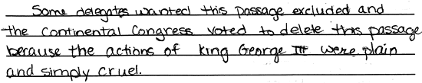

**Score 1:** This response demonstrates minimal understanding of why some delegates wanted the passage excluded and why the Continental Congress voted to delete this passage. The explanation is minimal and the reasoning is seriously flawed. The response is inaccurate.

**Sample 315-4 #2 of 2**

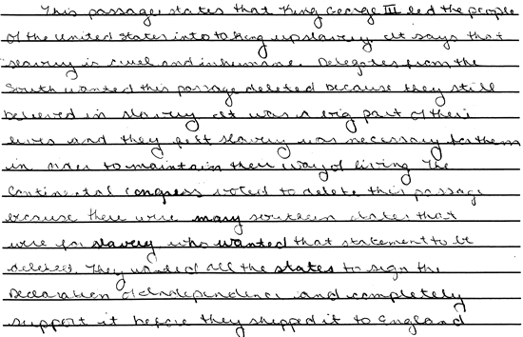

**Score 2:** This response demonstrates an understanding of the underlying objections to the slavery clause in the original Declaration of Independence and why the Continental Congress voted to strike the clause. The response provides clear and accurate explanations of both the objections to the clause and the reasons for striking it.

(Item#:315-05)

89. The Declaration of Independence remains a remarkable document. Our nation is still striving to realize all of its ideals. In 1776, virtually every country in the world had a monarchical form of government. Select four of the ideals within the Declaration and explain how these ideals challenged the political principles of monarchical government.

[Scoring Criteria](http://metacat2.com/cssap/sg/315-5sg.html)

**Module: 315  
Item: 5   
Descriptor: The Creation of the Declaration of Independence**

**Scoring Criteria**

Scores are based on the student's ability to:

* Identify four philosophical points or ideals from the Declaration of Independence.
* Explain how those ideals challenged the political principles of monarchical government.

A proficient response will demonstrate an understanding of the revolutionary aspects of four political ideals espoused in the Declaration of Independence, and how those principles challenged the political principles of monarchical government. Students will employ comparison and contrast to explain how the ideals of the Declaration of Independence challenge the system of constitutional monarchy. Students should address four of the following ideals:

* Equality of men
* Unalienable rights given by God:
  + Life
  + Liberty
  + Pursuit of Happiness
* Governments exist because the consent of the governed grants them just powers ("Social Contract")
* Popular sovereignty

**Score Level Descriptions**

**NS** Not Scorable (blank, off-topic, hostile, etc.)

**1** A response at this level demonstrates minimal understanding of the revolutionary aspects of the political ideals espoused in the Declaration of Independence, and how those principles challenged the political principles of monarchical government. The response is largely inaccurate. The student may provide one or two appropriate examples of ideals, but the explanations, if provided, are exceedingly vague or inaccurate. Logic and reasoning are very simplistic and/or seriously flawed. The response demonstrates minimal understanding.

**2** A response at this level demonstrates partial understanding of the revolutionary aspects of the political ideals espoused in the Declaration of Independence and how those principles challenged the political principles of monarchical government. The student will provide a partially accurate response (two or three appropriate examples), but the explanations are inadequately developed or incomplete. Evidence of rudimentary logic will be present, but it will contain flaws. The response demonstrates partial understanding.

**3** A response at this level demonstrates an adequate understanding of the revolutionary aspects of the political ideals espoused in the Declaration of Independence and how those principles challenged the political principles of monarchical government. The student will provide an accurate response (three or four appropriate examples), and the explanations are generally complete and accurate, although minor errors may be present. The logic and reasoning employed are justified, but may contain minor flaws. The response is sufficient to demonstrate understanding.

**4** A response at this level demonstrates a superior understanding of revolutionary aspects of the political ideals espoused in the Declaration of Independence and how those principles challenged the political principles of monarchical government. The student will provide four appropriate examples. The explanations are detailed, thorough, and accurate, and may go beyond that which is required in the question. The logic and reasoning used are sophisticated. The response demonstrates superior understanding.

[Student Work](http://metacat2.com/cssap/sg/315-5ss.html)

**Sample 315-5 #1 of 3**

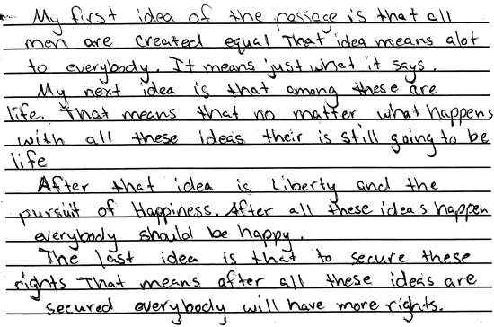

**Score 1:** This response demonstrates minimal understanding of the political ideals espoused in the Declaration of Independence and how those principles challenged the political principles of monarchical governments. Although the response clearly names three appropriate ideals, the explanations are exceedingly vague and inaccurate. The logic and reasoning are very simplistic. The response exhibits minimal response. This is a "high" 1.

**Sample 315-5 #2 of 3**

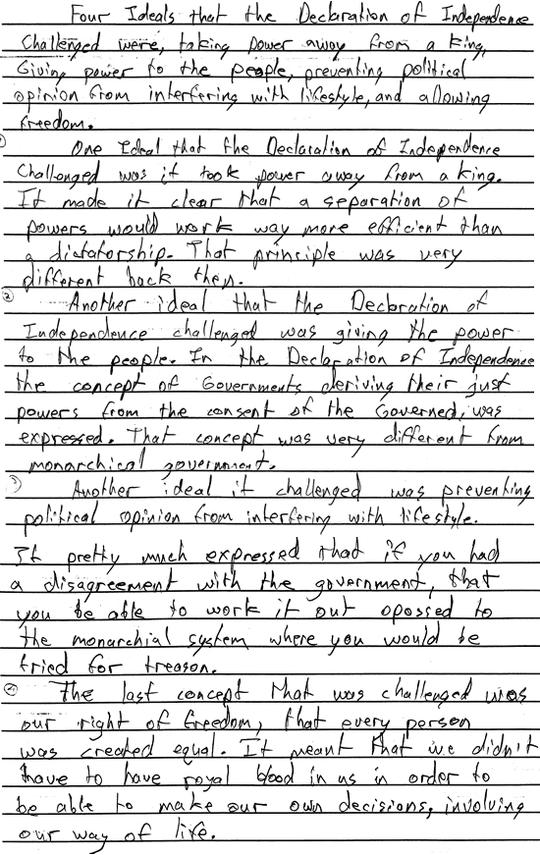

**Score 2:** This response demonstrates partial understanding of the revolutionary aspects of the political ideals espoused in the Declaration of Independence and how those principles challenged the political principles of monarchical government. Although the response provides examples of four ideals, the explanations are somewhat vague and poorly expressed. Some attempt at comparison is evident. The response reveals incomplete, or partial understanding.

**Sample 315-5 #3 of 3**

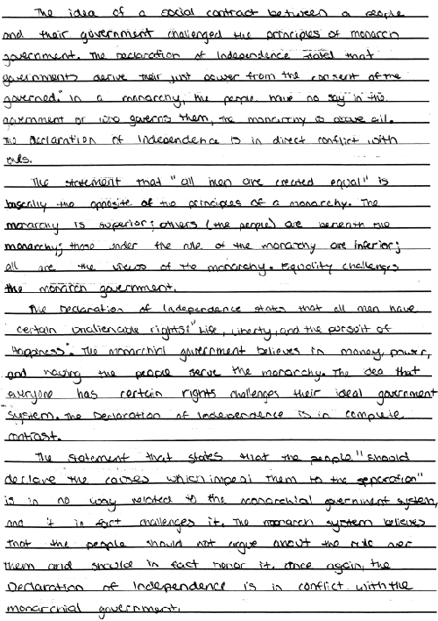

**Score 3:** This response demonstrates an adequate understanding of the revolutionary aspects of the political ideals espoused in the Declaration of Independence and how those principles challenged the political principles of monarchical government. The response provides four examples with explanations that are generally complete and accurate. Comparison is used effectively, and the logic and reasoning are justified. The response is sufficient to demonstrate understanding.

|  |
| --- |
| History and experience prove that foreign influence is one of the most baneful foes of republican government....  The great rule of conduct for us in regard to foreign nations is, in extending our commercial relations to have with them as little political connection as possible. So far as we have already formed engagements let them be fulfilled with perfect good faith. Here let us stop.  Europe has a set of primary interests which to us have none of a very remote relation. Hence she must be engaged in frequent controversies, the causes of which are essentially foreign to our concerns.  --George Washington, Farewell Address (1796) |

|  |
| --- |
| We have become a great nation, forced by the fact of its greatness into relations with the other nations of the earth, and we must behave as beseems a people with such responsibilities.  --Theodore Roosevelt, Inaugural Address (1905) |

(Item#:316-01)

90. Which of the following positions best characterizes Washington's Farewell Address?

      A. Pacifism

      B. Interventionism

      C. Isolationism

      D. Libertarianism

Answer: C

(Item#:316-02)

91. Which of the following policies has historically provided justification for United States intervention in the Western Hemisphere?

      A. Embargo Act

      B. Monroe Doctrine

      C. Alien Act

      D. Ostend Manifesto

Answer: B

(Item#:316-03)

92. What was the popular phrase used to describe President Theodore Roosevelt's foreign policy?

      A. The "Big Stick" policy

      B. The "Open Door" policy

      C. The "Rough Rider" policy

      D. The "Good Neighbor" policy

Answer: A

(Item#:316-04)

93. Briefly explain two reasons why the United States chose to play an increasingly active role in international affairs after 1900.

[Scoring Criteria](http://metacat2.com/cssap/sg/316-4sg.html)

**Module: 316  
Item: 4   
Descriptor: Growth of United States' Involvement in World Affairs**

**Scoring Criteria**

Scores are based on the student's ability to:

* Explain two reasons why the United States chose to play an increasingly active role in international affairs after 1900.

A proficient response will demonstrate an understanding of why the United States chose to play an increasingly active role in international affairs after 1900. The student will provide two reasons, such as the following:

* It was believed that continued industrial growth and economic prosperity necessitated overseas markets. The developing system of global commerce meant that the world was becoming increasingly internationalized.
* An increased international presence was a logical extension of "manifest destiny," as the U.S. expanded beyond its borders.
* One wing of the expansionist lobby held the belief that it was America's mission to spread the blessings of Christianity, or for Anglo-Saxons to bestow the elements of civilization upon the "weaker races" of the world.
* The U.S. believed it necessary to police the Western Hemisphere, i.e. the "Roosevelt Corollary" in Latin America, and check the expansionism of European nations.

**Score Level Descriptions**

**NS** Not Scorable (blank, off-topic, hostile, etc.)

**1** A response at this level demonstrates minimal understanding of why the United States chose to play an increasingly active role in international affairs after 1900. The response is largely inaccurate and incomplete. The explanations are exceedingly vague and/or inaccurate. Logic or reasoning, if in evidence, is exceedingly simplistic and/or seriously flawed. The response demonstrates minimal understanding.

**2** A response at this level demonstrates partial understanding of why the United States chose to play an increasingly active role in international affairs after 1900. The response is partially accurate but incomplete. The explanations are somewhat unclear and inadequately developed. Some evidence of logic or reasoning may be present, but it will be incomplete and partially flawed. The response reveals partial understanding.

**3** A response at this level demonstrates an understanding of why the United States chose to play an increasingly active role in international affairs after 1900. The response is complete and accurate, although minor errors may be present. The explanations are clear and generally complete and accurate. The response exhibits valid logic and reasoning. The response is sufficient to demonstrate understanding.

[Student Work](http://metacat2.com/cssap/sg/316-4ss.html)

**Sample 316-4 #1 of 3**

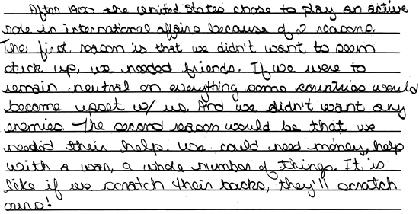

**Score 1:** This response demonstrates minimal understanding of why the United States chose to play an increasingly active role in international affairs after 1900. The response is inaccurate. Although the answer seems to make sense (the notion of reciprocity), it has little, if anything, to do with the actual situation.

**Sample 316-4 #2 of 3**

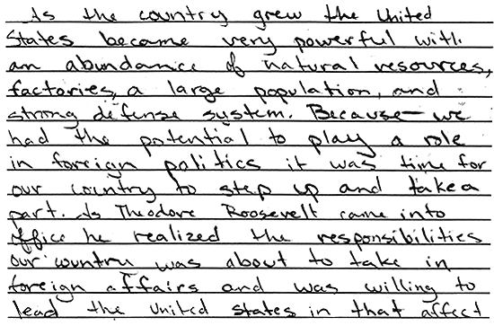

**Score 2:** This response demonstrates partial understanding of the subject. The response is partially accurate but incomplete. Although the student presents an interesting idea --that the U.S. got involved because it *could*-- no other reasons are given. The explanation is incomplete.

**Sample 316-4 #3 of 3**

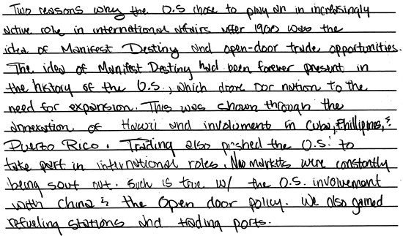

**Score 3:** This response demonstrates an understanding of the subject. The response is complete, accurate, and clear; the examples are appropriate; the logic valid.

(Item#:316-05)

94. The United States' involvement in World War I culminated in the Versailles Peace Conference in 1919. Upon returning home from the Conference, President Woodrow Wilson presented the Versailles treaty to the Senate for ratification. An important provision in that treaty was for a "League of Nations," which pledged each member nation to preserve the political independence and territorial integrity of all other League members.

Explain the reservations of some in the Senate to the League of Nations' proposal. What, specifically, did those led by Henry Cabot Lodge object to?

[Scoring Criteria](http://metacat2.com/cssap/sg/316-5sg.html)

**Module: 316   
Item: 5  
Descriptor: Growth of United States Involvement in World Affairs**

**Scoring Criteria**

Scores are based on the student's ability to:

* Explain the reasons against U.S. inclusion in the League of Nations, as reflected in the position of Senator Henry Cabot Lodge.

A proficient response will explain the position espoused by Lodge and his followers in opposition to the League of Nations proposal. Lodge argued that the U.S. had already made sacrifice enough, with close to one million American casualties in WWI, and that U.S. membership in the League would only drag the country into future wars. Lodge may also have paraphrased George Washington's admonition about European political involvement.

**Score Level Descriptions**

**NS** Not Scorable (blank, off-topic, hostile, etc.)

**1** A response at this level demonstrates minimal understanding of the position espoused by Lodge and his followers in opposition to the League of Nations proposal. The response is largely inaccurate or incomplete. The explanation, if provided, is exceedingly vague or inaccurate. Logic and reasoning are very simplistic and/or seriously flawed. The response demonstrates minimal understanding.

**2** A response at this level demonstrates partial understanding of the position espoused by Lodge and his followers in opposition to the League of Nations proposal. The student will provide a partially accurate response, but the explanation is inadequately developed or incomplete. Evidence of rudimentary logic will be present, but it will contain flaws. The response demonstrates partial understanding.

**3** A response at this level demonstrates an adequate understanding the position espoused by Lodge and his followers in opposition to the League of Nations proposal. The explanation is generally complete and accurate, although minor errors may be present. The logic and reasoning employed are justified, but may contain minor flaws. The response is sufficient to demonstrate understanding.

**4** A response at this level demonstrates a superior understanding of the position espoused by Lodge and his followers in opposition to the League of Nations proposal. The explanation is detailed, thorough, and accurate, and may go beyond that which is required in the question. The logic and reasoning used are sophisticated. The response demonstrates superior understanding.

[Student Work](http://metacat2.com/cssap/sg/316-5ss.html)

**Sample 316-5 #1 of 4**

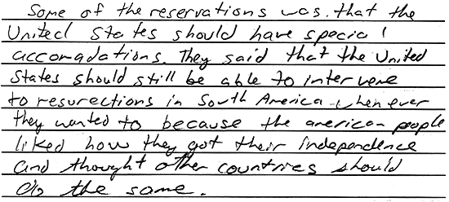

**Score 1:** This response demonstrates minimal understanding of the position espoused by Lodge and his followers in opposition to the League of Nations' proposal. The response is completely inaccurate. Logic and reasoning are very simplistic and seriously flawed.

**Sample 316-5 #2 of 4**

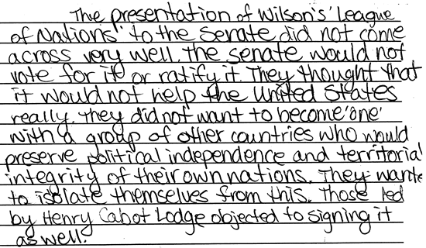

**Score 2:** This response demonstrates partial understanding of the position espoused by Lodge and his followers in opposition to the League of Nations' proposal. Although the response is largely accurate, it is very general and underdeveloped. The student offers no explanation why isolationists would object to respecting territorial integrity on independence. The response reveals incomplete or partial understanding.

**Sample 316-5 #3 of 4**

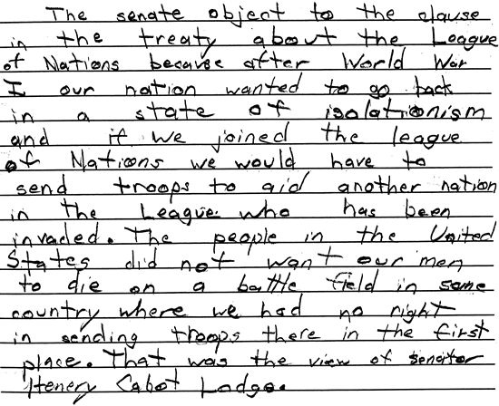

**Score 3:** This response demonstrates an adequate understanding of the topic. The explanation is accurate and reasonably complete, and the logic is valid. Although somewhat general, the student provides enough of an explanation to demonstrate adequate understanding.

**Sample 316-5 #4 of 4**

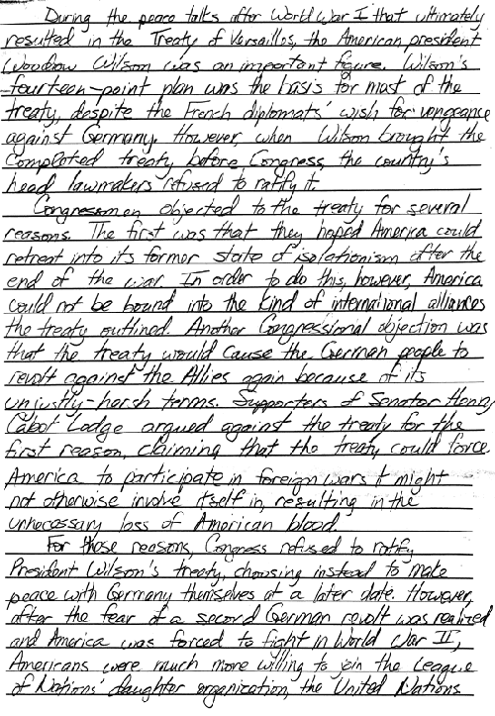

**Score 4:** This response demonstrates a superior understanding of the topic. The student employs significant details and important concepts in providing a sophisticated explanation of the anti-League position. The response is complete, clear and accurate, revealing a superior understanding.

Each branch of the federal government exercises some control over the operations of the other two branches, a principle referred to as checks and balances. The presidential veto is one such example. While Congress has been given lawmaking authority, the president can reject (veto) any act passed by Congress. The table below shows the number of times each president has used the veto power since 1789.

**Table 1  
Presidential Vetoes: 1789-1996**

|  |  |  |  |  |  |
| --- | --- | --- | --- | --- | --- |
| **Time Period** | **President** | **Regular Vetoes** | **Pocket Vetoes** | **Total Vetoes** | **Vetoes Overridden** |
| 1789-1797 | George Washington | 2 | 0 | 2 | 0 |
| 1797-1801 | John Adams | 0 | 0 | 0 | 0 |
| 1801-1809 | Thomas Jefferson | 0 | 0 | 0 | 0 |
| 1809-1817 | James Madison | 5 | 2 | 7 | 0 |
| 1817-1826 | James Monroe | 1 | 0 | 1 | 0 |
| 1825-1829 | John Q. Adams | 0 | 0 | 0 | 0 |
| 1829-1837 | Andrew Jackson | 5 | 7 | 12 | 0 |
| 1837-1841 | Martin Van Buren | 0 | 1 | 1 | 0 |
| 1841-1841 | W. H. Harrison | 0 | 0 | 0 | 0 |
| 1841-1845 | John Tyler | 8 | 4 | 10 | 1 |
| 1845-1849 | James K. Polk | 2 | 1 | 3 | 0 |
| 1849-1850 | Zachary Taylor | 0 | 0 | 0 | 0 |
| 1850-1853 | Millard Fillmore | 0 | 0 | 0 | 0 |
| 1853-1857 | Franklin Pierce | 9 | 0 | 9 | 5 |
| 1857-1861 | James Buchanan | 4 | 3 | 7 | 0 |
| 1861-1865 | Abraham Lincoln | 2 | 5 | 7 | 0 |
| 1865-1869 | Andrew Johnson | 21 | 8 | 29 | 15 |
| 1869-1877 | Ulysses S. Grant | 45 | 48 | 93 | 4 |
| 1877-1881 | Rutherford B. Hayes | 12 | 1 | 13 | 1 |
| 1881-1881 | James A. Garfield | 0 | 0 | 0 | 0 |
| 1881-1885 | Chester A. Arthur | 4 | 8 | 12 | 1 |
| 1885-1889 | Grover Cleveland | 304 | 110 | 414 | 2 |
| 1889-1893 | Benjamin Harrison | 19 | 25 | 44 | 1 |
| 1893-1897 | Grover Cleveland | 42 | 126 | 170 | 5 |
| 1897-1901 | William McKinley | 6 | 36 | 42 | 0 |
| 1901-1909 | Theodore Roosevelt | 42 | 40 | 82 | 1 |
| 1909-1913 | William H. Taft | 30 | 9 | 39 | 1 |
| 1913-1921 | Woodrow Wilson | 33 | 11 | 44 | 9 |
| 1921-1923 | Warren G. Harding | 5 | 1 | 6 | 0 |
| 1923-1929 | Calvin Coolidge | 20 | 30 | 50 | 4 |
| 1929-1933 | Herbert Hoover | 21 | 16 | 37 | 3 |
| 1933-1945 | Franklin D. Roosevelt | 372 | 293 | 636 | 9 |
| 1945-1953 | Harry S. Truman | 180 | 70 | 250 | 12 |
| 1953-1961 | Dwight D. Eisenhower | 73 | 108 | 181 | 2 |
| 1961-1963 | John F. Kennedy | 12 | 9 | 21 | 0 |
| 1963-1969 | Lyndon B. Johnson | 16 | 14 | 30 | 0 |
| 1969-1974 | Richard M. Nixon | 26 | 17 | 43 | 7 |
| 1974-1977 | Gerald R. Ford | 48 | 18 | 66 | 12 |
| 1977-1981 | Jimmy Carter | 13 | 18 | 31 | 2 |
| 1981-1989 | Ronald Reagan | 39 | 39 | 78 | 9 |
| 1990-1993 | George Bush | 29 | 17 | 46 | 1 |
| 1993-1996 | Bill Clinton | 17 | 0 | 17 | 1 |
| --From *Presidential Vetoes, 1789-1996.* Congressional Research Service, Library of Congress, 1997. | | | | | |

(Item#:319-01)

95. Based on the information presented in the table, which of the following is an accurate conclusion?

      A. Pocket vetoes have been overridden more frequently than regular vetoes.

      B. Most presidential vetoes are not overridden by Congress.

      C. Most presidents have used the pocket veto more often than they have used the regular veto.

      D. The veto power was used more frequently in the 19th century than in the 20th.

Answer: B

(Item#:319-02)

96. A veto override occurs when vetoed legislation is passed for a second time by:

      A. Majority vote of the house of origin in Congress.

      B. Majority vote of both houses of Congress.

      C. Two thirds vote of both houses of Congress.

      D. Three fourths vote of both houses of Congress.

Answer: C

(Item#:319-03)

97. Which of the following conclusions is supported by the information in the table?

      A. Presidents used the veto more often after WWII than earlier.

      B. The pocket veto is used more often than the regular veto.

      C. Congress sustains a veto more often than it overrides a veto.

      D. Congress overrides a pocket veto more often than it does a regular veto.

Answer: C

(Item#:319-04)

98. In 1996, Congress passed the Line Item Veto Act, giving the president the authority to reject one or more items in a budget bill without rejecting the entire measure. The Act allowed the president to cancel specific provisions in tax and spending bills, provided the cancellation was used for deficit reduction. Opponents of the Act immediately challenged its constitutionality in the courts.

Identify one major argument favoring the use of the line item veto and one major argument opposing it.

[Scoring Criteria](http://metacat2.com/cssap/sg/319-4sg.html)

**Module: 319   
Item: 4  
Descriptor: The Presidential Veto**

**Scoring Criteria**

Scores are based on the student's ability to:

* Identify one argument in support of the line item veto.
* Identify one argument against the line item veto.

A proficient response will identify one argument in support of the line item veto and one argument in opposition to it. Use the following chart to guide the scoring of student responses:

|  |  |
| --- | --- |
| **Arguments Favoring Line Item Veto** | **Arguments Opposing Line Item Veto** |
| Popularly endorsed by presidents for more than 100 years | Other presidents have "survived" without line item veto |
| Congress voluntarily delegated line item veto power to the president | Unconstitutional to delegate law-making authority to President; unconstitutional to allow President to "pick and choose" |
| Historically, power shifts between the Legislative and Executive branches; Congress had become too powerful as of late | Upsets balance of power in federal government |
| Shifts power to President, who is better insulated from public pressure to spend money on wasteful pork barrel legislation; budget trimmer | Line item veto has done little to reduce federal budget deficits (1/10 of one percent) |
| Most state governors have line item veto powers and have not abused them | President plays politics with the veto pen; political opponents are the only ones who see their projects cut |
| Obliges members of Congress to think in terms of national, rather than local, interest | Scale and "stupidity of pork" have not dictated the use of the red pen to date |

**Score Level Descriptions**

**NS** Not Scorable (blank, off-topic, hostile, etc.)

**1** A response at this level demonstrates minimal understanding of arguments for and against the line item veto. The response is largely inaccurate or incomplete. The explanations are exceedingly vague and/or inaccurate. Logic or reasoning, if in evidence, is exceedingly simplistic and/or seriously flawed. The response will typically exhibit minimal development.

**2** A response at this level demonstrates some understanding of arguments for and against the line item veto. The response is partially accurate but incomplete. The explanations are somewhat unclear and inadequately developed. Some evidence of logic or reasoning may be present, but it will be incomplete and partially flawed. The development of ideas reveals partial understanding.

**3** A response at this level demonstrates an understanding of arguments for and against the line item veto. The response is complete and accurate, although minor errors may be present. The explanations are clear and generally complete and accurate. The response exhibits valid logic and reasoning. The development of ideas is sufficient to demonstrate understanding.

[Student Work](http://metacat2.com/cssap/sg/319-4ss.html)

**Sample 319-4 #1 of 3**

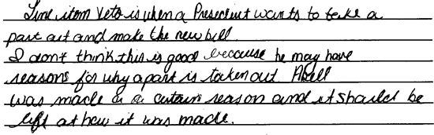

**Score 1:** This response demonstrates minimal understanding of arguments for and against the line item veto. The response is largely inaccurate and incomplete. Logic is exceedingly simplistic. The second sentence contradicts itself, and the con argument is prematurely conclusive due to its lack of justifications. The response exhibits minimal development of ideas.

**Sample 319-4 #2 of 3**

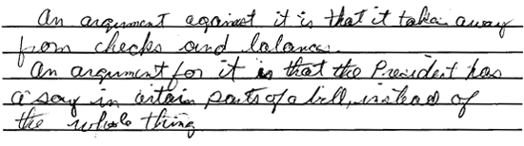

**Score 2:** This response demonstrates partial understanding of the subject, but the explanation is inadequately developed. The adverse repercussions on checks and balances are not explained, similarly, the positive impact of the president's line item veto power is not addressed clearly.

**Sample 319-4 #3 of 3**

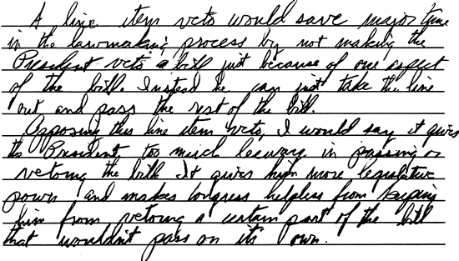

**Score 3:** This response demonstrates an understanding of the major arguments for and against the line item veto. The student addresses substantive arguments for and against the line item. The explanation is clear and generally complete and accurate.

(Item#:319-05)

99. In 1998, the Supreme Court ruled that the Line Item Veto Act was unconstitutional. Explain the concept of the line item veto and describe its likely impact on the separation of powers doctrine.

[Scoring Criteria](http://metacat2.com/cssap/sg/319-5sg.html)

**Module: 319   
Item: 5  
Descriptor: The Presidential Veto**

**Scoring Criteria**

Scores are based on the student's ability to:

* Explain the concept of line item veto.
* Describe its likely impact on the separation of powers doctrine.

A proficient response will demonstrate an understanding of the concept of line item veto and its likely impact on the separation of powers doctrine. Given the possibility of differing views on the issue, attention should be given to the accuracy and logic of the student's response.

Students should indicate that the line item veto empowers the president to veto certain provisions (such as controversial "riders") within a bill.

It is anticipated that most students will indicate that the line item veto will have a major impact on the separation of powers doctrine by granting significantly more power to the executive, thus diminishing the power of the legislative branch. In such cases, the explanation should include at least two logical points, to the following effect:

* The line item veto could be used by the executive to attack opponents in the legislature, instead of "pork" in spending bills.
* The line item veto alters the Constitution by empowering the executive branch to "dismantle" legislation in an attempt to advance its own legislative agenda, i.e., the president is encroaching on the lawmaking powers of Congress.
* Congress can't delegate law-making authority.
* The president must accept or reject bill in entirety; to pick and choose violates Article I.
* There is no precedent for the federal executive to exercise line item veto powers.

Although a less likely position to take, those students indicating that the line item veto would have little impact on the separation of powers should make at least two of the following points:

* Congress can voluntarily delegate power to the president.
* Congress delegates rule-making power to executive agencies (i.e., FCC).
* This is not an excessive delegation (limited to specified items in budget bills).
* Congress can override the president's line item veto by a 2/3 majority vote of both houses.
* Power has historically shifted between the legislative and executive branches.

**Score Level Descriptions**

**NS** Not Scorable (blank, off-topic, hostile, etc.)

**1** A response at this level demonstrates minimal understanding of the line item veto and its likely impact on the separation of powers doctrine. The response is largely inaccurate or incomplete. The explanations, if provided, are exceedingly vague or inaccurate. Logic and reasoning are very simplistic and/or seriously flawed. The response demonstrates minimal understanding.

**2** A response at this level demonstrates partial understanding of the line item veto and its likely impact on the separation of powers doctrine. The student will provide a partially accurate response, but the explanations are inadequately developed or incomplete. Evidence of rudimentary logic will be present, but it will contain flaws. The response demonstrates partial understanding.

**3** A response at this level demonstrates an adequate understanding of the line item veto and its likely impact on the separation of powers doctrine. The explanations are generally complete and accurate, although minor errors may be present. The logic and reasoning employed are justified, but may contain minor flaws. The response is sufficient to demonstrate understanding.

**4** A response at this level demonstrates a superior understanding of the line item veto and its likely impact on the separation of powers doctrine. The explanations are detailed, thorough, and accurate, and may go beyond that which is required in the question. The logic and reasoning used are sophisticated. The response demonstrates superior understanding.

[Student Work](http://metacat2.com/cssap/sg/319-5ss.html)

**Sample 319-5 #1 of 4**

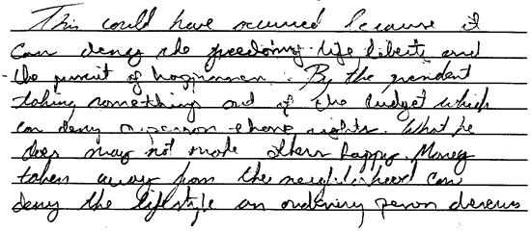

**Score 1:** This response demonstrates minimal understanding of the line item veto and its likely impact on the separation of powers doctrine. The student attempts to discuss repercussions of the line item veto, but fails to explain the concept and discuss its impact on the separation of powers.

**Sample 319-5 #2 of 4**

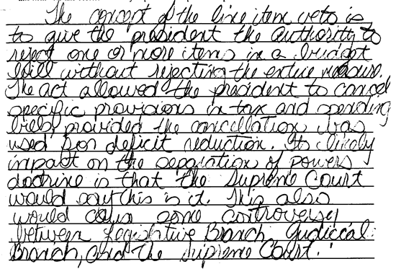

**Score 2:** This response demonstrates partial understanding of the line item veto and its likely impact on the separation of powers doctrine. The explanation of the concept of line item veto is adequate but fails to address the real separation of powers issue. The student notes that when Congress is overruled by the Supreme Court, there is controversy about the Act because Congress would not have passed it had they not thought it was constitutional. The real issue, however, is the impact on the separation of powers between the executive and legislative branches. The response reveals partial understanding.

**Sample 319-5 #3 of 4**

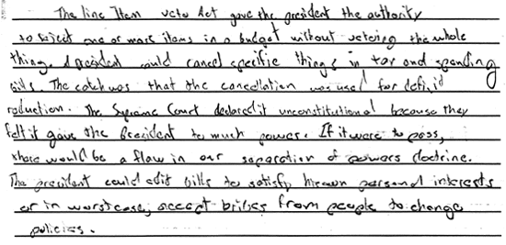

**Score 3:** This response demonstrates an adequate understanding of the line item veto and its likely impact on the separation of powers doctrine. The student understands the concept of the line item veto and articulates the Supreme Court's rationale for striking down the Act due to the shift of power to the president. The danger, according to the answer, is that the president may use it for personal interests. The logic is flawed by the inference that the president could use the line item veto to accept bribes, but the response is sufficient to demonstra te understandine

**Sample 319-5 #4 of 4**

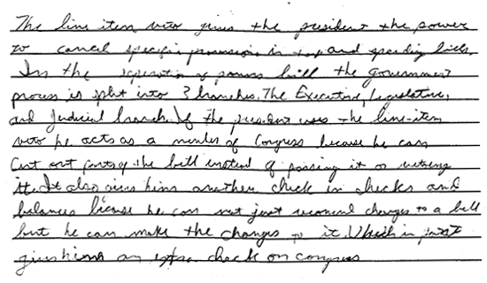

**Score 4:** Although brief, this response demonstrates a superior understanding of the line item veto and its likely impact on the separation of powers doctrine. The explanations are detailed, precise, and accurate. The logic and reasoning used are sophisticated.

"Observe good faith and justice toward all nations. Cultivate peace and harmony with all... A passionate attachment of one nation for another produces a variety of evils. Sympathy for the favorite nation, facilitating the illusion of an imaginary common interest in cases where no real common interest exists, and infusing into one the enmities of the other betrays the former into a participation in the quarrels and wars of the latter without adequate inducement or justification... It is our true policy to steer clear of permanent alliances with any portion of the foreign world so far, I mean, as we are now at liberty to do it...."

--Excerpt from George Washington's Farewell Address, 1796

Throughout our nation's history, our foreign policy has been shaped by the changing conceptions of the national security interests of the United States. While early presidents were very cautious about committing the United States to foreign alliances, more recent administrations have come to emphasize the mutual benefits of such arrangements. Since the 1940s, the United States has entered into a number of regional security alliances, based on the agreement that member nations in those regions consider an attack on one as an attack on all. Below is a timeline illustrating the major security alliances to which the United States is, or has been, a member:

(Item#:320-01)

100. Based on the timeline, with which areas of the world has the United States **NOT** negotiated a region security alliance?

      A. Asia

      B. Europe

      C. Latin America

      D. Middle East

Answer: D

(Item#:320-02)

101. Which constitutional process would be used by the United States to formally enter into regional security alliances?

      A. Congressional legislation

      B. Executive agreement

      C. Treaty ratification

      D. Popular referendum

Answer: C

(Item#:320-03)

102. The regional security alliances featured on the timeline were established in response to which of the following?

      A. The invasion of Poland by Nazi Germany

      B. The creation of the United Nations

      C. The election of President Franklin D. Roosevelt

      D. The expansion of communism after World War II

Answer: D

(Item#:320-04)

103. When President George Washington left office in 1796, he offered the new American republic the advice concerning foreign policy quoted in the introduction. First, identify Washington's position and the rationale he offered for it. Then, drawing on your background knowledge, explain why Washington's advice may have been appropriate for the time.

[Scoring Criteria](http://metacat2.com/cssap/sg/320-4sg.html)

**Module: 320   
Item: 4  
Descriptor: American Foreign Policy and Security Alliances**

**Scoring Criteria**

Scores are based on the student's ability to:

* Identify Washington's position concerning the foreign policy of the United States, and the rationale underlying his position.
* Explain why isolationism/neutrality may have been an appropriate foreign policy in the early history of the United States.

A proficient response should reflect the following interpretation:

* In his statement, Washington advocated a policy of neutrality/isolationism, contending that permanent alliances would drag the United States into "quarrels and wars" that would not advance the self-interest of the nation.
* Washington's advice was appropriate for the 1790s because the United States was a small, weak nation that would have had difficulty defending itself against a strong enemy. Furthermore, the United States government was strapped with debt from the Revolutionary War, making costly foreign entanglements imprudent. As a new and growing nation, available resources were needed for exploration, settlement, and industrial development, rather than defending the interests of foreign allies.

**Score Level Descriptions**

**NS** Not Scorable (blank, off-topic, hostile, etc.)

**1** A response at this level demonstrates minimal understanding of Washington's position concerning the foreign policy of the United States, the rationale underlying his position, and why isolationism/neutrality may have been an appropriate foreign policy in the early history of the United States. The response is largely inaccurate or incomplete. The explanation is exceedingly vague and/or inaccurate. Logic or reasoning, if in evidence, is exceedingly simplistic and/or seriously flawed. The response demonstrates minimal understanding.

**2** A response at this level demonstrates partial understanding of Washington's position concerning the foreign policy of the United States, the rationale underlying his position, and why isolationism/neutrality may have been an appropriate foreign policy in the early history of the United States. The response is partially accurate but incomplete. The explanation is somewhat unclear and inadequately developed. Some evidence of logic or reasoning may be present, but it will be incomplete and partially flawed. The response demonstrates partial understanding.

**3** A response at this level demonstrates an understanding of Washington's position concerning the foreign policy of the United States, the rationale underlying his position, and why isolationism/neutrality may have been an appropriate foreign policy in the early history of the United States. The response is complete and accurate, although minor errors may be present. The explanation is clear and generally complete and accurate. The response exhibits valid logic and reasoning. The response is sufficient to demonstrate understanding.

[Student Work](http://metacat2.com/cssap/sg/320-4ss.html)

**Sample 320-4 #1 of 3**

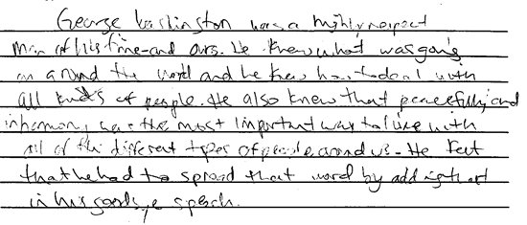

**Score 1:** This response demonstrates minimal understanding of Washington's position concerning the foreign policy of the U.S., the rationale underlying his position, or why isolationism/neutrality may have been an appropriate foreign policy in the early history of the U.S. The response fails to explain the essential element of the rationale behind Washington's position, namely that a position of neutrality best promoted the interests of the U.S.

**Sample 320-4 #2 of 3**

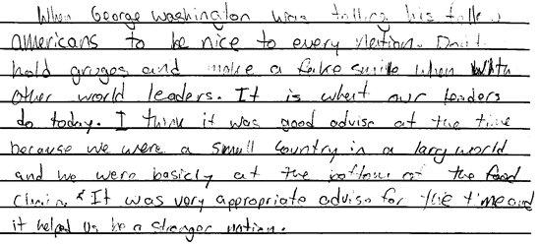

**Score 2:** This response demonstrates partial understanding of the topic by acknowledging the U.S. position in the world as comparatively attenuated. Furthermore, it views Washington's position as a means to become a stronger nation. However, the student does not provide a complete response in so much as it is not clear that "to be nice to every nation" is equivalent to Washington's prescription of isolationism/neutrality.

**Sample 320-4 #3 of 3**

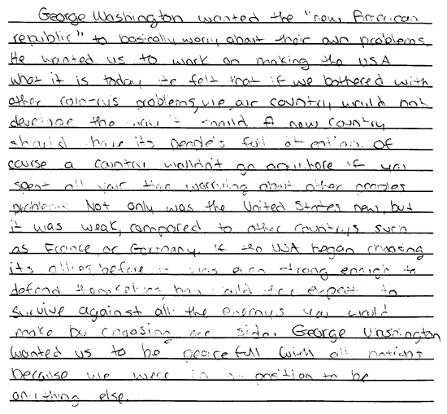

**Score 3:** This response demonstrates an understanding of the topic. The student acknowledge s the U.S. position as a weak country compared to France and Germany, as well as addressing Washington's prescription to forego restrictive alliances and opting to focus on U.S. domestic problems. The response accurately conveys the idea that strength as a nation would be achieved through a path of isolation/neutrality and not through self-etiolating alliances.

(Item#:320-05)

104. The following statements illustrate foreign policy positions advocated by two former American presidents.

"I believe that it must be the policy of the United States to support free peoples who are resisting attempted subjugation by armed minorities or by outside pressures. I believe that we must assist free peoples to work out their own destinies in their own way... The seeds of totalitarian regimes are nurtured by misery and want. They spread and grow in the evil soil of poverty and strife. They reach their full growth when the hope of a people for a better life has died. We must keep that hope alive. The free peoples of the world look to us for support in maintaining their freedoms. If we falter in our leadership, we may endanger the peace of the world and we shall surely endanger the welfare of this nation."

--Excerpt from the Truman Doctrine, 1947

"Let the word go forth from this time and place, to friend and foe alike, that the torch has been passed to a new generation of Americans --born in this century, tempered by war, disciplined by a hard and bitter peace, proud of our ancient heritage -- and unwilling to witness or permit the slow undoing of those human rights to which this nation has always been committed, and to which we are committed today at home and around the world. Let every nation know, whether it wishes us well or ill, that we shall pay any price, bear any burden, meet any hardship, support any friend, oppose any foe to assure that survival and the success of liberty. This much we pledge - and more."

--Excerpt from John F. Kennedy's Inaugural Address, 1961

Evaluate the foreign policy positions of Truman and Kennedy with respect to current national security interests.

* Identify some principles of U.S. foreign policy from the excerpts.
* Do they still apply?
* Use specific examples to support your response.

[Scoring Criteria](http://metacat2.com/cssap/sg/320-5sg.html)

**Module: 320   
Item: 5  
Descriptor: American Foreign Policy and Security Alliances**

**Scoring Criteria**

Scores are based on the student's ability to:

* Compare post-WWII foreign policy positions advocated by Presidents Truman and Kennedy.
* Identify the major principles embodied in those positions.
* Explain the relevance of those principles relative to the United States' present role in world affairs.

A proficient response will demonstrate an understanding of the major principles of foreign policy espoused by Presidents Truman and Kennedy, and the relevance of those principles today. Students should recognize the following major principles:

* Truman: stop the spread of totalitarian regimes in the world (contain communism)
* Kennedy: support any friend and oppose any foe (active interventionist)

The explanation of the relevance of these principles, i.e., the extent to which they still apply, is a matter of opinion; however, in scoring student responses, careful attention should be given to the examples used to demonstrate the logic behind the student's opinion.

**Score Level Descriptions**

**NS** Not Scorable (blank, off-topic, hostile, etc.)

**1** A response at this level demonstrates minimal understanding of the major principles underlying U.S. foreign policy as espoused by Presidents Truman and Kennedy, and the relevance of those principles relative to the United States' present role in world affairs. The response is largely inaccurate or incomplete. The student will not identify the main principles of foreign policy espoused by Presidents Truman and Kennedy. The explanation, if provided, is exceedingly vague or inaccurate. Logic and reasoning are very simplistic and/or seriously flawed. The response demonstrates minimal understanding.

**2** A response at this level demonstrates partial understanding of the major principles underlying U.S. foreign policy as espoused by Presidents Truman and Kennedy, and the relevance of those principles relative to the United States' present role in world affairs. The student will provide a partially accurate response. The student may identify the main principles of foreign policy espoused by Presidents Truman and Kennedy, but the explanation of the relevance of those principles is inadequately developed or incomplete. Evidence of rudimentary logic will be present, but it will contain flaws. The response demonstrates partial understanding.

**3** A response at this level demonstrates an adequate understanding of the major principles underlying U.S. foreign policy as espoused by Presidents Truman and Kennedy, and the relevance of those principles relative to the United States' present role in world affairs. The student will identify the main principles of foreign policy espoused by Presidents Truman and Kennedy. The explanation of the relevance of those principles is generally complete and accurate, although minor errors may be present. The logic and reasoning employed are justified with appropriate examples, but may contain minor flaws. The response is sufficient to demonstrate understanding.

**4** A response at this level demonstrates a superior understanding of the major principles underlying U.S. foreign policy as espoused by Presidents Truman and Kennedy, and the relevance of those principles relative to the United States' present role in world affairs. The student will identify the main principles of foreign policy espoused by Presidents Truman and Kennedy. The explanation of the relevance of those principles is detailed, thorough, and accurate, and may go beyond that which is required in the question. The logic and reasoning used are sophisticated and flawless, and are supported by appropriate examples. The response demonstrates superior understanding.

[Student Work](http://metacat2.com/cssap/sg/320-5ss.html)

**Sample 320-5 #1 of 4**

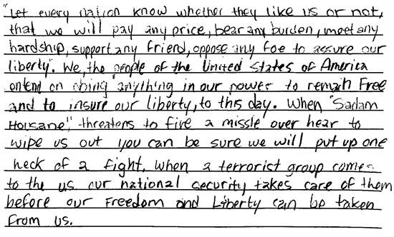

**Score 1:** This response demonstrates minimal understanding of the major principles underlying U.S. foreign policy as espoused by President Truman and Kennedy, and the relevance of those principles relative to the United States' present role in world affairs. The response inaccurately asserts the policies as proposing a course of action if a country threatens the U.S., as opposed to the real intent of the policies to propose a course of action if a country threatens another country's liberty. The explanation is largely inaccurate.

**Sample 320-5 #2 of 4**

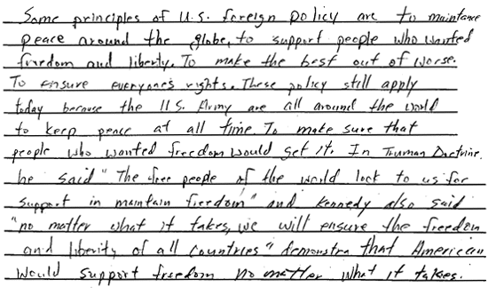

**Score 2:** This response demonstrates partial understanding of the topic. It fails, however, to provide specific examples of U.S. military deployments (Grenada, Nicaragua, Honduras, Bosnia, Kosovo, Kuwait, Somalia, Taiwan) and illustrate how they relate to these policies. In addition, the response discusses only the similarities between the Kennedy policy and the Truman doctrine, omitting the differences, which if addressed, would demonstrate a more proficient understanding of the subject.

**Sample 320-5 #3 of 4**

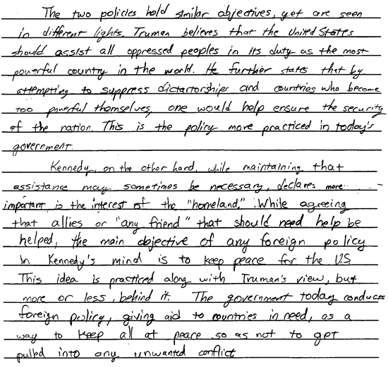

**Score 3:** This response demonstrates an adequate understanding of the topic by engaging in a discourse about the objectives of the respective policies and how the two policies relate to one another. The logic employed has a solid foundation, but fails to demonstrate a superior understanding because specific contemporary examples were not used to support the c onclusions.

**Sample 320-5 #4 of 4**

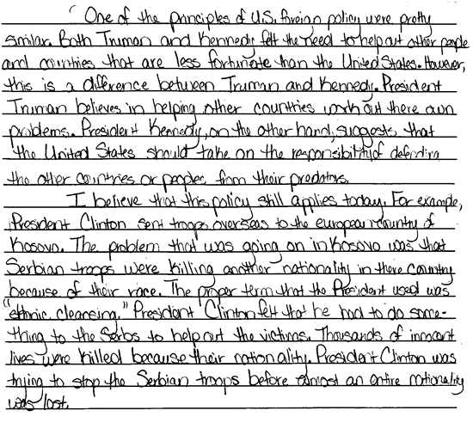

**Score 4:** The response demonstrates a superior understanding of the topic. The student identifies the main principles of foreign policy espoused by Presidents Truman and Kennedy. The explanation of the similarities and differences between the two policies, referencing their contemporary application to the U.S. involvement in Kosovo, is very well done and insightful. The response demonstrates superior understanding.