December 24, 2012

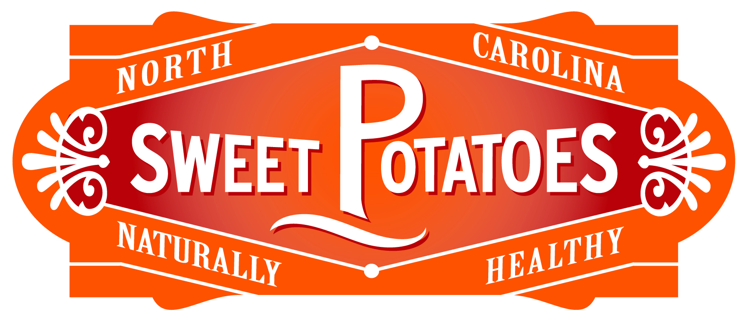
Much has changed in the half-century since the inception of the North Carolina SweetPotato Commission. What began as a small organization with big ideas is now an industry leader with bigger ideas and more opportunities—yet always focused on the original, root purpose: to expand the industry and be the source for ideas, answers and solutions for those connected to it. Education, research, and technology continue to yield new heartier and healthier sweet potato varieties. The NCSPC pledges to continue to seek resources that will further research how the nutritive properties of sweet potatoes can best benefit human health and wellness; strive to serve as a model for environmental stewardship and will continue to collaborate with like-minded organizations to protect North Carolina’s natural resources. Increased marketing and promotion have literally exposed the nation and the world to the availability, versatility, ease of preparation, and nutrition of sweet potatoes. As a forward-thinking organization, NCSPC will continue to evaluate and embrace appropriate emerging technologies that will serve to enhance our communication and improve production practices and to pursue innovative ideas that better the interests of growers and consumers far into the future,

Drought NEWS
Severe Drought Returns to Southwestern N.C.: Severe drought has returned to North Carolina and prompted state officials to encourage people to pay attention in case local communities enact water saving measures. Thursday’s federal drought map moved eight counties-Cabarrus, Catawba, Cleveland, Gaston, Lincoln, Mecklenburg, Rutherford, and Union- in southwestern North Carolina into severe drought, the second worst ranking in the system. Thursday marks the first time since February of this year that any part of the Tar Heel State has experienced a severe drought. Another 57 North Carolina counties are experiencing moderate drought. In addition, 16 counties are abnormally dry, which means drought in those areas could reemerge without adequate rainfall. The drought map can be seen at www.ncdrought.org.
Washington NEWS
Lucas Announces New Leadership Team for Ag Committee: Chairman Frank Lucas of Oklahoma named five members to serve as subcommittee chairmen of the House Agriculture Committee for the 113th Congress. Chairman Lucas designated the following subcommittee chairmen: Rep. Steve King (IA-5), Department Operations, Oversight, and Nutrition; Rep. K. Michael Conaway, (TX-11), General Farm Commodities and Risk Management; Rep. Glenn “GT” Thompson (PA-5), Conservation, Energy, and Forestry; Rep. Austin Scott (GA-8), Horticulture, Research, Biotechnology, and Foreign Agriculture; Rep. Rick Crawford (AR-1), Livestock, Rural Development, and Credit.
Peterson Announces New House Ag Committee Democrats: U.S. House Agriculture Committee Ranking Member Collin C. Peterson, D-Minn., announced four new Democratic members appointed to the committee. New members joining the committee: Michelle Lujan Grisham (NM-1), Ann Kuster (NH-2), Gloria McLeod (CA-35), Filemon Vela (TX-34).
Senate and House Committees: Congressman Bob Goodlatte (R-VA) was elected by the House Republican Conference to serve as Chairman of the House Judiciary Committee. Goodlatte appointed Rep. Trey Gowdy, a Republican from South Carolina, to head the Subcommittee on Immigration and Border Security. Gowdy received a grade of “A-“ from NumbersUSA, a group focused on decreasing the numbers of legal and illegal immigrants. Sen. Patrick J. Leahy (D-VT) said he will continue as chairman of the Senate Judiciary Committee. He was expected to take over the Appropriations Committee after Sen. Daniel K. Inouye of Hawaii died last week.
N.C. Legislative NEWS
Sen. Ed Jones Dies: N.C. Sen. Ed Jones of Halifax County, 62, died Friday, Dec. 14. Jones, a Democrat, was diagnosed with pancreatic cancer several months ago. Democratic leaders will choose a replacement to serve the rest of Jones’ term, which ends in 2014.
Brock, Jackson to Chair Senate Committee on Agriculture, Environment, and Natural Resources: N.C. Senate President Pro Tempore Phil Berger announced he plans to appoint Sen. Andrew Brock (R-Davie) and Sen. Brent Jackson (R-Sampson) as co-chairmen of the Senate Committee on Agriculture, Environment, and Natural Resources and the Appropriations Subcommittee on Natural and Economic Resources when the legislature convenes early next year.
N.C. House Appointments: N.C. House Speaker Thom Tillis announced appointments to several committees: Rep. Tom Murry, a Cary Republican, will chair the Commerce and Job Development committee. Rep. Tim Moffitt, an Asheville Republican, will chair a new committee on regulatory reform. The House Judiciary Committee will be led by Rep. Leo Daughtry, a Republican from Smithfield. Rep. Paul “Skip” Stam of Apex was picked to serve as speaker pro tem.
McCrory Makes More Appointments: Gov. elect Pat McCrory is filling his cabinet. Lyons Gray, a former legislator and former employee of R.J. Reynolds Tobacco Co., will serve as secretary of the N.C. Department of Revenue. Art Pope, founding member of both Civitas Institute and Civitas Action, will serve as director of the State Office of Management and Budget.
Business NEWS
Austrian Timber Manufacturer to Create 350 Jobs in Enfield: Klausner Lumber Two, a privately-owned softwood timber manufacturer, will establish a state-of-the-art sawmill in Halifax County. The company plans to create 350 jobs over the next three years and invest $110 million. The project was made possible in part by state grants from the Job Development Investment Grant and the One North Carolina Fund. Klausner currently operates two mills in Germany, with the company’s headquarters based in Tyrol, Austria. The company produces custom-sized rough and planed lumber products that are used in the construction, pressure-treating, secondary processing, furniture and packaging industries.
Gildan to Create 170 Jobs in Rowan County: Gildan Activewear Inc., through its yarn-spinning subsidiary, CanAm Yarns LLC, plans to open a new ring-spinning facility in Salisbury to support its projected growth. Gildan is a marketer and vertically-integrated manufacturer of quality-branded basic family apparel and is rapidly expanding its presence in the U.S. and international markets. The company plans to create approximately 170 jobs over the next two years and invest over $50 million. The project was made possible in part by a state Job Development Investment Grant. Gildan currently employs 100 people at a yarn-spinning facility operated by CanAm in Bladen County and 294 people at one of its distribution centers in Rockingham County.
Textile Manufacturer to Add 37 Jobs in Surry County: Willow Tex LLC, a textile manufacturer and distributor, will locate a new facility in Surry County. The company plans to create 37 jobs and invest $6.1 million during the next three years in Mount Airy. The project was made possible in part by a $130,000 grant from the One North Carolina Fund.
People NEWS
Civitas Announces Pope Resignation from Boards: James A. “Art” Pope has resigned from the boards of the Civitas Institute and Civitas Action. Pope has been named deputy budget director by incoming North Carolina Gov. Pat McCrory.
Environmental NEWS
EPA’s Update to Clean Air Standards Does Not Change Farm Dust: In response to a court order, the U.S. EPA finalized an update to its national air quality standards for harmful fine particle pollution (PM2.5), including soot, setting the annual health standard at 12 micrograms per cubic meter. By 2020, 99 percent of U.S. counties are projected to meet revised health standard without any additional actions. The announcement has no effect on the existing daily standard for fine particles or the existing daily standard for coarse particles (PM10), which includes dust from farms and other sources, both of which remain unchanged.
Court Rules in Favor of Poultry Grower: The Waterkeeper Alliance, the Assateague Coastal Trust, and the University of Maryland Environmental Law Clinic have lost their lawsuit claiming a Maryland farm family violated the Clean Water Act and that the company that contracts with them to raise chickens controls the farm. Judge William M. Nickerson of the U.S. District Court in Baltimore, Md., has ruled against the plaintiffs, saying they did not prove their case against Perdue Farms Inc. and contract chicken growers Alan and Kristin Hudson of Berlin, Md. In the order, the judge held that the New York-based Waterkeeper Alliance and the Assateague Coastal Trust “has failed to meet its burden of establishing that there was a discharge of pollution from the poultry operation on the Hudson Farm.” According to Julie DeYoung, Perdue’s spokesperson, the Waterkeepers put an innocent farm family through hell and tried to drive a wedge between farmers and responsible environmentalists. Evidence presented during the trial showed that the Waterkeeper Alliance and the Assateague Coastal Trust were determined to file a lawsuit against a poultry farm affiliated with a major chicken producer and went looking for a victim in flights over the Eastern Shore.
University NEWS
NCSU CALS Listening Sessions: N.C. State University’s College of Agriculture and Life Sciences is developing a strategic plan to guide the college’s future. Anyone with an interest in the college is invited to attend listening sessions that are being held across the state. Sessions will be held from Jan. 7 through Feb. 8. For more info and to register go to http://go.ncsu.edu/2013_cals_listening_sessions. To learn more about the strategic plan, click here.
Commodity NEWS
N.C. Growing More Organic Grains: Organic grain production in N.C. is increasing. According to NCSU organic crops specialist Chris Reberg-Horton, organic corn and soybeans are most common but there’s been a rise in organic wheat production. N.C. farmers grew approximately 12,000 acres of organic grain crops in 2012. While still only accounting for a small portion of N.C.’s ag industry, Reberg-Horton says it is growing and farmers are making money. Typically, organic grain crops bring higher prices than conventional ones. When Reberg-Horton started at NCSU, most of the focus was on organic corn and soybeans, but wheat is proving to be more profitable so production is increasing.
NCDA NEWS
NCDA&CS to Host Workshop on Preventing Food Recalls: A workshop aimed at helping small food businesses prevent and respond to recalls will take place Wednesday, Jan. 16, in the Triad. The workshop will take place from 8:30 a.m. to 3 p.m. in the Moose Cafe meeting room at the Piedmont Triad Farmers Market in Colfax. It is sponsored by the NCDA&CS and the N.C. Food Safety and Defense Task Force. The cost is $30 and includes lunch and materials. The registration deadline is Jan. 9. A registration form can be downloaded from www.ncagr.gov/markets/agribiz. For more information, contact Annette Dunlap at 919-707-3117.
USDA NEWS
Troxler Encourages N.C. Farmers to Take Part in Ag Census: Agriculture Commissioner Steve Troxler is encouraging North Carolina farmers to “speak up” for their livelihood by taking part in the 2012 Census of Agriculture. USDA’s National Agricultural Statistics Service will mail out census forms this month to collect data for the 2012 calendar year. Completed forms are due by Feb. 4. Farmers can fill out the census online using a secure website, www.agcensus.usda.gov, or return their form by mail. Federal law requires all agricultural producers to participate in the census and requires NASS to keep all individual information confidential.
USDA Announces No Storage Deficit Areas for the 2012-Crop Cotton Marketing Assistance Loan Program: The USDA’s Commodity Credit Corporation (CCC) announced that no storage deficit areas have been determined for the 2012-crop cotton marketing year. CCC determines that a storage deficit area exists if the production of cotton exceeds the combined approved inside storage capacity of warehouses that have entered into a cotton storage agreement with CCC, less carry-in stocks for the area. Based on Oct. 12, 2012, production estimates and carry-in stock reports from the National Agricultural Statistics Service, CCC determined there was no cotton storage deficit and therefore did not designate storage deficit areas for the 2012- crop cotton.
USDA Issues Final Rule for Animal Disease Traceability: The USDA announced a final rule establishing general regulations for improving the traceability of U.S. livestock moving interstate. Under the final rule, unless specifically exempted, livestock moved interstate would have to be officially identified and accompanied by an interstate certificate of veterinary inspection or other documentation, such as owner-shipper statements or brand certificates. After considering the public comments received, the final rule has several differences from the proposed rule issued in August 2011. For more specific details about the regulation and how it will affect producers, visit www.aphis.usda.gov/traceability.
Mark Your Calendar
To see all upcoming events - click here for the AgCalendar.

