Log-in to the GA PSC site:
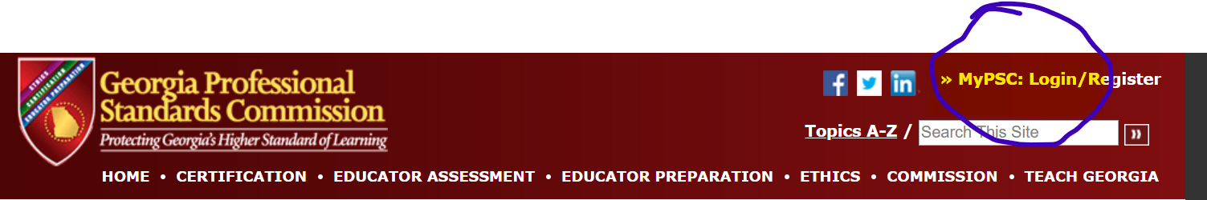
Choose Assessments:
Choose #7:
Request Access:
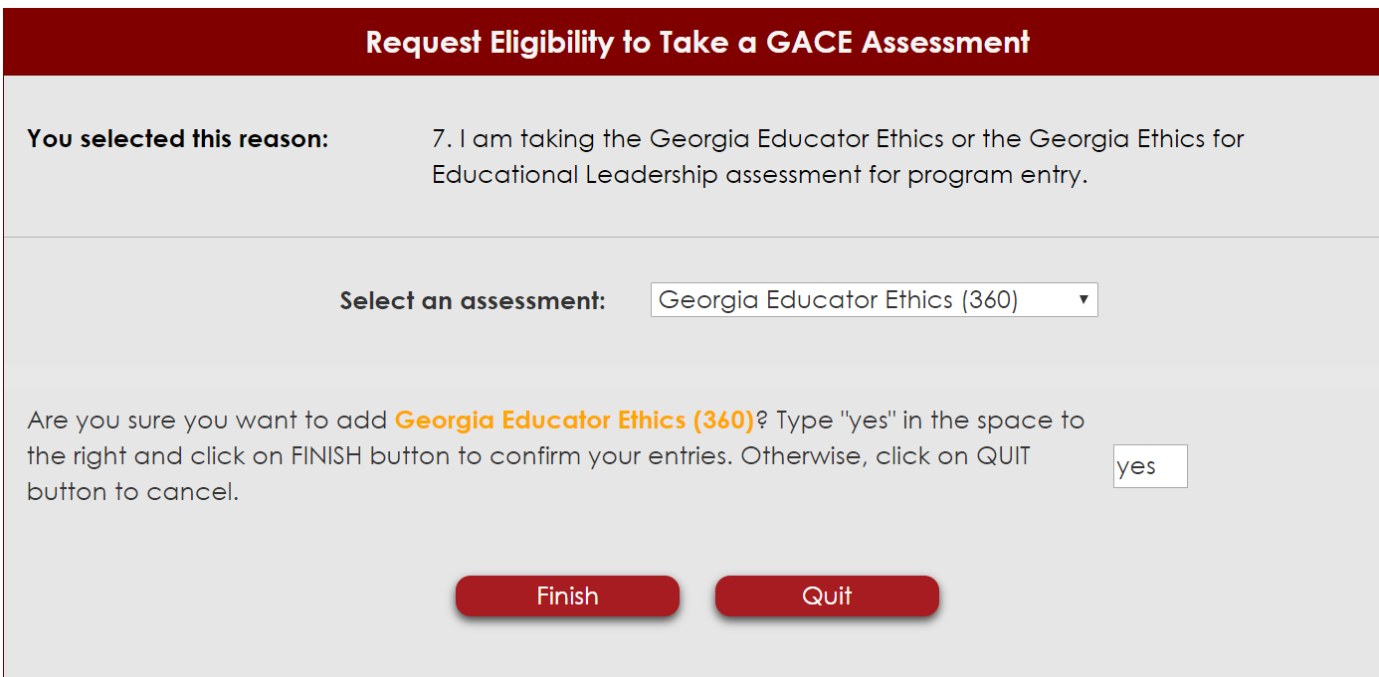
Eligibility active:
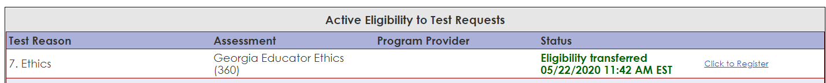
Click “Click to register:
Receive Email:
Follow Link:
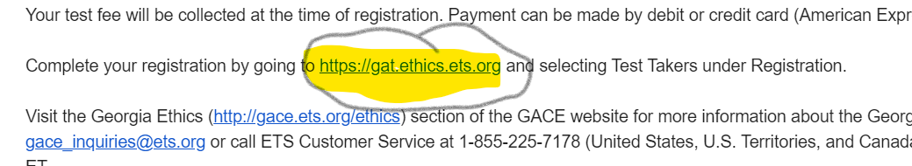
Create account or log in if you already have an account:
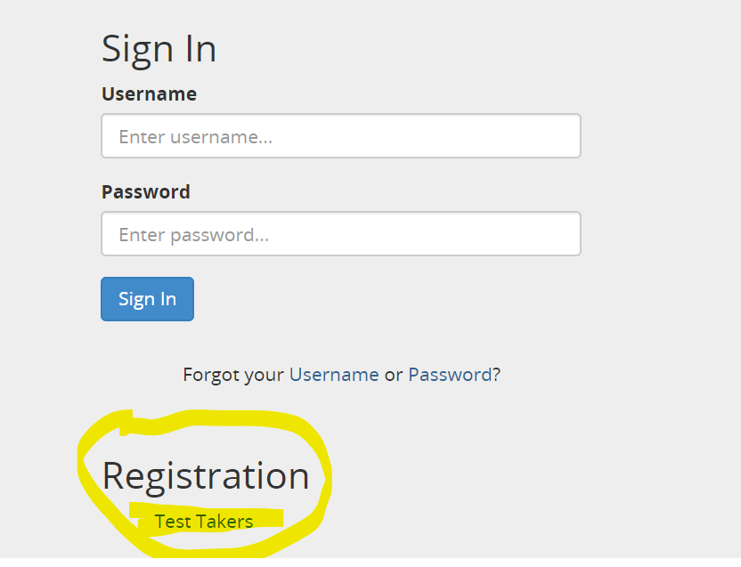
Click ‘Make Payment’:
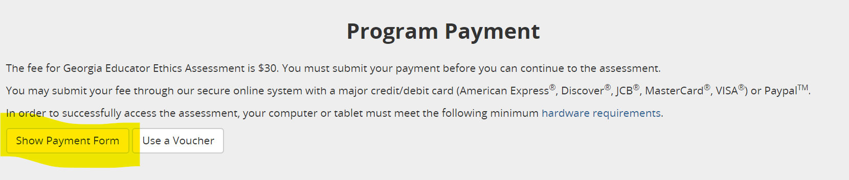
Follow steps to make payment.

Answer background questions:
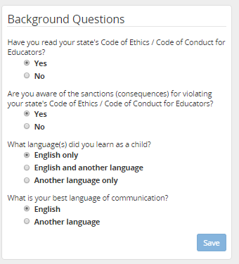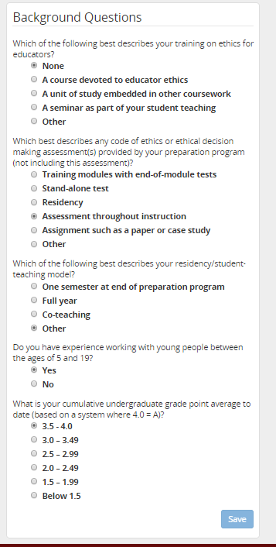
Complete modules:
Each module guides the test taker through a variety of videos and scenarios on different ethics related topics. There are multiple assessments as you go through the modules. Each assessment allows up to 5 attempts.
There is a final 32 question assessment that is cumulative of questions from the other assessments and also allows up to 5 attempts to pass.
The question below is part of the GACE post-survey and leads me to believe the course could be taken as a large group:
