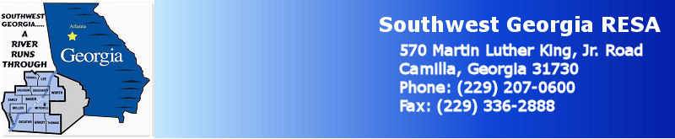

*Southwest Georgia RESA seeks to provide support and assistance for principals among RESA systems by providing a* ***Principal Support Network*** *during the 2014-2015 school year.*

**Format:**

* Provide support and technical assistance for principals in their implementation of the TKES, Tiered Certification Support, and the design of effective Professional Learning. To do so, we will hold regular workshops throughout the year. (See Dates Below)
* Develop a Professional Learning Network of Principals in the SWGA RESA. Beyond the face-to-face meetings, establish an ongoing community of learning and support among the principals.
* Sessions will be some presentation, but chiefly facilitated conversations among principals. Principals in the program will be actively engaged, sharing effective practices as well as questions.

**Research Basis and Learning Framework:** The Georgia TKES and LKEs; The Wallace Foundation’s Five Practices of Effective Principals, NASSP’s Ten Skills for Successful School Leaders.

**Goals:**

* Increased student performance and growth through more effective support of teachers;
* Ongoing professional learning for principals through Professional Learning Network.

**Who Should Attend?:**

* Principals of Schools of all grade bands;
* Principals of all experience levels;

**Facilitator:** Dr. Mark Wilson, long-time principal and teacher, former National Principal of the Year, principal trainer coach and consultant for school leaders throughout Georgia and across the country.

**Dates/Major Topics:**  All Meetings Begin at 8:30 AM and conclude at Noon; Sessions will focus on the ***Leader’s Understanding*** of the TAPS Performance Standards and Strategies for Student Growth.

Thursday, July 24, 2014 Leading Teachers Successfully Through The New System ; Time Mgmt.

Wednesday, August 13, 2014 Professional Knowledge and Instructional Planning

Monday, September 22, 2014 Instructional Strategies and Assessment Strategies

Wednesday, October 29, 2014 Assessment Uses and Differentiation

Tuesday, December 9, 2014 Academically Challenging Environment and Positive Learning Env.

Wednesday, February 25, 2015 Communication and Professionalism

Wednesday, April 22, 2015 Platform Challenges and Final Entry of Evaluation Data

Tuesday, June 23, 2015 Evaluating the System: What Worked, What Didn’t

**SW GA RESA Principal Support Network:**

*Leadership For Success Through Effective Use of the TKES*

2014-2015